**Integrated Term Project**

**An Analysis of Various Apparel Products and its Price range in Online Shopping**

**Bachelor of Fashion Technology**

Submitted By

**Aditi Galada (BFT/16/91)  
Monisha (BFT/16/960)**

**Karthik.S (BFT/16/N2197)**

**Utkarsh Chaturvedi (BFT/16/575)**

Under the Guidance of

**Mr. Praveen D Nagarajan**

Department of Fashion Technology

National Institute of Fashion Technology

2016-2020

**AKNOWLEDGEMENT**

First of all, we would like to that our Almighty God for the knowledge, strength and wisdom. His guidance leads us to select the most desirable way to success.

We would also like to take this opportunity to thank our Institute for creating such a pathway to explore the Industry and present our Integrated Term Project.

We are much thankful to our mentor Mr. Praveen Nagarajan, Asst. Prof. for his active guidance and immense support during the period of the whole project. Without that, the completion of the project would not have been possible.

**Content**

|  |  |  |
| --- | --- | --- |
| S.No. | Topic | Pg. No. |
|  | Objective | 7 |
|  | Methodology | 7 |
|  | Scope of study | 7 |
|  | Introduction | 8 |
|  | Process of online shopping | 11 |
|  | Methods of payment | 12 |
|  | Advantages, disadvantages and limitations of online shopping | 13 |
|  | Online safety | 15 |
|  | Basic understanding and comparison between traditional stores and online stores | 16 |
|  | Market survey | 19 |
|  | Size description of products | 23 |
|  | Top Online Sites | 25 |
|  | Comparison of features of top 5 online shopping sites | 27 |
|  | Sites Referred | 28 |
|  | Product categories | 33 |
|  | Product Catalogue | 34 |
|  | Analysis of pricing of infant boys garments | 101 |
|  | Analysis of pricing of infant girls garments | 108 |
|  | Analysis of pricing of kids boys garments | 115 |
|  | Analysis of pricing of kids girls garments | 122 |
|  | Analysis of pricing of mens garments | 130 |
|  | Analysis of pricing of womens garments | 137 |
|  | Impact of social commerce on buying fashion online | 145 |
|  | Challenges | 146 |
|  | Future of e-commerce | 147 |
|  | Conclusion | 150 |
|  | References | 151 |
|  | Annexure 1 : How to measure the human body | 152 |
|  | Annexure 2: Size chart | 156 |
|  | Annexure 3: Top 10 online shopping sites | 160 |
|  | Annexure 4: Various styles of garments | 161 |

|  |  |  |
| --- | --- | --- |
| Fig.No. | Topic | Pg. No. |
|  | Category split of E-commerce in India | 9 |
|  | Segment wise contribution in apparel retailing | 10 |
|  | Total Apparel Market in crore | 19 |
|  | Mens apparel market in crore | 19 |
|  | Womens apparel market in crore | 19 |
|  | Volume of transaction people in the age 13-27 are comfortable with | 20 |
|  | Volume of transaction people in the age 28-50 are comfortable with | 20 |
|  | Top 15 sites with highest overall satisfaction score | 25 |
|  | Top sites recommended to friends/ relatives | 26 |
|  | No. of garments found in each site for lower price for infant boys | 105 |
|  | No. of garments found in each site for average price for infant boys | 105 |
|  | Prices of garments for infant boys | 106 |
|  | No. of products from selected brands for infant boys | 107 |
|  | No. of garments found in each site for lower price for infant girls | 112 |
|  | No. of garments found in each site for average price for infant girls | 112 |
|  | Prices of garments for infant girls | 113 |
|  | No. of products from selected brands for infant girls | 114 |
|  | No. of garments found in each site for lower price for kids boys | 119 |
|  | No. of garments found in each site for average price for kids boys | 119 |
|  | Prices of garments for infant boys for kids boys | 120 |
|  | No. of products from selected brands for kids boys | 121 |
|  | No. of garments found in each site for lower price for kids girls | 127 |
|  | No. of garments found in each site for average price for kids girls | 127 |
|  | Prices of garments for kids girls | 128 |
|  | No. of products from selected brands for kids girls | 129 |
|  | No. of garments found in each site for lower price for mens | 134 |
|  | No. of garments found in each site for average price for mens | 134 |
|  | Prices of garments for mens | 135 |
|  | No. of products from selected brands for mens | 136 |
|  | No. of garments found in each site for lower price for womens | 141 |
|  | No. of garments found in each site for average price for womens | 141 |
|  | Prices of garments for womens | 142 |
|  | No. of products from selected brands for womens | 143 |

1. **OBJECTIVE**

The main objective of this study is to compare and find out best prices for various apparel products for various categories of clothing in online shopping websites. Other objectives include

1. To understand the working of e-commerce websites
2. To study the Indian apparel market
3. To study the important demographic, psychological and socio-economic factors which influence the consumer purchase behavior for apparel
4. **METHODOLOGY:**

Secondary study was done on the apparel market in India through books and the internet. Various pattern making books were referred to find out different categories of apparels for different age groups Then we found out different styles of garments for different age groups and genders after which we searched for various online sites for buying apparel online. After this we studied standard sizes and standard measuring techniques, collected primary data by browsing online shopping websites and finding out different price range of products ,i.e., lower price and average price. Then we analyzed the collected data with the help of pie charts and bar graphs.

1. **SCOPE OF STUDY:**

This study is done to present the consumer with a relative price chart, product range and quality of brands and the websites associated with them. This gives an overview to the consumer about the best price ranges available for the selected product category and the best site to purchase that particular product category.

While we study about the e-commerce sites and its product and price categories, we get a better knowledge about that fields and this helps us to use this knowledge while our tenure in the industry and take quick decisions without further references. We know the functioning of e-Commerce sites and will be able to interpret their further products and mentally compare and contrast their quality with their price range.

1. **INTRODUCTION**

Online shopping or e-shopping is a form of electronic commerce which allows consumers to directly buy goods or services from a seller over the Internet using a web browser. Shoppers can visit web stores from the comfort of their homes and shop as they sit in front of the computer.

**EVOLUTION OF SHOPPING :**

Before 1991 – Customers went to the nearest shopping market and bought whichever 1-2 brands were available since there was monopoly.

Before 2009 – Customers hopped with family in tow from shops to shops over the entire weekend coupled with endless bargaining. Only to go back to Shop No 1 in the end.

In 2012 – Customers spent hours on online shopping sites, opened multiple tabs to compare and bookmarked the one product they finally liked to purchase later. Only to discover the discount is no longer available after a week. Hours of research starts again.

In present time- Customers now open Online Shopping Comparison site, see the list of sellers in one page and buy from the one offering the highest discount.

As pointed above, just like many things, shopping has evolved. From pre-liberalization monopoly, now it has become an online open market space where customers have tons of options to choose from. So much so, that in the Ecommerce world, each day is a fresh struggle to attract and retain customers. Unbelievable discounts, deals, perks and offers have become a regular thing and consumers now expect to be wooed with better and better deals each day.  This is why shopping comparison has become so popular lately in India and why Ecommerce owners should list themselves on it.We prepared a few Price comparison charts that act like a search engine where shoppers can sort through various garments based on category, price, discount, size availability etc. and compare them .

* Shoppers at lower income levels have been hunting bargains for years but now even wealthy shoppers have begun to compare prices between retailers on everything they buy, and their brand loyalty has plummeted.
* The customer is visiting retail store a little less frequently
* Customers in general are less loyal to any one retailer and that is because of the price transparency of online.

Fig 1: Timeline of Indian E-Commerce Websites

Source: https://www.pwc.in/assets/pdfs/publications/2014/evolution-of-e-commerce-in-india.pdf

**CONTRIBUTION OF FASHION IN E-TAILING**

The e-tailing evolution started in India with books and media as a key category. Electronics got adopted next and apparel, lifestyle gained acceptance at the next level. The other categories that have found traction include baby care, home and living, etc. E-tailing market at present is led by electronics category with a share of 45 percent followed by apparel and lifestyle that contributes 30 percent of the market with the rest being captured by others. The category split of e-tail is projected to remain same in 2020 with electronics contributing to 44 percent of the total e-tail market in India followed by apparel and lifestyle at 30 percent. Currently, menswear dominate the fashion and lifestyle space with contribution of 52-54 percent followed by women contributing to approximately 38-42 percent and contribution of kids ranges from 5-10 percent. However in light of increasing women in the workforce with more financial independence, the share of women in e-tail is expected to increase to 45-48 percent, whereas men’s segment is expected contribute 45-47 percent, with kid’s section remaining constant around 5-10 %.

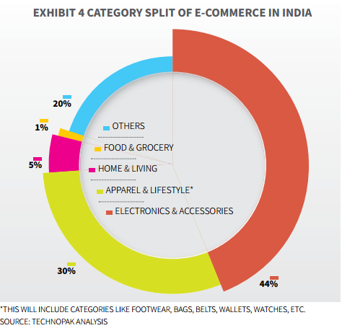 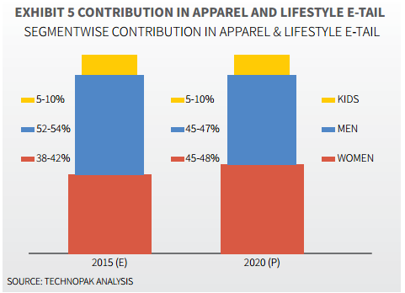

Fig 2: Segment wise Contribution in Apparel Retailing

Source: Technopak

Year: 2015

Fig 1: Category Split of E-commerce in India

Source: Technopak

Year: 2015

1. **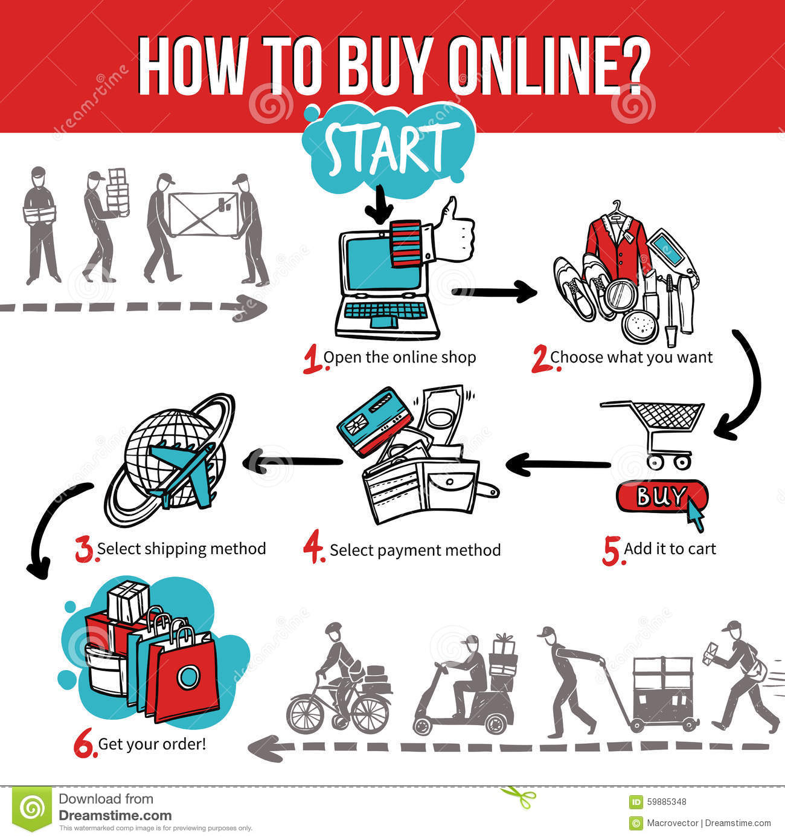PROCESS OF ONLINE SHOPPING**

Shopping on our web site occurs in the following easy steps:

step 1: **select products:** Visit the online store. Select the product and quantity that you want to purchase.

Step 2: **confirmation:** A confirmation page is presented to you with the total value of your order after you have selected the products you wish to purchase. You are required to enter your name, email address and postal address to proceed. The credit card number is taken in the next step.

Step 3: **credit card details:** This step takes you to the credit card processor's site, where your credit card details (the name, number and expiry date on the credit card) are requested. This is done through a secure connection with state-of-the-art encryption. The transaction is approved subject to the verification of your credit card number and other details.

Step 4: **email receipt and installation codes:** After the transaction is approved, you are automatically sent an email by customer service with all the product installation codes. This normally takes a few seconds, and you can expect to receive this email even before you proceed to the next step. You also receive an email which is an electronic receipt of the order.

Step 5: **product delivery**

1. **METHODS OF PAYMENT**

* Credit Card: The most popular payment method. The advantage is the ease for the customer to pay. It is issued to users (cardholders) to enable the cardholder to pay a merchant for [goods and services](https://en.wikipedia.org/wiki/Goods_and_services), based on the cardholder's promise to the [card issuer](https://en.wikipedia.org/wiki/Credit_card_issuer) to pay them for the amounts so paid plus other agreed charges.
* Debit Card: Debit card is a plastic card that provides an alternative payment method to cash when making purchases in which the issuer and the cardholder enter into an agreement that the debt incurred on the charge account will be paid in full and by due date. Most online merchants will accept debit card purchases.
* Payment Websites: Websites like PayPal and Google Checkout offer a means of instant payment if both parties have an account with them. During the online checkout process, the merchant redirects the consumer to their financial institution’s online banking site where they login and authorize charges. After charges are authorized, the financial institution redirects the consumer back to the merchant site. PayPal is an e-commerce payment processing company owned by eBay.
* Electronic Check: The electronic check is a method of payment which draws cash from a checking account, eliminating the paper check. The payer provides the name, amount, routing and account number, and the transaction is then electronically processed and the funds are withdrawn from the checking account.
* Checks and Money Orders : Customers who don't have credit cards, or are paying from a company or municipality may want to pay by check or money order. It is a negotiable instrument instructing a financial institution to pay a specific amount of a specific currency from a specified demand account held in the maker/depositor's name with that institution. Both the maker and payee may be natural persons or legal entities.
* Bank Transfer: A bank transfer, also known as a wire transfer or credit transfer, is a method of transferring money from one person or institution (entity) to another. A wire transfer can be made from one bank account to another bank account or through a transfer of cash at a cash office. A bank wire transfer is often the most expedient method for transferring funds between bank accounts.
* Mobile Payments: The mobile payment option is relatively new and gaining popularity in foreign countries. With phone payments, consumers are billed via their regular telephone number, whereby the charges are added to their phone bill.

1. **ADVANTAGES , DISADVANTAGES AND LIMITATIONS**

ADVANTAGES

* Convenience: One of the biggest benefits of online shopping is that you can buy almost anything you could imagine without ever leaving your house.
* Selection: Online stores are able to carry more selection than traditional brick-and-mortar stores.
* Information: Online shops tend to provide more information about items for sale than you would get in a physical store(unless you asked a sales associate).
* Price: Because online stores don’t have to pay rent for a storefront in a nice part of town and tend to sell much larger quantities of goods, they can offer to sell products for a much lower price.
* Availability: Online retailers accept orders twenty four hours a day while consumers who wish to shop at traditional stores have to be available to visit the store during normal business hours.
* Virtual Fitting Rooms: To make consumer experience for size and fitting when buying online.
* Online stylist: Online shops came up with online stylist which lets the customer know about a celebrity look.
* Convenience: “No Question Asked” return Policies
* COD: Lets the customer see the product before buying and help those who have no access to online payment facility.
* Try at home: A new facility to the online buyers which is emerging as a trend is “try at home”.
* The powers of discounts cannot be discounted: Amazon’s the great Indian Diwali sale, Flipkart’s big billion sale, end of season sale.
* Fashion on rent: Clothes on rent is not a new concept but fashion online on rent is the next big thing in the fashion industry in India.
* Gifts: Sending gifts to relatives and friends is easy, no matter where they are.
* Price comparisons: Comparing and researching products and their prices is so much easier online.
* No crowds:Especially during festivals or special events, they can be such a huge mess.
* Less compulsive shopping: Shop keepers pressure us or because of the lack of choices in those shops.
* Long Waiting Lines: When buying items online, there are no long lines you have to endure, just to buy your merchandise.

**DISADVANTAGES**

* Hands-On Inspection: One thing that online stores can’t replace is the experience of actually seeing and touching the item you are considering buying.
* Shipping: Some major online retailers now offer free shipping for their products, but many require you to meet a minimum order cost to qualify.
* Wait Time: waiting for your item to arrive is another downside of online shopping. One of the great pleasures of shopping at a store is the instant gratification.
* Privacy: when you shop online, you waive certain privacy rights to the online retailer.
* Many people have fear to disclose personal and private information for security.

**LIMITATIONS**

* Risky credit card purchase: It is pertinent to do online shopping from a reliable and a trusted web portal. A number of these web portals ask for payment through a credit/debit card.
* No bargaining: Online shopping does not offer us that liberty to bargain and we are bound to buy the item in the quoted price.
* Deceptive pictures: What may appear to have a matte texture in the picture may actually turn out to be quite glossy and shiny in reality.
* Makes you lazy: With the advent of a new phenomenon called online shopping, people who have an access to the internet, hardly show an inclination to venture out of their house into the open.
* Deprives you of tangibility: Online shopping makes it difficult to exchange items as well, in case of discrepancies.
* Internet does not come free of cost: every time you open a page on an online shopping portal to choose a specific item, you get charged for it.

1. **ONLINE SAFETY**

**Check out sellers:** Conduct independent research before you buy from a seller you have never done business with. Some attackers try to trick you by creating malicious websites that appear legitimate, so you should verify the site before supplying any information.

**Make sure the site is legitimate**:Before you enter your personal and financial information to make an online transaction, look for signs that the site is secure.

**Protect your personal information:** Before providing personal or financial information, check the website's privacy policy. Make sure you understand how your information will be stored and used.

**Keep a paper trail**:Read your credit card statements as soon as you get them to make sure there aren’t any unauthorized charges. If there is a discrepancy, call your bank and report it immediately.

**Use safe payment options:** Credit cards are generally the safest option because they allow buyers to seek a credit from the issuer if the product isn’t delivered or isn’t what was ordered.

**Turn your computer off when you’re finished shopping:**Many people leave their computers running and connected to the Internet all day and night. This gives scammers 24/7 access to your computer to install malware and commit cyber-crimes.

1. **BASIC UNDERSTANDING AND COMPARISON BETWEEN TRADITIONAL STORES AND ONLINE STORES**

Consider a person ‘X’ who wants to buy active wear from the brand Puma.

|  |  |  |
| --- | --- | --- |
| CRITERION | TRADITIONAL | E COMMERCE |
| PRICE | Costs higher (Includes the cost of rent, employees, electricity etc.) | Costs much lower than maintaining a physical store at an equally popular location |
| CONVINIENCE | It requires much more time and money to drive down to a store and buy something | It just requires a working internet connection and a basic knowledge of how to use a website |
| VARIETY | Physical stores can only store a limited number of materials, according to the available store space | Online stores have no restrictions on the number of styles it can include, usually going up to thousands |
| TRUST | Most people have no issues trusting a store which they can walk into, buying an item they can physically touch, and dealing with people they can interact with, face to face. | Since there have been cases of credit card frauds etc., most people still find it difficult to place their trust in an e tail store. |
| FITTING | Ability to touch and check the items, to make sure they are suitable, and even try them on. | It’s only possible to check the fitting of the item once it’s been delivered. |
| TIME | The buyer receives the product as soon as he selects it and pays for it | Ecommerce websites take at least a day to deliver the products. |

X chooses to shop from an online store

|  |  |  |
| --- | --- | --- |
| CRITERION | PUMA Store Online | AMAZON.IN |
| PRICE | Comparatively provides fewer discounts. | Provides more percentage of discounts. |
| CONVINIENCE | Better if a peculiar brand is an attraction for the buyer. | More convenient if buyer is looking for a particular article and not a brand specifically. Quite similar to the “mall culture” shopping, just online. |
| VARIETY | Provides stock versatility of an individual brand. Lacks variety in design and prices. | Provides ample choices to the customer on one website with versatile price and quality ranges. |
| TRUST | Same in both cases. | Same in both cases. |
| FITTING | Same in both cases. | Same in both cases. |
| TIME | A brand specific costumer would be saving his time since he/she knows what design, quality and price he/she is looking for exclusively. | Saves time drastically if the customer is not brand specific and is open for different designs and tastes. |

1. **MARKET SURVEY**

The domestic market: The domestic apparel retail market is expected to reach Rs. 470000 crore (US $ 100 bn) by 2020, as per the Technopak report. The apparel market is highly fragmented as the organised sector contributed only 14% of the total sales in 2009. The share of the organised sector, however, reached 17% in 2010. The same reached 25% in 2015 and is estimated to reach 40% in 2020, according to the Technopak report. So it is clear that the industry is moving towards higher penetration of organised sector players. Another interesting trend is that the market is shifting from ready to switch (RTS) to ready to wear (RTW) as RTS‟s current share of about 16% is projected to come down to 12% by 2020.

Fig 3: Total Apparel Market in crore ; Source: Technopak; Year: 2015

Men’s and women’s wear: Currently menswear is the biggest segment of the domestic market with 43% share of the total pie, while women’s wear constitutes 38%. About 10% comes from boys wear while girls bring in the remaining 9% sale. However the growth of women’s wear is more than men’s wear.

Fig4:Men’s Apparel market in crore ; Source: Technopak; Year: 2015

Fig5:Women’s Apparel market in crore ; Source: Technopak; Year: 2015

**Payment Method**

Fig7: volume of transaction people in the age 28-50 are comfortable with

Source: Technopak

Year: 2015

Fig6: volume of transaction people in the age 13-27 are comfortable with

Source: Technopak

Year: 2015

Fig6: volume of transaction people in the age 13-27 are comfortable with ; Source: Technopak; Year: 2015

**Cash On Delivery (COD):**

It is observed that 89% of the customers are comfortable with the Cash on Delivery option, the reasons being:

* Lack of Payment Alternatives

Most of India’s population either does not have a Debit or Credit card and the ones that do, do not such it much for online transactions. Cards are basically used to withdraw cash from ATMs but not for making payments online. Therefore COD is one means where a seller can reach out to buyers even if they don’t have means to make an online payment.

* Product Condition and Satisfaction

There have been so many cases where you order something but you get something else. In such cases, it just makes the process of online shopping very painful. If you have paid online, you’ll have to initiate refunds which again takes some time. Moreover, people prefer to physically look, feel and touch something that we buy. In such cases, COD comes as a good option for buyers to actually check the product before paying for it.

* Competition

With so many ecommerce companies coming up, COD is a great way to have an upper hand over competition. Essentially it’s the difference between life and death for many of the small businesses.

* Scam Scare

The trust for online shopping and ecommerce has been increasing in India but many still fear using new ecommerce companies and fear that they’ll be scammed.

* Human Nature

Like mentioned, people love to have the ability to see, feel and touch things that they are going to buy. People have similar expectations when they buy online as well. If it wasn’t for COD, people would still walk in to a store so as to meet this criteria.

**Product Choice:**

1. **SIZE DESCRIPTION OF PRODUCTS:**

Before the invention of clothing sizes in the early 1800s, all clothing was made to fit individuals by either tailors or makers of clothing in homes. Then garment makers noticed that the range of human body dimensions was relatively small.

Horizontal torso measurements include the neck circumference, the shoulder width, the [bustline measurements](https://en.wikipedia.org/wiki/Bustline) – over-bust circumference, the full bust circumference, the bust-point separation, and the under-bust (rib-cage) circumference – the natural [waist circumference](https://en.wikipedia.org/wiki/Waistline_(clothing)), the upper hip circumference and the lower hip circumference.

Vertical torso measurements include the back (neck-waist) length, the shoulder-waist length (not the same as the back length, due to the slope of the shoulder), the bust-shoulder length, the bust-waist length, and the two hip-waist lengths.

Sleeve measurements include the under-arm and over-arm lengths, the fore-arm length, the wrist circumference and the biceps circumference.

*For more information on how to measure the human body, refer annexure 1*

There are 3 Standard size charts:

The US standard size

The UK standard size

The European standard size

HISTORY OF SIZING OF APPAREL:’

These were based on the chest measurement, with other measurements being assumed to be either proportional (the circumference of the neck, waist, hips, and thighs) or easily altered (length of the inseam). As this was largely successful in men, the same approach was attempted in the early 20th century for women using the bust as the sole measurement. However, this proved unsuccessful because women's bodies have far more variety in shape. The [hourglass figure](https://en.wikipedia.org/wiki/Hourglass_figure) is frequently used as an industry standard, but only 8% of women have this body shape. A woman with an hourglass figure and a woman with an apple-shaped figure who have the same bust size will not have the same waist or hip sizes. After discovering the complex diversity of women's actual sizes, which produced five to seven different body shapes. The various combinations of height and girth resulted in nine different sizes for each numerical upper-body measurement, which was highly impractical for manufacturing. In current time there are multiple size types, designed to fit somewhat different body shapes. Variations include the height of the person's [torso](https://en.wikipedia.org/wiki/Torso) (known as *back length*), whether the bust, waist, and hips are straighter (characteristic of teenagers) or curvier (like many adult women), and whether the bust is higher or lower (characteristic of younger and older women, respectively). These categories include:

Misses sizes : The most common size category. For women of about average height (5'4") with an average bust height and an hourglass figure. Dress sizes may be given as girth at the bust in inches (e.g., 36), but even-numbered sizes from 2 to 16 are more common. Categorical sizes range from XS (extra-small) to XL (extra-large).

Junior sizes : For short women with higher busts and fairly straight bodies. Junior sizes are commonly given as odd-numbered sizes from 1 to 15, which correspond to the next number up in misses' sizes.

Women's sizes or plus sizes : For larger women of average height, sometimes with lower bust lines. Like misses' sizes, the sizes may be given as a dress size based on the bust measurement, but they are usually given as even-numbered sizes from 18 up. Categorical sizes usually range from 1X (similar to extra-large, but with slightly different proportions compared to the misses' size) up.

Misses petite : For short women with average busts and more hourglass body shapes. Sizes follow the misses' standard and are marked with a P, as in 10P.Junior petiteFor very short women with average busts and fairly straight bodies. Size may be denoted as "5JP" or as "5P".

Women's petite : For larger, shorter women, sometimes with lower bust lines. Sizes are marked the same as women's with a P, as in 20P.

Young junior : For short women with high busts and fairly straight bodies.

Tall sizes : For taller women (usually 5'8" or above), usually with a proportionately average bust height and an hourglass figure. Sizes are usually written with the corresponding misses' size and a T to indicate tall, as in "10T".

Half sizes : For short women with lower busts and more hourglass body shapes. Sizes are written with a ½, as in "10½".

For further information on size charts, refer annexure 2

1. **TOP ONLINE SITES**

**Top Fashion eTailers**

* Flipkart(including Myntra, Jabong), Snapdeal and Amazon are some of the major players in the online fashion retail space.
* With the acquisition of Jabong, Flipkart owned Myntra tops the list and by 2020, they will constitute 65-70% of market share.
* 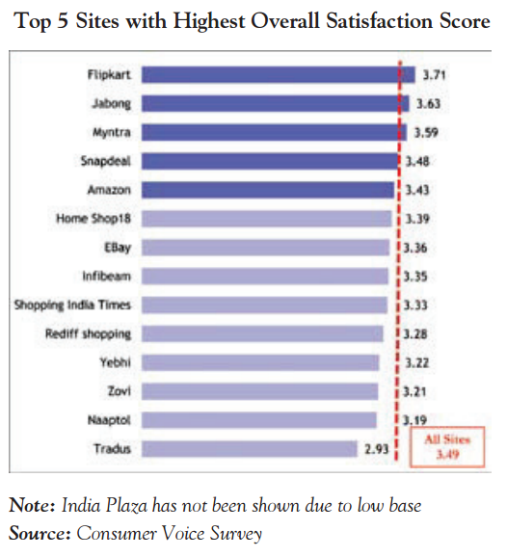Also, there is a rise amongst niche online fashion players such as Koovs, Abof , Voonik , YepMe and Craftsvilla.

**OVERALL CUSTOMER SATISFACTION WITH QUALITY OF SERVICE**

Consumers not only rated the 15 websites on the constructs listed above, they also rated their overall satisfaction with each site. Respondents rated the overall quality of service on a scale of 1 to 5, where 1 meant ‘poor’ and 5 meant ‘excellent’. The graph here shows only 14 sites – India Plaza was excluded because number responses/sample size for it was less than 30.

Flipkart topped the chart by attaining highest overall satisfaction score of 3.71, followed by Jabong (3.63) and Myntra (3.59).

Tradus with a score of 2.93 scored the lowest in terms of overall satisfaction with service quality, followed by Naaptol (3.19), Zovi (3.21) and Yebhi (3.22).

The degree of difference on the overall satisfaction chart varies from a minimum of 2.93 (Tradus) to a maximum of 3.71 (Flipkart). While Flipkart ranked on top, Jabong, Myntra, Snapdeal and Amazon were quite close. Considering the little difference in ratings, it can be assumed that most of these sites provide a similar experience to shoppers.

Fig 8: Top 15 sites with Highest Overall Satisfaction Score

Source: Consumer Voice Survey

Year: 2016

**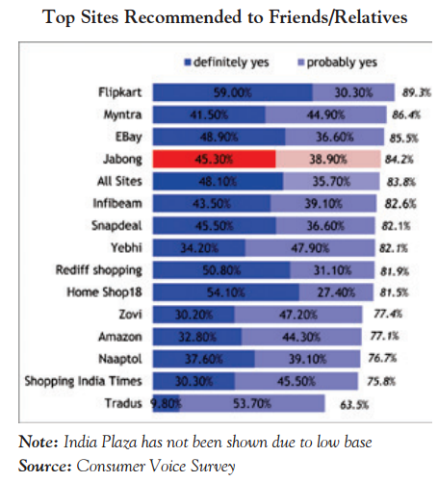WHICH SITE WOULD YOU RECOMMEND?**

The respondents were asked which sites they would recommend to their friends or relatives on a scale of 1 to 5, where 1 meant ‘definitely yes’, 2 ‘yes’, 3 ‘not sure’, 4 ‘probably not’, and 5 ‘definitely not’.

Flipkart was rated on top with 89.2 per cent of respondents saying they would ‘definitely or probably recommend’ the site. It was followed by Myntra (86.5 per cent), Ebay (85.5 per cent) and Jabong (84.2 per cent).

It is important to note that rankings of Infibeam (82.6 per cent), Snapdeal and Yebhi (82.1 per cent), Rediff Shopping (81.9 per cent) and Homeshop 18 (81.5 percent) are quite close to this average.

The scores of Zovi, Amazon, Naaptol and Shopping India Times are between 75 per cent and 77 per cent. The ranking is lowest at 63.5 per cent for Tradus.

Fig 9: Top Sites Recommended to Friends/ Relatives

Source: Consumer Voice Survey

Year: 2016

*For further information on top online shopping websites, refer annexure 3*

1. **COMPARISON OF FEATURES OF TOP 5 ONLINE SHOPPING WEBSITES**

Special features of Amazon

* Amazon prime highlights the special feature of amazon which is one day delivery and in select cities, you can get one hour delivery for tens of thousands of products from local stores.
* Amazon ranks high in search results for various reasons. It has many inbound links, has quality content, good product description, almost everything about the product.

Special features of myntra

* Myntra has now come up with gift cards which you can send them instantly to your loved ones to spread the joy of looking good. The minimum card value is Rs. 100 and the maximum value is Rs. 10,000. You can buy this with ease from both the mobile app and also the website.
* On Myntra you can also create your profile in Myntra app and be part of the fashion community wherein you can post your collections/outfits your have and also follow the fashion brands, style icons.
* Now you can share the products with your friends and family if you are overwhelmed.
* Myntra has also opened an offline store in Bangalore by launching its brand Roadster.

Special feature of flipkart

* India’s largest online retailer Flipkart has launched voice search feature on its website.The feature enables users’ to search Flipkart’s’ catalogue by voice recognition mechanism.
* [Flipkart](http://tech.economictimes.indiatimes.com/tag/flipkart) [launched](http://tech.economictimes.indiatimes.com/news/mobile/flipkart-ping-allows-users-to-chat-and-shop-with-their-friends/48665931) a new social feature called Ping that lets customers share product images and discuss with each other while shopping on the e-commerce platform.

Special features snapdeal

* Snapdeal launches 'price search on SMS' feature : This feature can be used to get the links of products by SMS.
* Snapdeal's integration with a leading service provider like bookmyshow so you can also book your show while working and shopping on the app. Now you can also Book Uber From Snapdeal App.
* Snapdeal will be available in English and 11  regional languages  Hindi, Telugu, Gujarati, Tamil, Marathi, Bengali, Kannada, Malayalam, Oriya, Assamese and Punjabi.

Special features of jabong

* Jabong is a hub of all big brands and a person can easily access their products.
* Jabong offers a good user interface with a clean and minimalist layout.

1. **SITES REFERRED**

FLIPKART

Launched in October 2007, Flipkart.com is India’s leading e-commerce marketplace with over 30 million products across 70+ categories.

It is the first ‘Billion Dollar’ company in Indian ecommerce.

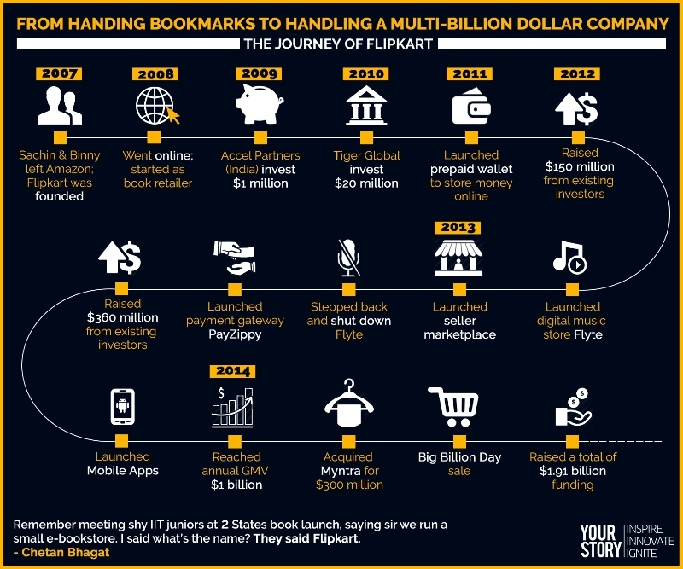Flipkart is ranked amongst the top 5 websites in India, with 45% market share (including Myntra) in Indian ecommerce.

Be it selling products worth INR 650 Crore on ‘The Big Billion Day’ or exclusive tieups with companies such as Motorola Mobility and Xiaomi Tech, the company stands for converting every challenge into an opportunity.

Extending services like cash-on-delivery and credit card payment at doorstep were introduced to provide ample choice and comfort to customers.

To address the problems of supply chain, Flipkart launched its own supply chain management system to deliver orders in a timely fashion.

At Flipkart, innovation is the key to company’s success. Now, the attempt is to widen Flipkart's reach in the digital domain through Flyte, the portal's recently launched paid music download service. Customers can buy music in MP3 format from over 700 genres, and 55 languages. The files, which are digital rights management (DRM) free, can be played without any restrictions on any type of device and for an unlimited number of times.

SNAPDEAL

In February 2010, Snapdeal.com was founded. Today it has a wide assortment of 12 million+ products across 500+ diverse categories from thousands of regional, national, and international brands and retailers.

The marketplace has 150,000 sellers and delivers to 5000+ cities and towns across India.

Snapdeal is ranked amongst the top websites in India, with 26% market share (minus FreeCharge) in Indian ecommerce.

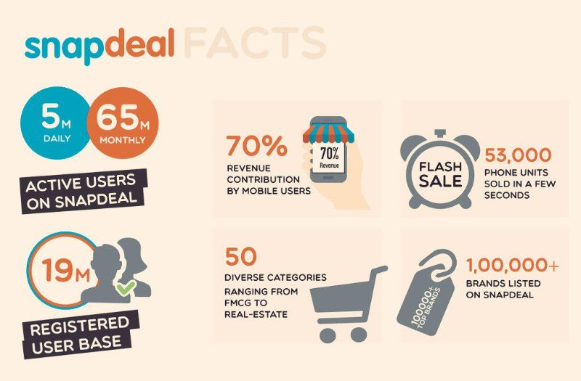Since its inception, Snapdeal has acquired around 12 businesses in various sectors ranging from Grabbon.in, Exclusively.in to FreeCharge.in.

It is also the first website in India to sell automobiles online.

Snapdeal has a ‘Deal of the Day’ offer for its customers every day. This ensures that customers visit the website daily for attractive offers.

With the Octane Premium Platform, Snapdeal is powering up its successful email campaigns including segmentation, advanced targeting, automatic responses and email marketing analytic functions. Delivering 6 to 7 million emails every day, reaching out to millions of opt-in subscribers, the Snapdeal team is leveraging the 46 flexibility and massive scalability of Octane’s cloud computing platform to successfully leverage the power of email marketing.

AMAZON

The aim is to build a shopping destination in India by giving customers– vast selection, low prices, fast and reliable delivery, and a trusted and convenient online shopping experience. This also includes providing sellers a world-class e-commerce platform.

Amazon ranks third with 12% share in the Indian ecommerce.

What sets Amazon apart from others are the services it provides- - Kindle for e-reader - Amazon Fashion Store - Same day delivery - Today’s deal, to save big everyday - Gift a Smile- give product online to charity through verified NGOs

JABONG

Jabong, India's leading online fashion retailer and one of the top five fashion ecommerce companies.

Jabong is known for its product assortment; 1000+ brands and over 90,000 products are available on the website from national to international brands and retailers

The company also embarked on a huge mass communication campaign, created its own logistics network and ensured a significant presence in the market within a very short span while others took at least two-three years to build them up.

Jabong focuses on variety, widest assortment, fastest delivery time and excellent customer service rather than just deals and discounts

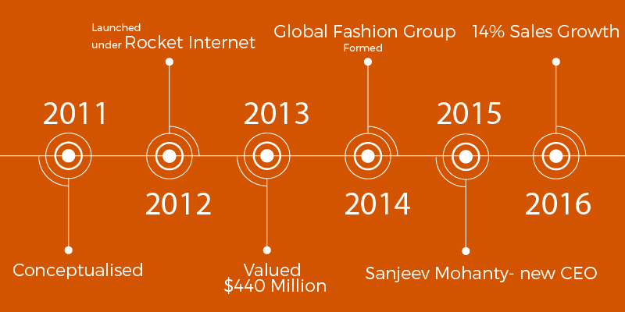

MYNTRA

Myntra is an online e-commerce portal, which deals in fashion lifestyle retailing. It was initiated as personalization portal and had a catalogue of products which could be customized such as T-shirts, mugs, jersey.

Logistics is an important aspect of any ecommerce company and Myntra’s model for success is its Hybrid logistics models. They have distributed the operational logistics between themselves and third party service providers on the basis of geography.

Myntra has also tied up with celebrities through associations with movies and events.

With Flipkart’s backing, Myntra and Flipkart together own 45% share in the market.

Myntra offers try and buy to attract more customers.

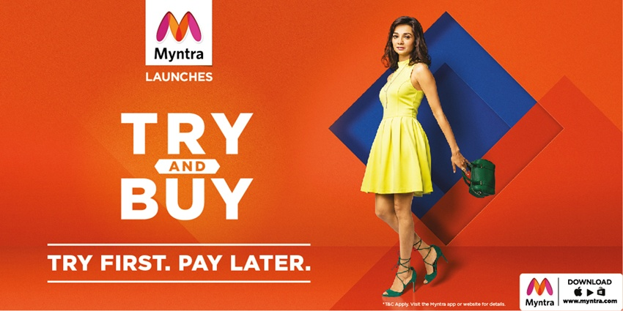

1. **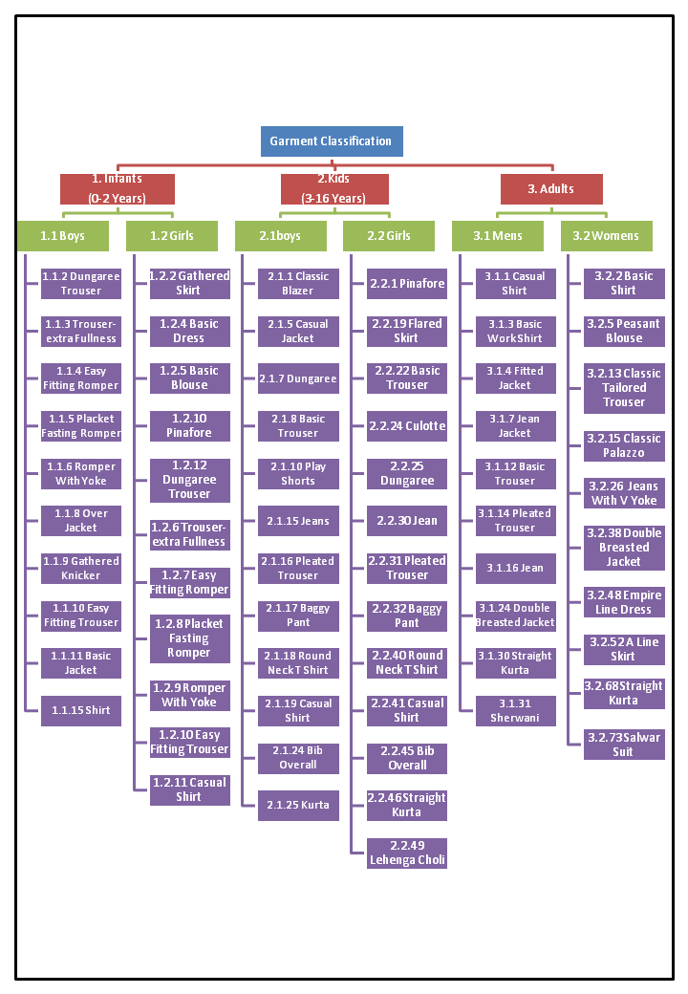PRODUCT CATEGORIES**

These are the garment categories for which we have found out the lowest and average prices on the top online shopping websites.

*For further information on various styles of garments, refer annexure 4*

1. **PRODUCT CATALOGUE**

**INFANT BOYS**

**DUNGAREE TROUSER**

**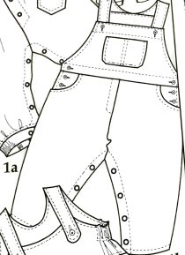**  Lowest price

|  |  |  |  |  |  |  |  |  |
| --- | --- | --- | --- | --- | --- | --- | --- | --- |
| S. No. | Class.  No. | Category | Gender | Prdt. | Style | Website | Brand | Price |
| 1 | 1.1.2 | Infant | Male | Trouser | Dungaree Trouser | Amazon | Ahhaa | 449 |
| 2 | 1.1.2 | Infant | Male | Trouser | Dungaree Trouser | Amazon | Tales &Stories | 449 |
| 3 | 1.1.2 | Infant | Male | Trouser | Dungaree Trouser | First Cry | Johny Johny | 449 |
| 4 | 1.1.2 | Infant | Male | Trouser | Dungaree Trouser | Snapdeal | Kothari | 499 |
| 5 | 1.1.2 | Infant | Male | Trouser | Dungaree Trouser | Flipkart | Babee2 | 499 |

Average price

|  |  |  |  |  |  |  |  |  |
| --- | --- | --- | --- | --- | --- | --- | --- | --- |
| S. No. | Class.  No. | Category | Gender | Prdt. | Style | Website | Brand | Price |
| 6 | 1.1.2 | Infant | Male | Trouser | Dungaree Trouser | Myntra | My Little Lamp | 690 |
| 7 | 1.1.2 | Infant | Male | Trouser | Dungaree Trouser | Amazon | Kuchipoo | 699 |
| 8 | 1.1.2 | Infant | Male | Trouser | Dungaree Trouser | Snapdeal | Peridot | 699 |
| 9 | 1.1.2 | Infant | Male | Trouser | Dungaree Trouser | Flipkart | Tony Boy | 750 |
| **10** | 1.1.2 | Infant | Male | Trouser | Dungaree Trouser | First Cry | Gini & Jony | 750 |

**TROUSER - EXTRA FULLNESS**

Lowest price

|  |  |  |  |  |  |  |  |  |
| --- | --- | --- | --- | --- | --- | --- | --- | --- |
| S. No. | Class.  No. | Category | Gender | Prdt. | Style | Website | Brand | Price |
| 11 | 1.1.3 | Infant | Male | Trouser | Trouser-extra fullness | Flipkart | Ahhaa | 349 |
| 12 | 1.1.3 | Infant | Male | Trouser | Trouser-extra fullness | First Cry | Tales &Stories | 349 |
| 13 | 1.1.3 | Infant | Male | Trouser | Trouser-extra fullness | Snapdeal | Johny Johny | 350 |
| 14 | 1.1.3 | Infant | Male | Trouser | Trouser-extra fullness | Amazon | Kothari | 350 |
| 15 | 1.1.3 | Infant | Male | Trouser | Trouser-extra fullness | Amazon | Babee2 | 399 |

**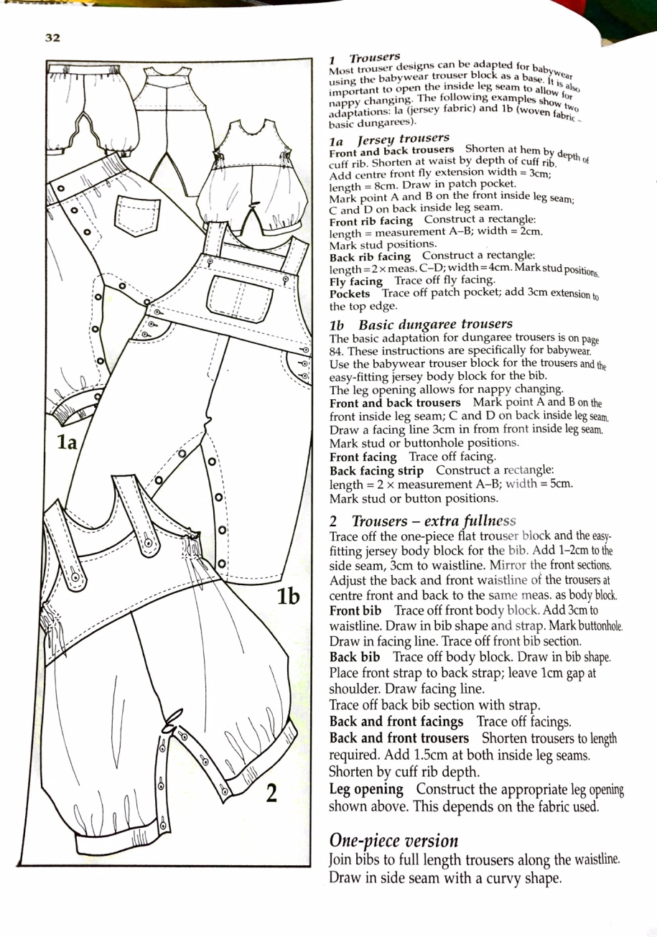**

Average price

|  |  |  |  |  |  |  |  |  |
| --- | --- | --- | --- | --- | --- | --- | --- | --- |
| S. No. | Class.  No. | Category | Gender | Prdt. | Style | Website | Brand | Price |
| 16 | 1.1.3 | Infant | Male | Trouser | Trouser-extra fullness | Miss U | Ahhaa | 999 |
| 17 | 1.1.3 | Infant | Male | Trouser | Trouser-extra fullness | Baby World | Tales &Stories | 899 |
| 18 | 1.1.3 | Infant | Male | Trouser | Trouser-extra fullness | Icable | Johny Johny | 999 |
| 19 | 1.1.3 | Infant | Male | Trouser | Trouser-extra fullness | FS Mini Klub | Kothari | 1099 |
| 20 | 1.1.3 | Infant | Male | Trouser | Trouser-extra fullness | Kuchipoo | Babee2 | 1299 |

**EASY FITTING ROMPER**

|  |  |  |  |  |  |  |  |  |
| --- | --- | --- | --- | --- | --- | --- | --- | --- |
| S. No. | Class.  No. | Category | Gender | Prdt. | Style | Website | Brand | Price |
| 21 | 1.1.3 | Infant | Male | Pant Deri. | Easy Fitting Romper | Flipkart | Ahad | 385 |
| 22 | 1.1.3 | Infant | Male | Pant Deri. | Easy Fitting Romper | First Cry | Fingers | 799 |
| 23 | 1.1.3 | Infant | Male | Pant Deri. | Easy Fitting Romper | Amazon | Kaboo's | 249 |
| 24 | 1.1.3 | Infant | Male | Pant Deri. | Easy Fitting Romper | Flipkart | Kandy | 400 |
| 25 | 1.1.3 | Infant | Male | Pant Deri. | Easy Fitting Romper | Snapdeal | Little Studio | 320 |

*Lowest price*

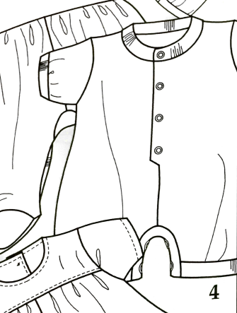

*Average price*

|  |  |  |  |  |  |  |  |  |
| --- | --- | --- | --- | --- | --- | --- | --- | --- |
| S. No | Class.  No. | Category | Gender | Prdt. | Style | Website | Brand | Price |
| 26 | 1.1.3 | Infant | Male | Pant Deri. | Easy Fitting Romper | Flipkart | Ahhaa | 649 |
| 27 | 1.1.3 | Infant | Male | Pant Deri. | Easy Fitting Romper | First Cry | Tales &Stories | 899 |
| 28 | 1.1.3 | Infant | Male | Pant Deri. | Easy Fitting Romper | Amazon | Johny Johny | 799 |
| 29 | 1.1.3 | Infant | Male | Pant Deri. | Easy Fitting Romper | Flipkart | Kothari | 1099 |
| 30 | 1.1.3 | Infant | Male | Pant Deri. | Easy Fitting Romper | Snapdeal | Babee2 | 599 |

**PLACKET FASTING ROMPER**

Lowest price

|  |  |  |  |  |  |  |  |  |
| --- | --- | --- | --- | --- | --- | --- | --- | --- |
| S. No. | Class.  No. | Category | Gender | Prdt. | Style | Website | Brand | Price |
| 31 | 1.1.5 | Infant | Male | Pant Deri. | Placket Fasting Romper | Amazon | B&B | 699 |
| 32 | 1.1.5 | Infant | Male | Pant Deri. | Placket Fasting Romper | Snapdeal | Sand Beach | 799 |
| 33 | 1.1.5 | Infant | Male | Pant Deri. | Placket Fasting Romper | Flipkart | Icable | 799 |
| 34 | 1.1.5 | Infant | Male | Pant Deri. | Placket Fasting Romper | Snapdeal | Little Studio | 320 |
| 35 | 1.1.5 | Infant | Male | Pant Deri. | Placket Fasting Romper | Amazon | FS Mini Klub | 699 |

***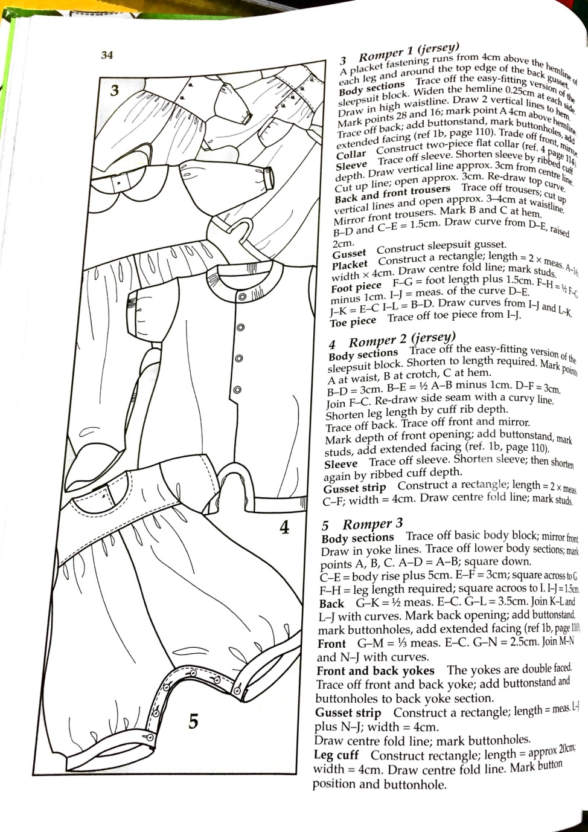***

Average price

|  |  |  |  |  |  |  |  |  |
| --- | --- | --- | --- | --- | --- | --- | --- | --- |
| S. No. | Class.  No. | Category | Gender | Prdt. | Style | Website | Brand | Price |
| 36 | 1.1.5 | Infant | Male | Pant Deri. | Placket Fasting Romper | First Cry | Baby World | 649 |
| 37 | 1.1.5 | Infant | Male | Pant Deri. | Placket Fasting Romper | Snapdeal | Little Studio | 899 |
| 38 | 1.1.5 | Infant | Male | Pant Deri. | Placket Fasting Romper | Amazon | Phenovo | 799 |
| 39 | 1.1.5 | Infant | Male | Pant Deri. | Placket Fasting Romper | Myntra | Mothercare | 1099 |
| 40 | 1.1.5 | Infant | Male | Pant Deri. | Placket Fasting Romper | Flipkart | Lil Penguin | 599 |

**ROMPER WITH YOKE**

Lowest price

|  |  |  |  |  |  |  |  |  |
| --- | --- | --- | --- | --- | --- | --- | --- | --- |
| S. No. | Class.  No. | Category | Gender | Prdt. | Style | Website | Brand | Price |
| 41 | 1.1.6 | Infant | Male | Pant Deri. | Romper With Yoke | Flipkart | Ahad | 156 |
| 42 | 1.1.6 | Infant | Male | Pant Deri. | Romper With Yoke | Snapdeal | Little Studio | 165 |
| 43 | 1.1.6 | Infant | Male | Pant Deri. | Romper With Yoke | Flipkart | Awesome | 180 |
| 44 | 1.1.6 | Infant | Male | Pant Deri. | Romper With Yoke | Amazon | Pride | 199 |
| 45 | 1.1.6 | Infant | Male | Pant Deri. | Romper With Yoke | Amazon | Indirand | 199 |

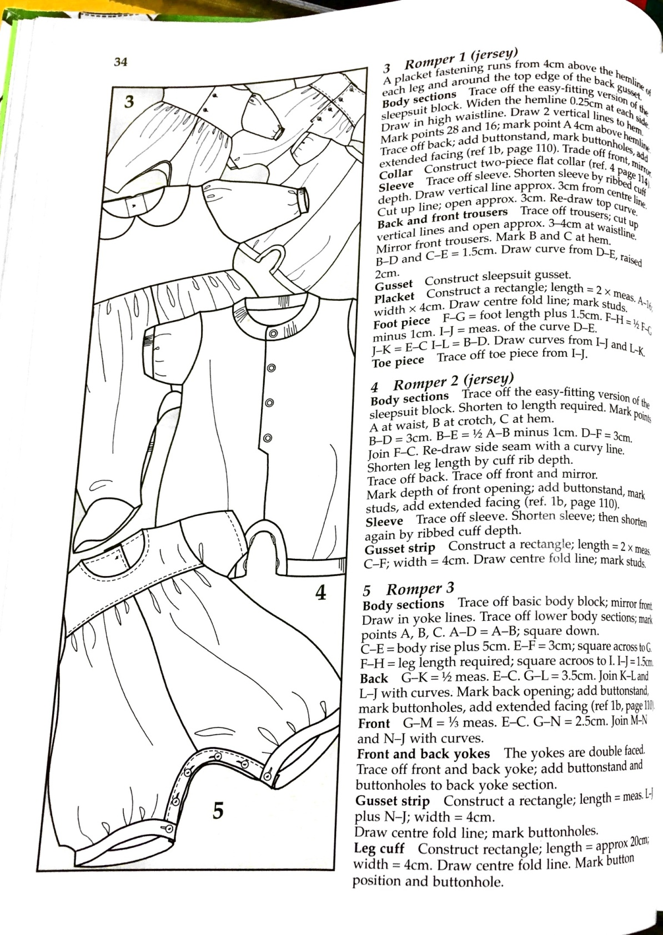

Average price

|  |  |  |  |  |  |  |  |  |
| --- | --- | --- | --- | --- | --- | --- | --- | --- |
| S. No. | Class.  No. | Category | Gender | Prdt. | Style | Website | Brand | Price |
| 46 | 1.1.6 | Infant | Male | Pant Deri. | Placket Fasting Romper | Myntra | Kothari | 310 |
| 47 | 1.1.6 | Infant | Male | Pant Deri. | Placket Fasting Romper | Snapdeal | Camey | 300 |
| 48 | 1.1.6 | Infant | Male | Pant Deri. | Placket Fasting Romper | First Cry | Baby Bucket | 360 |
| 49 | 1.1.6 | Infant | Male | Pant Deri. | Placket Fasting Romper | Amazon | FS Mini Klub | 320 |
| 50 | 1.1.6 | Infant | Male | Pant Deri. | Placket Fasting Romper | Flipkart | Chicabelle | 347 |

**Over - jacket**

Lowest price

|  |  |  |  |  |  |  |  |  |
| --- | --- | --- | --- | --- | --- | --- | --- | --- |
| S. No. | Class.  No. | Category | Gender | Prdt. | Style | Website | Brand | Price |
| 51 | 1.1.8 | Infant | Male | Jacket | Over jacket | First Cry | FS Mini Klub | 224 |
| 52 | 1.1.8 | Infant | Male | Jacket | Over jacket | Amazon | Camey | 264 |
| 53 | 1.1.8 | Infant | Male | Jacket | Over jacket | Snapdeal | Autumn | 297 |
| 54 | 1.1.8 | Infant | Male | Jacket | Over jacket | Flipkart | Johny Johny | 299 |
| 55 | 1.1.8 | Infant | Male | Jacket | Over jacket | Snapdeal | Ahad | 299 |

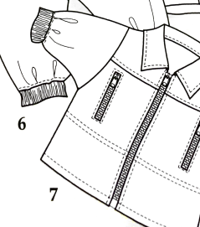

|  |  |  |  |  |  |  |  |  |
| --- | --- | --- | --- | --- | --- | --- | --- | --- |
| S. No. | Class.  No. | Category | Gender | Prdt. | Style | Website | Brand | Price |
| 56 | 1.1.8 | Infant | Male | Jacket | Over jacket | Myntra | Gini & Jony | 910 |
| 57 | 1.1.8 | Infant | Male | Jacket | Over jacket | Myntra | Little Kangaroos | 680 |
| 58 | 1.1.8 | Infant | Male | Jacket | Over jacket | Snapdeal | FS Mini Klub | 700 |
| 59 | 1.1.8 | Infant | Male | Jacket | Over jacket | Jabong | Palm Tree | 876 |
| 60 | 1.1.8 | Infant | Male | Jacket | Over jacket | First Cry | Mothercare | 974 |

Average price

**GATHERED KNICKER**

*Lowest price*

|  |  |  |  |  |  |  |  |  |
| --- | --- | --- | --- | --- | --- | --- | --- | --- |
| S. No. | Class.  No. | Category | Gender | Prdt. | Style | Website | Brand | Price |
| 61 | 1.1.9 | Infant | Male | Pant Deri. | Gathered Knicker | Flipkart | Mahadi | 99 |
| 62 | 1.1.9 | Infant | Male | Pant Deri. | Gathered Knicker | Flipkart | Harsha | 125 |
| 63 | 1.1.9 | Infant | Male | Pant Deri. | Gathered Knicker | Amazon | Donuts | 150 |
| 64 | 1.1.9 | Infant | Male | Pant Deri. | Gathered Knicker | Myntra | Chirpie | 170 |
| 65 | 1.1.9 | Infant | Male | Pant Deri. | Gathered Knicker | Snapdeal | Johny Johny | 199 |

***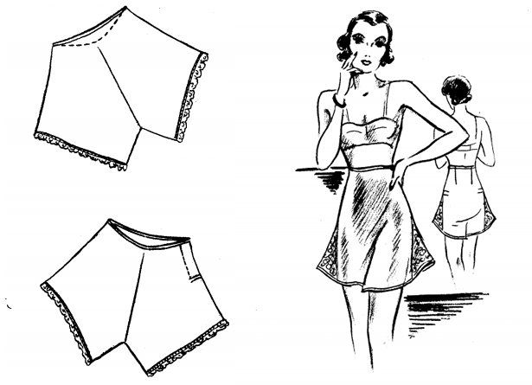***

*Average price*

|  |  |  |  |  |  |  |  |  |
| --- | --- | --- | --- | --- | --- | --- | --- | --- |
| S. No. | Class.  No. | Category | Gender | Prdt. | Style | Website | Brand | Price |
| 66 | 1.1.9 | Infant | Male | Pant Deri. | Gathered Knicker | Myntra | UCB | 449 |
| 67 | 1.1.9 | Infant | Male | Pant Deri. | Gathered Knicker | First Cry | Gini & Jony | 399 |
| 68 | 1.1.9 | Infant | Male | Pant Deri. | Gathered Knicker | Flipkart | Carters | 374 |
| 69 | 1.1.9 | Infant | Male | Pant Deri. | Gathered Knicker | Myntra | YK | 399 |
| 70 | 1.1.9 | Infant | Male | Pant Deri. | Gathered Knicker | Amazon | FS Mini Klub | 349 |

**EASY FITTING TROUSER**

Lowest price

|  |  |  |  |  |  |  |  |  |
| --- | --- | --- | --- | --- | --- | --- | --- | --- |
| S. No. | Class.  No. | Category | Gender | Prdt. | Style | Website | Brand | Price |
| 71 | 1.1.10 | Infant | Male | Trouser | Easy Fitting Trouser | Myntra | YK | 599 |
| 72 | 1.1.10 | Infant | Male | Trouser | Easy Fitting Trouser | Amazon | PTP | 199 |
| 73 | 1.1.10 | Infant | Male | Trouser | Easy Fitting Trouser | Amazon | Just Kids | 610 |
| 74 | 1.1.10 | Infant | Male | Trouser | Easy Fitting Trouser | Flipkart | Baby World | 550 |
| 75 | 1.1.10 | Infant | Male | Trouser | Easy Fitting Trouser | Snapdeal | Mankoose | 385 |

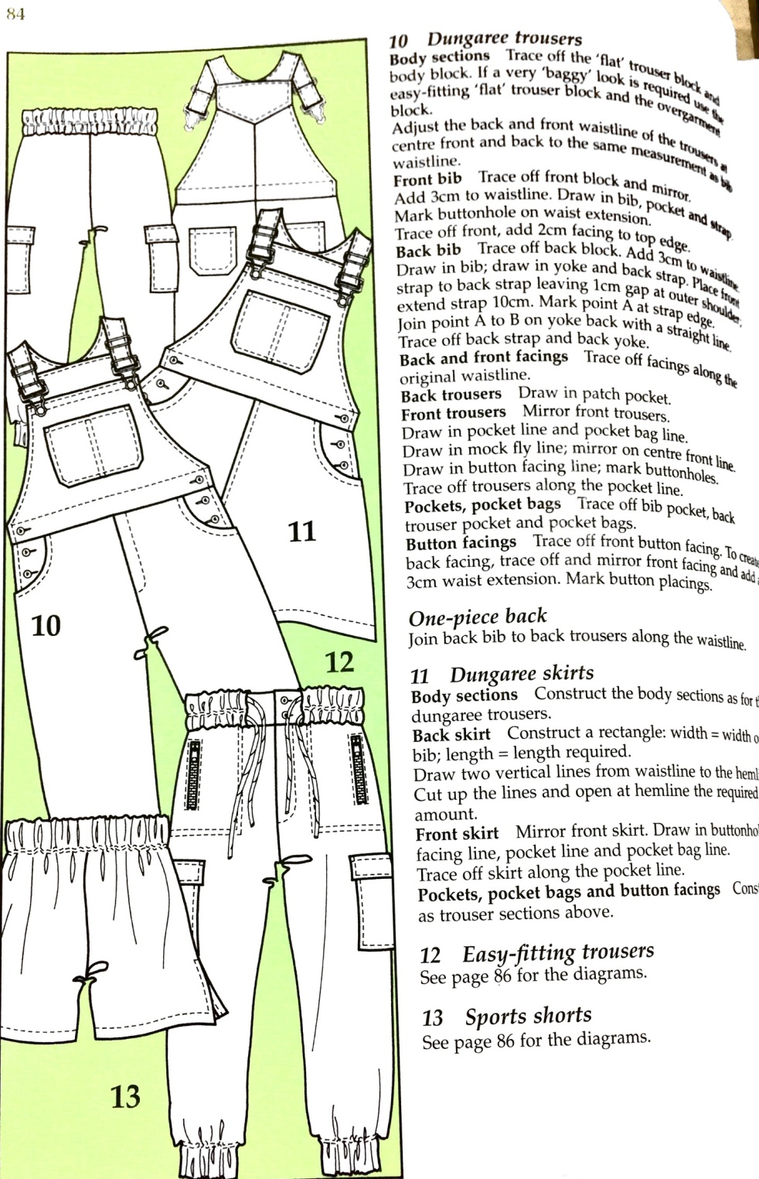

Average price

|  |  |  |  |  |  |  |  |  |
| --- | --- | --- | --- | --- | --- | --- | --- | --- |
| S. No. | Class.  No. | Category | Gender | Prdt. | Style | Website | Brand | Price |
| 76 | 1.1.10 | Infant | Male | Trouser | Easy Fitting Trouser | Amazon | FS Mini Klub | 699 |
| 77 | 1.1.10 | Infant | Male | Trouser | Easy Fitting Trouser | Myntra | Mothercare | 899 |
| 78 | 1.1.10 | Infant | Male | Trouser | Easy Fitting Trouser | Flipkart | UCB | 1499 |
| 79 | 1.1.10 | Infant | Male | Trouser | Easy Fitting Trouser | First Cry | Jack & Jones | 1399 |
| 80 | 1.1.10 | Infant | Male | Trouser | Easy Fitting Trouser | Snapdeal | Mufti | 1299 |

**BASIC JACKET**

*Lowest price*

|  |  |  |  |  |  |  |  |  |
| --- | --- | --- | --- | --- | --- | --- | --- | --- |
| S. No. | Class.  No. | Category | Gender | Prdt. | Style | Website | Brand | Price |
| 81 | 1.1.11 | Infant | Male | Jacket | Basic Jacket | First Cry | FS Mini Klub | 499 |
| 82 | 1.1.11 | Infant | Male | Jacket | Basic Jacket | Flipkart | Johny Johny | 999 |
| 83 | 1.1.11 | Infant | Male | Jacket | Basic Jacket | Amazon | Tales & Stories | 599 |
| 84 | 1.1.11 | Infant | Male | Jacket | Basic Jacket | Myntra | YK | 799 |
| 85 | 1.1.11 | Infant | Male | Jacket | Basic Jacket | Snapdeal | Baby World | 899 |

*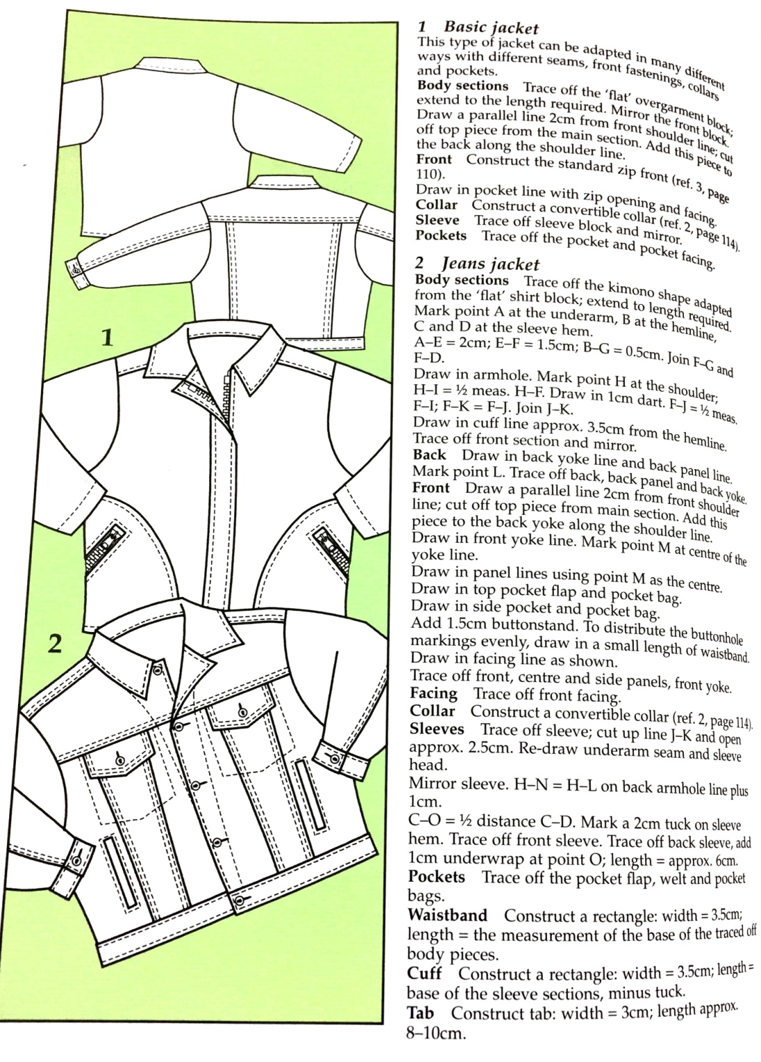*

*Average price*

|  |  |  |  |  |  |  |  |  |
| --- | --- | --- | --- | --- | --- | --- | --- | --- |
| S. No. | Class.  No. | Category | Gender | Prdt. | Style | Website | Brand | Price |
| 86 | 1.1.11 | Infant | Male | Jacket | Basic Jacket | Amazon | Irin | 1449 |
| 87 | 1.1.11 | Infant | Male | Jacket | Basic Jacket | Flipkart | Svanik | 1099 |
| 88 | 1.1.11 | Infant | Male | Jacket | Basic Jacket | Snapdeal | JBN | 1335 |
| 89 | 1.1.11 | Infant | Male | Jacket | Basic Jacket | Myntra | Mufti | 1099 |
| 90 | 1.1.11 | Infant | Male | Jacket | Basic Jacket | Myntra | Black Berry | 1399 |

**CASUAL SHIRT**

*Lowest price*

|  |  |  |  |  |  |  |  |  |
| --- | --- | --- | --- | --- | --- | --- | --- | --- |
| S. No. | Class.  No. | Category | Gender | Prdt. | Style | Website | Brand | Price |
| 91 | 1.1.11 | Infant | Male | Jacket | Basic Jacket | First Cry | FS Mini Klub | 499 |
| 92 | 1.1.11 | Infant | Male | Jacket | Basic Jacket | Flipkart | Johny Johny | 999 |
| 93 | 1.1.11 | Infant | Male | Jacket | Basic Jacket | Amazon | Tales & Stories | 599 |
| 94 | 1.1.11 | Infant | Male | Jacket | Basic Jacket | Myntra | YK | 799 |
| 95 | 1.1.11 | Infant | Male | Jacket | Basic Jacket | Snapdeal | Baby World | 899 |

*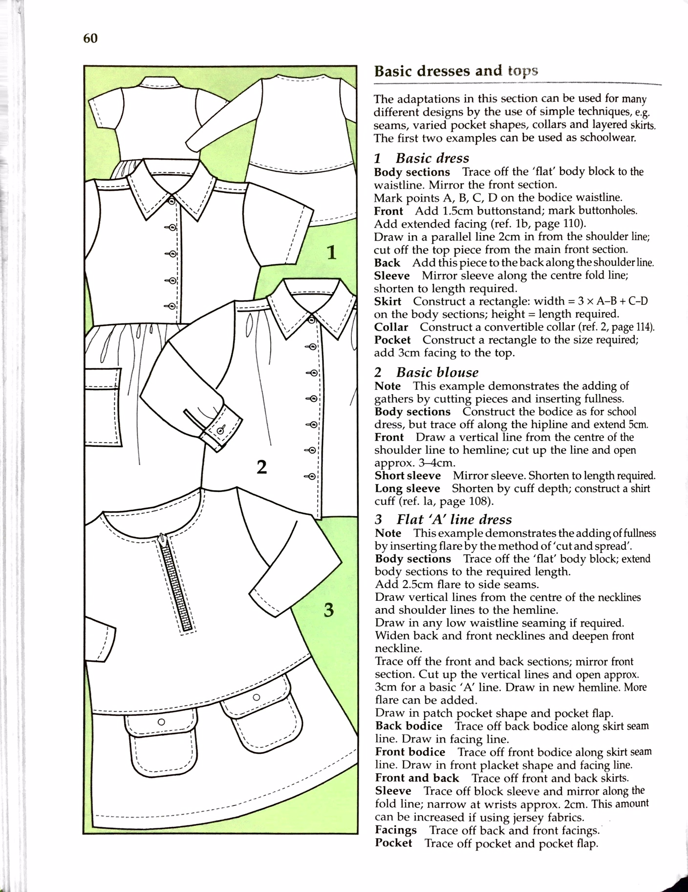*

*Average price*

|  |  |  |  |  |  |  |  |  |
| --- | --- | --- | --- | --- | --- | --- | --- | --- |
| S. No. | Class.  No. | Category | Gender | Prdt. | Style | Website | Brand | Price |
| 96 | 1.1.11 | Infant | Male | Jacket | Basic Jacket | Amazon | Irin | 1449 |
| 97 | 1.1.11 | Infant | Male | Jacket | Basic Jacket | Flipkart | Svanik | 1099 |
| 98 | 1.1.11 | Infant | Male | Jacket | Basic Jacket | Snapdeal | JBN | 1335 |
| 99 | 1.1.11 | Infant | Male | Jacket | Basic Jacket | Myntra | Mufti | 1099 |
| 100 | 1.1.11 | Infant | Male | Jacket | Basic Jacket | Myntra | Black Berry | 1399 |

**INFANT GIRLS**

**GATHERED SKIRT**

LOWER PRICE

|  |  |  |  |  |  |  |  |  |
| --- | --- | --- | --- | --- | --- | --- | --- | --- |
| S. No. | Class.  No. | Category | Gender | Prdt. | Style | Website | Brand | PRICE |
|
| 1 | 1.2.2 | Infant | Female | Skirt | Gathered Skirt | Flipkart | Harsha | 120 |
| 2 | 1.2.2 | Infant | Female | Skirt | Gathered Skirt | Amazon | Mahadi | 145 |
| 3 | 1.2.2 | Infant | Female | Skirt | Gathered Skirt | Snapdeal | Ahad | 210 |
| 4 | 1.2.2 | Infant | Female | Skirt | Gathered Skirt | Snapdeal | Lil Orchid | 242 |
| 5 | 1.2.2 | Infant | Female | Skirt | Gathered Skirt | Amazon | Phenovo | 269 |

|  |  |  |  |  |  |  |  |  |
| --- | --- | --- | --- | --- | --- | --- | --- | --- |
| S. No. | Class.  No. | Category | Gender | Prdt. | Style | Website | Brand | Price |
|
| 6 | 1.2.2 | Infant | Female | Skirt | Gathered Skirt | Myntra | Gini & Jony | 423 |
| 7 | 1.2.2 | Infant | Female | Skirt | Gathered Skirt | Amazon | FS Mini Klub | 400 |
| 8 | 1.2.2 | Infant | Female | Skirt | Gathered Skirt | First Cry | Babyhug | 399 |
| 9 | 1.2.2 | Infant | Female | Skirt | Gathered Skirt | Snapdeal | UCB | 449 |
| 10 | 1.2.2 | Infant | Female | Skirt | Gathered Skirt | Myntra | Mothercare | 439 |

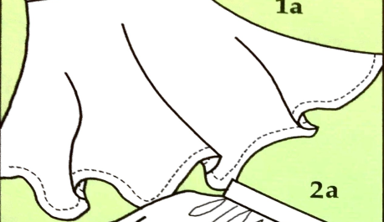

AVERAGE PRICE

**BASIC DRESS**

LOWER PRICE

|  |  |  |  |  |  |  |  |  |
| --- | --- | --- | --- | --- | --- | --- | --- | --- |
| S. No | Class.  No. | Category | Gender | Prdt. | Style | Website | Brand | Price |
|
| 11 | 1.2.4 | Infant | Female | Dress | Basic Dress | Snapdeal | Marisons | 187 |
| 12 | 1.2.4 | Infant | Female | Dress | Basic Dress | Snapdeal | Ahad | 190 |
| 13 | 1.2.4 | Infant | Female | Dress | Basic Dress | Amazon | Needy Butterfly | 208 |
| 14 | 1.2.4 | Infant | Female | Dress | Basic Dress | Amazon | Jagam's | 359 |
| 15 | 1.2.4 | Infant | Female | Dress | Basic Dress | Myntra | YK | 399 |

**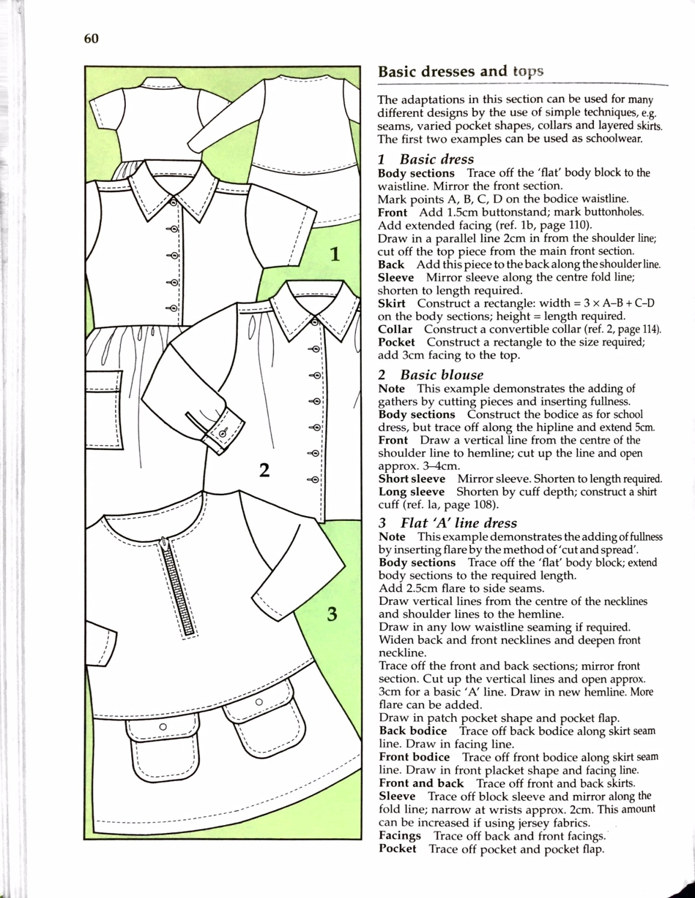**

|  |  |  |  |  |  |  |  |  |
| --- | --- | --- | --- | --- | --- | --- | --- | --- |
| S. No. | Class.  No. | Category | Gender | Prdt. | Style | Website | Brand | Price |
|
| 16 | 1.2.4 | Infant | Female | Dress | Basic Dress | Amazon | Ishika Garments | 542 |
| 17 | 1.2.4 | Infant | Female | Dress | Basic Dress | First Cry | Mothercare | 748 |
| 18 | 1.2.4 | Infant | Female | Dress | Basic Dress | Flipkart | Donut | 649 |
| 19 | 1.2.4 | Infant | Female | Dress | Basic Dress | Myntra | Gini & Jony | 761 |
| 20 | 1.2.4 | Infant | Female | Dress | Basic Dress | Snapdeal | Liliput | 696 |

AVERAGE PRICE

**BASIC BLOUSE**

**** LOWER PRICE

|  |  |  |  |  |  |  |  |  |
| --- | --- | --- | --- | --- | --- | --- | --- | --- |
| S. No. | Class.  No. | Category | Gender | Prdt. | Style | Website | Brand | Price |
|
| 21 | 1.2.5 | Infant | Female | Top | Basic Blouse | Amazon | Donut | 120 |
| 22 | 1.2.5 | Infant | Female | Top | Basic Blouse | Flipkart | Little Kangaroos | 149 |
| 23 | 1.2.5 | Infant | Female | Top | Basic Blouse | Amazon | FS Mini Klub | 149 |
| 24 | 1.2.5 | Infant | Female | Top | Basic Blouse | Amazon | Baby World | 160 |
| 21 | 1.2.5 | Infant | Female | Top | Basic Blouse | Amazon | Donut | 165 |

|  |  |  |  |  |  |  |  |  |
| --- | --- | --- | --- | --- | --- | --- | --- | --- |
| S. No. | Class.  No. | Category | Gender | Prdt. | Style | Website | Brand | Price |
|
| 26 | 1.2.5 | Infant | Female | Top | Basic Blouse | Myntra | Mothercare | 379 |
| 27 | 1.2.5 | Infant | Female | Top | Basic Blouse | Snapdeal | Lilliput | 491 |
| 28 | 1.2.5 | Infant | Female | Top | Basic Blouse | Flipkart | Gini & Jony | 420 |
| 29 | 1.2.5 | Infant | Female | Top | Basic Blouse | Myntra | UCB | 375 |
| 30 | 1.2.5 | Infant | Female | Top | Basic Blouse | Snapdeal | My lil Berry | 400 |

AVERAGE PRICE

**PINAFORE**

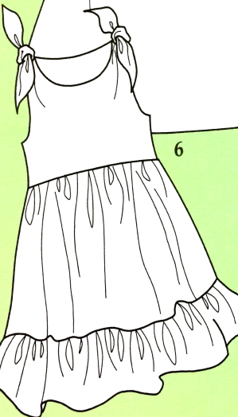

|  |  |  |  |  |  |  |  |  |
| --- | --- | --- | --- | --- | --- | --- | --- | --- |
| S. No. | Class.  No. | Category | Gender | Prdt. | Style | Website | Brand | Price |
|
| 31 | 1.2.10 | Infant | Female | Dress | Pinafore | First Cry | FS Mini Klub | 125 |
| 32 | 1.2.10 | Infant | Female | Dress | Pinafore | Snapdeal | Chirpie Pie | 125 |
| 33 | 1.2.10 | Infant | Female | Dress | Pinafore | Flipkart | Baby World | 149 |
| 34 | 1.2.10 | Infant | Female | Dress | Pinafore | Snapdeal | Little Studio | 199 |
| 35 | 1.2.10 | Infant | Female | Dress | Pinafore | Amazon | FS Mini Klub | 217 |

|  |  |  |  |  |  |  |  |  |
| --- | --- | --- | --- | --- | --- | --- | --- | --- |
| S. No. | Class.  No. | Category | Gender | Prdt. | Style | Website | Brand | Price |
|
| 36 | 1.2.10 | Infant | Female | Dress | Pinafore | Snapdeal | Ishika Garments | 556 |
| 37 | 1.2.10 | Infant | Female | Dress | Pinafore | Snapdeal | My lil Berry | 599 |
| 38 | 1.2.10 | Infant | Female | Dress | Pinafore | Myntra | Juniors | 775 |
| 39 | 1.2.10 | Infant | Female | Dress | Pinafore | First Cry | Gini & Jony | 499 |
| 40 | 1.2.10 | Infant | Female | Dress | Pinafore | Flipkart | Compana | 839 |

LOWER PRICE

AVERAGE PRICE

**DUNGAREE TROUSER**

LOWER PRICE

|  |  |  |  |  |  |  |  |  |
| --- | --- | --- | --- | --- | --- | --- | --- | --- |
| S. No. | Class.  No. | Category | Gender | Prdt. | Style | Website | Brand | Price |
|
| 41 | 1.2.12 | Infant | Female | Trouser | Dungaree Trouser | Amazon | Kandy | 449 |
| 42 | 1.2.12 | Infant | Female | Trouser | Dungaree Trouser | Amazon | Tales & Stories | 525 |
| 43 | 1.2.12 | Infant | Female | Trouser | Dungaree Trouser | First Cry | Liliput | 550 |
| 44 | 1.2.12 | Infant | Female | Trouser | Dungaree Trouser | Snapdeal | Adores | 555 |
| 45 | 1.2.12 | Infant | Female | Trouser | Dungaree Trouser | Flipkart | Fingers | 570 |



AVERAGE PRICE

|  |  |  |  |  |  |  |  |  |
| --- | --- | --- | --- | --- | --- | --- | --- | --- |
| S. No. | Class.  No. | Category | Gender | Prdt. | Style | Website | Brand | Price |
|
| 46 | 1.2.12 | Infant | Female | Trouser | Dungaree Trouser | Myntra | My Little Lamp | 1999 |
| 47 | 1.2.12 | Infant | Female | Trouser | Dungaree Trouser | Amazon | Kuchipoo | 799 |
| 48 | 1.2.12 | Infant | Female | Trouser | Dungaree Trouser | Snapdeal | Peridot | 699 |
| 49 | 1.2.12 | Infant | Female | Trouser | Dungaree Trouser | Flipkart | Little Kangaroos | 750 |
| 50 | 1.2.12 | Infant | Female | Trouser | Dungaree Trouser | Jabong | Gini & Jony | 1999 |

**TROUSER WITH EXTRA FULLNESS**

LOWER PRICE

|  |  |  |  |  |  |  |  |  |
| --- | --- | --- | --- | --- | --- | --- | --- | --- |
| S. No. | Class.  No. | Category | Gender | Prdt. | Style | Website | Brand | Price |
|
| 51 | 1.2.13 | Infant | Female | Trouser | Trouser-extra fullness | Flipkart | Adores | 449 |
| 52 | 1.2.13 | Infant | Female | Trouser | Trouser-extra fullness | Flipkart | Ahad | 525 |
| 53 | 1.2.13 | Infant | Female | Trouser | Trouser-extra fullness | Snapdeal | FS Mini Klub | 550 |
| 54 | 1.2.13 | Infant | Female | Trouser | Trouser-extra fullness | Amazon | Fingers | 555 |
| 55 | 1.2.13 | Infant | Female | Trouser | Trouser-extra fullness | Amazon | Lifestyle Junior | 570 |



AVERAGE PRICE

|  |  |  |  |  |  |  |  |  |
| --- | --- | --- | --- | --- | --- | --- | --- | --- |
| S. No. | Class.  No. | Category | Gender | Prdt. | Style | Website | Brand | Price |
|
| 56 | 1.2.13 | Infant | Female | Trouser | Trouser-extra fullness | Amazon | Miss U | 799 |
| 57 | 1.2.13 | Infant | Female | Trouser | Trouser-extra fullness | Snapdeal | UCB | 899 |
| 58 | 1.2.13 | Infant | Female | Trouser | Trouser-extra fullness | First Cry | Little Kangaroos | 999 |
| 59 | 1.2.13 | Infant | Female | Trouser | Trouser-extra fullness | Myntra | FS Mini Klub | 1199 |
| 60 | 1.2.13 | Infant | Female | Trouser | Trouser-extra fullness | Jabong | Gini & Jony | 1099 |

**EASY FITTING ROMPER**

LOWER PRICE

|  |  |  |  |  |  |  |  |  |
| --- | --- | --- | --- | --- | --- | --- | --- | --- |
| S. No. | Class.  No. | Category | Gender | Prdt. | Style | Website | Brand | Price |
|
| 61 | 1.2.14 | Infant | Female | Romper | Easy Fitting Romper | Flipkart | Ahad | 231 |
| 62 | 1.2.14 | Infant | Female | Romper | Easy Fitting Romper | First Cry | Fingers | 249 |
| 63 | 1.2.14 | Infant | Female | Romper | Easy Fitting Romper | Amazon | Kaboo's | 249 |
| 64 | 1.2.14 | Infant | Female | Romper | Easy Fitting Romper | Flipkart | Kandy | 249 |
| 65 | 1.2.14 | Infant | Female | Romper | Easy Fitting Romper | Snapdeal | Little Studio | 320 |



AVERAGE PRICE

|  |  |  |  |  |  |  |  |  |
| --- | --- | --- | --- | --- | --- | --- | --- | --- |
| S. No. | Class.  No. | Category | Gender | Prdt. | Style | Website | Brand | Price |
|
| 66 | 1.2.14 | Infant | Female | Romper | Easy Fitting Romper | Flipkart | Camey | 449 |
| 67 | 1.2.14 | Infant | Female | Romper | Easy Fitting Romper | Snapdeal | Donut | 449 |
| 68 | 1.2.14 | Infant | Female | Romper | Easy Fitting Romper | Snapdeal | Bateezworld | 543 |
| 69 | 1.2.14 | Infant | Female | Romper | Easy Fitting Romper | Myntra | FS Mini Klub | 599 |
| 70 | 1.2.14 | Infant | Female | Romper | Easy Fitting Romper | First Cry | Mothercare | 599 |

**PLACKET FASTING ROMPER**

LOWER PRICE

|  |  |  |  |  |  |  |  |  |
| --- | --- | --- | --- | --- | --- | --- | --- | --- |
| S. No. | Class.  No. | Category | Gender | Prdt. | Style | Website | Brand | Price |
|
| 71 | 1.2.15 | Infant | Female | Romper | Placket Fasting Romper | Amazon | B&B | 299 |
| 72 | 1.2.15 | Infant | Female | Romper | Placket Fasting Romper | Snapdeal | Sand Beach | 299 |
| 73 | 1.2.15 | Infant | Female | Romper | Placket Fasting Romper | Flipkart | Icable | 315 |
| 74 | 1.2.15 | Infant | Female | Romper | Placket Fasting Romper | Snapdeal | Little Studio | 320 |
| 75 | 1.2.15 | Infant | Female | Romper | Placket Fasting Romper | Amazon | FS Mini Klub | 325 |



AVERAGE PRICE

|  |  |  |  |  |  |  |  |  |
| --- | --- | --- | --- | --- | --- | --- | --- | --- |
| S. No. | Class.  No. | Category | Gender | Prdt. | Style | Website | Brand | Price |
|
| 76 | 1.2.15 | Infant | Female | Romper | Placket Fasting Romper | First Cry | Baby World | 1399 |
| 77 | 1.2.15 | Infant | Female | Romper | Placket Fasting Romper | Snapdeal | Little Studio | 699 |
| 78 | 1.2.15 | Infant | Female | Romper | Placket Fasting Romper | Amazon | Phenovo | 1300 |
| 79 | 1.2.15 | Infant | Female | Romper | Placket Fasting Romper | Myntra | Mothercare | 1300 |
| 80 | 1.2.15 | Infant | Female | Romper | Placket Fasting Romper | Flipkart | Lil Penguin | 1099 |

**ROMPER WITH YOKE**

LOWER PRICE

|  |  |  |  |  |  |  |  |  |
| --- | --- | --- | --- | --- | --- | --- | --- | --- |
| S. No. | Class.  No. | Category | Gender | Prdt. | Style | Website | Brand | Price |
|
| 81 | 1.2.16 | Infant | Female | Romper | Romper With Yoke | Flipkart | Ahad | 156 |
| 82 | 1.2.16 | Infant | Female | Romper | Romper With Yoke | Snapdeal | Little Studio | 165 |
| 83 | 1.2.16 | Infant | Female | Romper | Romper With Yoke | Flipkart | Awesome | 180 |
| 84 | 1.2.16 | Infant | Female | Romper | Romper With Yoke | Amazon | Pride | 199 |
| 85 | 1.2.16 | Infant | Female | Romper | Romper With Yoke | Amazon | Indirand | 199 |



AVERAGE PRICE

|  |  |  |  |  |  |  |  |  |
| --- | --- | --- | --- | --- | --- | --- | --- | --- |
| S. No. | Class.  No. | Category | Gender | Prdt. | Style | Website | Brand | Price |
|
| 86 | 1.2.16 | Infant | Female | Romper | Romper With Yoke | Myntra | Kothari | 310 |
| 87 | 1.2.16 | Infant | Female | Romper | Romper With Yoke | Snapdeal | Camey | 300 |
| 88 | 1.2.16 | Infant | Female | Romper | Romper With Yoke | First Cry | Baby Bucket | 360 |
| 89 | 1.2.16 | Infant | Female | Romper | Romper With Yoke | Amazon | FS Mini Klub | 320 |
| 90 | 1.2.16 | Infant | Female | Romper | Romper With Yoke | Flipkart | Chicabelle | 347 |

**EASY FITTING TROUSER**

LOWER PRICE

|  |  |  |  |  |  |  |  |  |
| --- | --- | --- | --- | --- | --- | --- | --- | --- |
| S. No. | Class.  No. | Category | Gender | Prdt. | Style | Website | Brand | Price |
|
| 91 | 1.1.17 | Infant | Female | Trouser | Easy Fitting Trouser | Myntra | YK | 199 |
| 92 | 1.1.17 | Infant | Female | Trouser | Easy Fitting Trouser | Amazon | PTP | 199 |
| 93 | 1.1.17 | Infant | Female | Trouser | Easy Fitting Trouser | Amazon | Just Kids | 220 |
| 94 | 1.1.17 | Infant | Female | Trouser | Easy Fitting Trouser | Flipkart | Baby World | 250 |
| 95 | 1.1.17 | Infant | Female | Trouser | Easy Fitting Trouser | First Cry | Aarika | 299 |



AVERAGE PRICE

|  |  |  |  |  |  |  |  |  |
| --- | --- | --- | --- | --- | --- | --- | --- | --- |
| S. No. | Class.  No. | Category | Gender | Prdt. | Style | Website | Brand | Price |
|
| 96 | 1.1.17 | Infant | Female | Trouser | Easy Fitting Trouser | Amazon | FS Mini Klub | 699 |
| 97 | 1.1.17 | Infant | Female | Trouser | Easy Fitting Trouser | Myntra | Mothercare | 539 |
| 98 | 1.1.17 | Infant | Female | Trouser | Easy Fitting Trouser | Flipkart | UCB | 600 |
| 99 | 1.1.17 | Infant | Female | Trouser | Easy Fitting Trouser | Snapdeal | Adores | 650 |
| 100 | 1.1.17 | Infant | Female | Trouser | Easy Fitting Trouser | Snapdeal | Beebay | 575 |

**CASUAL SHIRT**

LOWER PRICE

|  |  |  |  |  |  |  |  |  |
| --- | --- | --- | --- | --- | --- | --- | --- | --- |
| S. No. | Class.  No. | Category | Gender | Prdt. | Style | Website | Brand | Price |
|
| 101 | 1.2.23 | Infant | Female | Shirt | Casual Shirt | Flipkart | FS Mini Klub | 350 |
| 102 | 1.2.24 | Infant | Female | Shirt | Casual Shirt | Snapdeal | Adores | 355 |
| 103 | 1.2.25 | Infant | Female | Shirt | Casual Shirt | Snapdeal | Kandy | 360 |
| 104 | 1.2.26 | Infant | Female | Shirt | Casual Shirt | Myntra | FS Mini Klub | 375 |
| 105 | 1.2.27 | Infant | Female | Shirt | Casual Shirt | Amazon | Beebay | 399 |



AVERAGE PRICE

|  |  |  |  |  |  |  |  |  |
| --- | --- | --- | --- | --- | --- | --- | --- | --- |
| S. No. | Class.  No. | Category | Gender | Prdt. | Style | Website | Brand | Price |
|
| 106 | 1.2.28 | Infant | Female | Shirt | Casual Shirt | Myntra | UCB | 899 |
| 107 | 1.2.29 | Infant | Female | Shirt | Casual Shirt | Amazon | Aarika | 899 |
| 108 | 1.2.30 | Infant | Female | Shirt | Casual Shirt | First Cry | Gini & Jony | 550 |
| 109 | 1.2.31 | Infant | Female | Shirt | Casual Shirt | Flipkart | Allen Solly Jr. | 699 |
| 110 | 1.2.32 | Infant | Female | Shirt | Casual Shirt | Snapdeal | Lilliput | 770 |

**KIDS BOYS**

**CLASSIC BLAZER**

*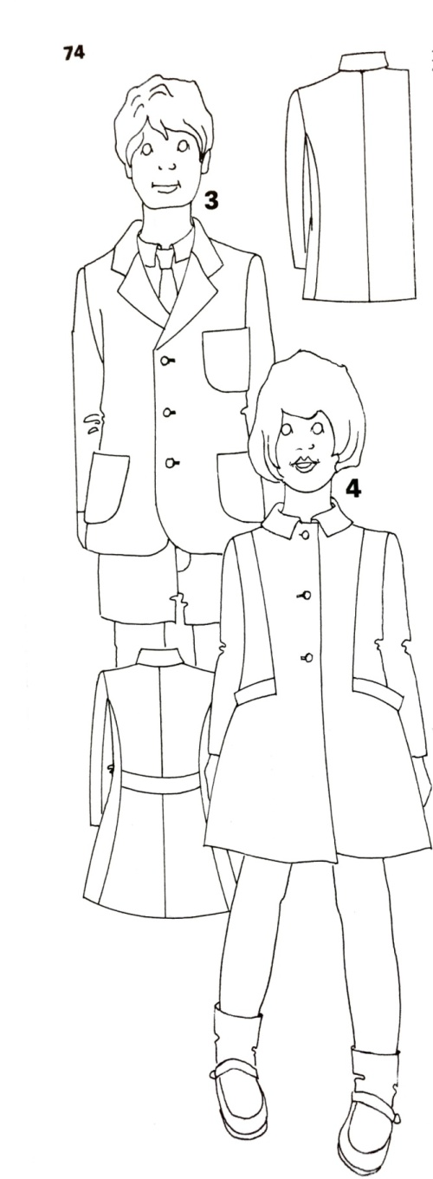Lowest price*

|  |  |  |  |  |  |  |  |  |
| --- | --- | --- | --- | --- | --- | --- | --- | --- |
| S. No. | Class.  No. | Category | Gender | Prdt. | Style | Website | Brand | Price |
| 1 | 2.1.1 | Kids | Male | Jacket | Classic Blazer | Flipkart | Little Kangaroo | 899 |
| 2 | 2.1.1 | Kids | Male | Jacket | Classic Blazer | Flipkart | Rib Fashion | 886 |
| 3 | 2.1.1 | Kids | Male | Jacket | Classic Blazer | Snapdeal | AD & AV | 999 |
| 4 | 2.1.1 | Kids | Male | Jacket | Classic Blazer | Amazon | Kids 17 | 1085 |
| 5 | 2.1.1 | Kids | Male | Jacket | Classic Blazer | Flipkart | AJ Dezines | 1099 |

*Average price*

|  |  |  |  |  |  |  |  |  |
| --- | --- | --- | --- | --- | --- | --- | --- | --- |
| S. No. | Class.  No. | Category | Gender | Prdt. | Style | Website | Brand | Price |
| 1 | 2.1.1 | Kids | Male | Jacket | Classic Blazer | Snapdeal | US Polo | 1552 |
| 2 | 2.1.1 | Kids | Male | Jacket | Classic Blazer | Flipkart | Tommy Hilfiger | 2099 |
| 3 | 2.1.1 | Kids | Male | Jacket | Classic Blazer | Snapdeal | Gini & Jony | 1999 |
| 4 | 2.1.1 | Kids | Male | Jacket | Classic Blazer | Myntra | JD Creations | 1499 |
| 5 | 2.1.1 | Kids | Male | Jacket | Classic Blazer | Snapdeal | Naveens | 1599 |

**CASUAL JACKET**

*Lowest price*

|  |  |  |  |  |  |  |  |  |
| --- | --- | --- | --- | --- | --- | --- | --- | --- |
| S. No. | Class.  No. | Category | Gender | Prdt. | Style | Website | Brand | Price |
| 1 | 2.1.5 | Kids | Male | Jacket | Casual Jacket | Flipkart | SML Original | 299 |
| 2 | 2.1.5 | Kids | Male | Jacket | Casual jacket | Flipkart | Grasshopper | 300 |
| 3 | 2.1.5 | Kids | Male | Jacket | Casual jacket | Amazon | Palm Tree | 350 |
| 4 | 2.1.5 | Kids | Male | Jacket | Casual jacket | Flipkart | Little Kangaroo | 360 |
| 5 | 2.1.5 | Kids | Male | Jacket | Casual jacket | Amazon | Motu Patlu | 379 |

******

*Average price*

|  |  |  |  |  |  |  |  |  |
| --- | --- | --- | --- | --- | --- | --- | --- | --- |
| S. No. | Class.  No. | Category | Gender | Prdt. | Style | Website | Brand | Price |
| 1 | 2.1.5 | Kids | Male | Jacket | Casual jacket | Amazon | US Polo | 1349 |
| 2 | 2.1.5 | Kids | Male | Jacket | Casual jacket | Flipkart | Full Collins | 1329 |
| 3 | 2.1.5 | Kids | Male | Jacket | Casual jacket | Snapdeal | Gini & Jony | 1345 |
| 4 | 2.1.5 | Kids | Male | Jacket | Casual jacket | Myntra | US Polo | 1599 |
| 5 | 2.1.5 | Kids | Male | Jacket | Casual jacket | Flipkart | UCB | 1513 |

**DUNGAREE**

***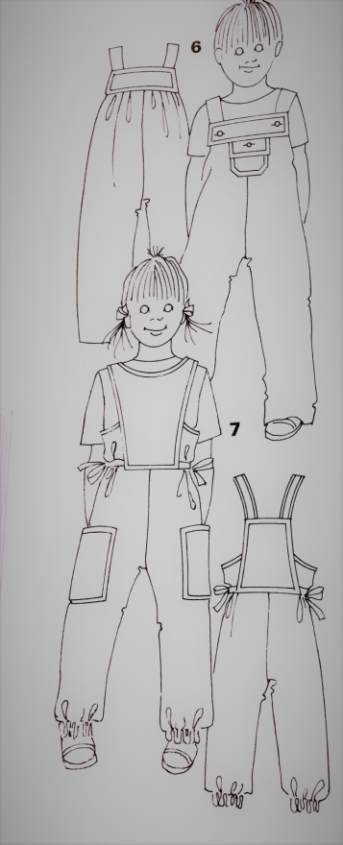***

*Lowest price*

|  |  |  |  |  |  |  |  |  |
| --- | --- | --- | --- | --- | --- | --- | --- | --- |
| S. No. | Class.  No. | Category | Gender | Prdt. | Style | Website | Brand | Price |
| 1 | 2.1.7 | Kids | Male | Dungaree | Dungaree | Aamzon | Cherokee | 299 |
| 2 | 2.1.7 | Kids | Male | Dungaree | Dungaree | Flipkart | Chirpie Pie | 349 |
| 3 | 2.1.7 | Kids | Male | Dungaree | Dungaree | Myntra | Junior Lifestyle | 396 |
| 4 | 2.1.7 | Kids | Male | Dungaree | Dungaree | Jabong | Children Place | 399 |
| 5 | 2.1.7 | Kids | Male | Dungaree | Dungaree | Flipkart | Benext | 399 |

*Average price*

|  |  |  |  |  |  |  |  |  |
| --- | --- | --- | --- | --- | --- | --- | --- | --- |
| S. No. | Class.  No. | Category | Gender | Prdt. | Style | Website | Brand | Price |
| 1 | 2.1.7 | Kids | Male | Dungaree | Dungaree | Snapdeal | Benext | 1099 |
| 2 | 2.1.7 | Kids | Male | Dungaree | Dungaree | Flipkart | Tales and stories | 1299 |
| 3 | 2.1.7 | Kids | Male | Dungaree | Dungaree | Jabong | Lilliput | 1116 |
| 4 | 2.1.7 | Kids | Male | Dungaree | Dungaree | Myntra | Cherry Crumble | 1311 |
| 5 | 2.1.7 | Kids | Male | Dungaree | Dungaree | Amazon | Allen Solly | 1259 |

**BASIC TROUSER**

***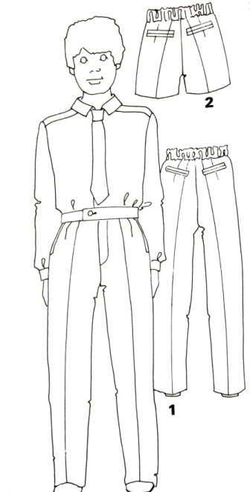***

*Lowest price*

|  |  |  |  |  |  |  |  |  |
| --- | --- | --- | --- | --- | --- | --- | --- | --- |
| S. No. | Class.  No. | Category | Gender | Prdt. | Style | Website | Brand | Price |
| 1 | 2.1.8 | Kids | Male | Trouser | Basic Trouser | Amazon | Cherokee | 347 |
| 2 | 2.1.8 | Kids | Male | Trouser | Basic Trouser | Flipkart | YK | 350 |
| 3 | 2.1.8 | Kids | Male | Trouser | Basic Trouser | Snapdeal | Fame Forver | 375 |
| 4 | 2.1.8 | Kids | Male | Trouser | Basic Trouser | Myntra | Poppers | 399 |
| 5 | 2.1.8 | Kids | Male | Trouser | Basic Trouser | Amazon | SML Original | 399 |

*Average price*

|  |  |  |  |  |  |  |  |  |
| --- | --- | --- | --- | --- | --- | --- | --- | --- |
| S. No. | Class.  No. | Category | Gender | Prdt. | Style | Website | Brand | Price |
| 1 | 2.1.8 | Kids | Male | Trouser | Basic Trouser | Snapdeal | US Polo | 1599 |
| 2 | 2.1.8 | Kids | Male | Trouser | Basic Trouser | Flipkart | UCB | 1499 |
| 3 | 2.1.8 | Kids | Male | Trouser | Basic Trouser | Myntra | Childrend Place | 1300 |
| 4 | 2.1.8 | Kids | Male | Trouser | Basic Trouser | Myntra | Pantaloons | 1599 |
| 5 | 2.1.8 | Kids | Male | Trouser | Basic Trouser | Myntra | Gini & Jony | 1620 |

**PLAY SHORT**

*Lowest price*

|  |  |  |  |  |  |  |  |  |
| --- | --- | --- | --- | --- | --- | --- | --- | --- |
| S. No. | Class.  No. | Category | Gender | Prdt. | Style | Website | Brand | Price |
| 1 | 2.1.11 | Kids | Male | Pant Deri. | Play Shorts | Amazon | SML Original | 199 |
| 2 | 2.1.11 | Kids | Male | Pant Deri. | Play Shorts | Myntra | Cilfton | 199 |
| 3 | 2.1.11 | Kids | Male | Pant Deri. | Play Shorts | Snapdeal | Bio Kid | 224 |
| 4 | 2.1.11 | Kids | Male | Pant Deri. | Play Shorts | Myntra | Lifestyle Junior | 375 |
| 5 | 2.1.11 | Kids | Male | Pant Deri. | Play Shorts | Myntra | Gini & Jony | 299 |

***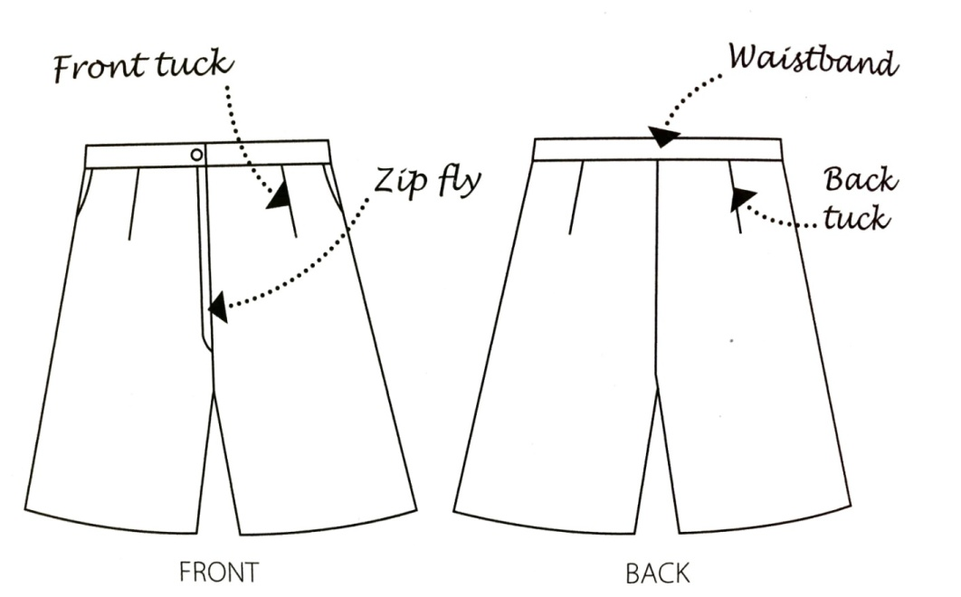***

*Average price*

|  |  |  |  |  |  |  |  |  |
| --- | --- | --- | --- | --- | --- | --- | --- | --- |
| S. No. | Class.  No. | Category | Gender | Prdt. | Style | Website | Brand | Price |
| 1 | 2.1.11 | Kids | Male | Pant Deri. | Play Shorts | Snapdeal | UCB | 649 |
| 2 | 2.1.11 | Kids | Male | Pant Deri. | Play Shorts | Flipkart | Puma | 604 |
| 3 | 2.1.11 | Kids | Male | Pant Deri. | Play Shorts | Myntra | Gini & Jony | 650 |
| 4 | 2.1.11 | Kids | Male | Pant Deri. | Play Shorts | Flipkart | US Polo | 719 |
| 5 | 2.1.11 | Kids | Male | Pant Deri. | Play Shorts | Myntra | Palm Tree | 650 |

**JEANS**

*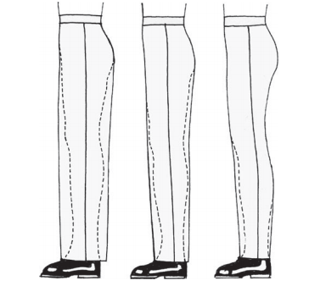Lowest price*

|  |  |  |  |  |  |  |  |  |
| --- | --- | --- | --- | --- | --- | --- | --- | --- |
| S. No. | Class.  No. | Category | Gender | Prdt. | Style | Website | Brand | Price |
| 1 | 2.1.15 | Kids | Male | Trouser | Jean | Amazon | Kuchipoo | 347 |
| 2 | 2.1.15 | Kids | Male | Trouser | Jean | Amazon | Cherokee | 349 |
| 3 | 2.1.15 | Kids | Male | Trouser | Jean | Flipkart | People | 359 |
| 4 | 2.1.15 | Kids | Male | Trouser | Jean | Flipkart | Guchu | 450 |
| 5 | 2.1.15 | Kids | Male | Trouser | Jean | Snapdeal | AD & AV | 535 |

*Average price*

|  |  |  |  |  |  |  |  |  |
| --- | --- | --- | --- | --- | --- | --- | --- | --- |
| S. No. | Class.  No. | Category | Gender | Prdt. | Style | Website | Brand | Price |
| 1 | 2.1.15 | Kids | Male | Trouser | Jean | Amazon | Allen Solly Junior | 1019 |
| 2 | 2.1.15 | Kids | Male | Trouser | Jean | Myntra | US Polo | 699 |
| 3 | 2.1.15 | Kids | Male | Trouser | Jean | Flipkart | Pantaloons | 1800 |
| 4 | 2.1.15 | Kids | Male | Trouser | Jean | Snapdeal | Indian Terrain Jr | 1699 |
| 5 | 2.1.15 | Kids | Male | Trouser | Jean | Snapdeal | Gini & Jony | 1399 |

**PLEATED TROUSER**

*Lowest price*

|  |  |  |  |  |  |  |  |  |
| --- | --- | --- | --- | --- | --- | --- | --- | --- |
| S. No. | Class.  No. | Category | Gender | Prdt. | Style | Website | Brand | Price |
| 1 | 2.1.16 | Kids | Male | Trouser | Pleated Trouser | Amazon | Cherokee | 400 |
| 2 | 2.1.16 | Kids | Male | Trouser | Pleated Trouser | Flipkart | Coffee Bean | 419 |
| 3 | 2.1.16 | Kids | Male | Trouser | Pleated Trouser | Myntra | Fame Forver | 419 |
| 4 | 2.1.16 | Kids | Male | Trouser | Pleated Trouser | Snapdeal | AD & AV | 518 |
| 5 | 2.1.16 | Kids | Male | Trouser | Pleated Trouser | Amazon | SML Original | 530 |

***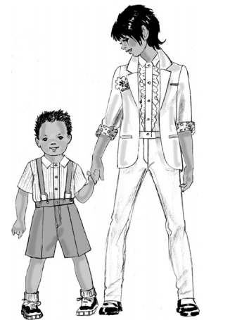***

*Average price*

|  |  |  |  |  |  |  |  |  |
| --- | --- | --- | --- | --- | --- | --- | --- | --- |
| S. No. | Class.  No. | Category | Gender | Prdt. | Style | Website | Brand | Price |
| 1 | 2.1.16 | Kids | Male | Trouser | Pleated Trouser | Myntra | Indian Terrain Jr | 999 |
| 2 | 2.1.16 | Kids | Male | Trouser | Pleated Trouser | Flipkart | UCB | 1035 |
| 3 | 2.1.16 | Kids | Male | Trouser | Pleated Trouser | Myntra | Childrens Place | 1079 |
| 4 | 2.1.16 | Kids | Male | Trouser | Pleated Trouser | Flipkart | Pantaloons | 1299 |
| 5 | 2.1.16 | Kids | Male | Trouser | Pleated Trouser | Amazon | Gini & Jony | 1195 |

**BAGGY PANT**

*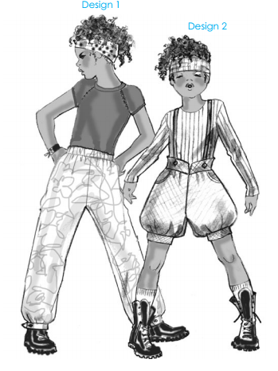Lowest price*

|  |  |  |  |  |  |  |  |  |
| --- | --- | --- | --- | --- | --- | --- | --- | --- |
| S. No. | Class.  No. | Category | Gender | Prdt. | Style | Website | Brand | Price |
| 1 | 2.1.17 | Kids | Male | Trouser | Baggy Pant | Flipkart | Boys League | 222 |
| 2 | 2.1.17 | Kids | Male | Trouser | Baggy Pant | Snapdeal | YK | 239 |
| 3 | 2.1.17 | Kids | Male | Trouser | Baggy Pant | Snapdeal | Childrens Place | 249 |
| 4 | 2.1.17 | Kids | Male | Trouser | Baggy Pant | Myntra | Palm Tree | 299 |
| 5 | 2.1.17 | Kids | Male | Trouser | Baggy Pant | Myntra | 612 League | 322 |

*Average price*

|  |  |  |  |  |  |  |  |  |
| --- | --- | --- | --- | --- | --- | --- | --- | --- |
| S. No. | Class.  No. | Category | Gender | Prdt. | Style | Website | Brand | Price |
| 1 | 2.1.17 | Kids | Male | Trouser | Baggy Pant | Amazon | UCB | 995 |
| 2 | 2.1.17 | Kids | Male | Trouser | Baggy Pant | Snapdeal | Barcelona | 899 |
| 3 | 2.1.17 | Kids | Male | Trouser | Baggy Pant | Flipkart | Indian Terrain Jr | 999 |
| 4 | 2.1.17 | Kids | Male | Trouser | Baggy Pant | Jabong | Gini & Jony | 899 |
| 5 | 2.1.17 | Kids | Male | Trouser | Baggy Pant | Jabong | Tommy Hilfiger | 1100 |

**ROUND NECK T SHIRT**

*Lowest price*

|  |  |  |  |  |  |  |  |  |
| --- | --- | --- | --- | --- | --- | --- | --- | --- |
| S. No. | Class.  No. | Category | Gender | Prdt. | Style | Website | Brand | Price |
| 1 | 2.1.18 | Kids | Male | T-shirt | Round Neck T-shirt | Amazon | SML Original | 199 |
| 2 | 2.1.18 | Kids | Male | T-shirt | Round Neck T-shirt | Amazon | Cherokee | 220 |
| 3 | 2.1.18 | Kids | Male | T-shirt | Round Neck T-shirt | Flipkart | Little Kangaroo | 255 |
| 4 | 2.1.18 | Kids | Male | T-shirt | Round Neck T-shirt | Snapdeal | Childrens Place | 279 |
| 5 | 2.1.18 | Kids | Male | T-shirt | Round Neck T-shirt | Flipkart | Palm Tree | 299 |

***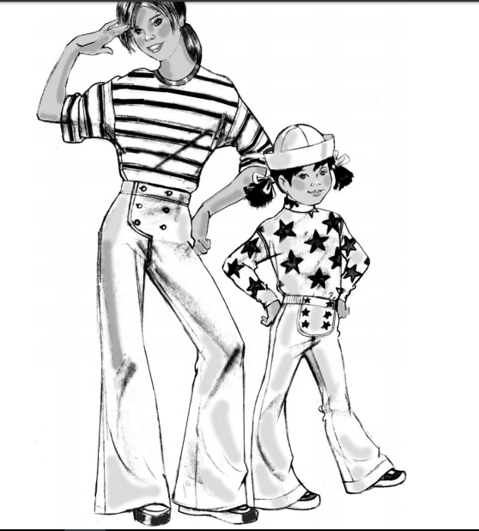***

*Average price*

|  |  |  |  |  |  |  |  |  |
| --- | --- | --- | --- | --- | --- | --- | --- | --- |
| S. No. | Class.  No. | Category | Gender | Prdt. | Style | Website | Brand | Price |
| 1 | 2.1.18 | Kids | Male | T-shirt | Round Neck T-shirt | Myntra | UCB | 599 |
| 2 | 2.1.18 | Kids | Male | T-shirt | Round Neck T-shirt | Jabong | Lifestyle Junior | 450 |
| 3 | 2.1.18 | Kids | Male | T-shirt | Round Neck T-shirt | Snapdeal | Gini & Jony | 499 |
| 4 | 2.1.18 | Kids | Male | T-shirt | Round Neck T-shirt | Amazon | Benext | 620 |
| 5 | 2.1.18 | Kids | Male | T-shirt | Round Neck T-shirt | Flipkart | Lilliput | 699 |

**CASUAL SHIRT**

*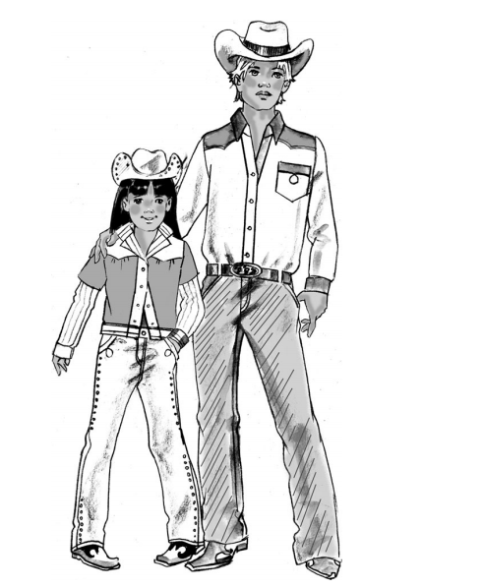Lowest price*

|  |  |  |  |  |  |  |  |  |
| --- | --- | --- | --- | --- | --- | --- | --- | --- |
| S. No. | Class.  No. | Category | Gender | Prdt. | Style | Website | Brand | Price |
| 1 | 2.1.19 | Kids | Male | Shirt | Casual Shirt | Flipkart | Grasshopper | 199 |
| 2 | 2.1.19 | Kids | Male | Shirt | Casual Shirt | Amazon | SML Original | 220 |
| 3 | 2.1.19 | Kids | Male | Shirt | Casual Shirt | Snapdeal | YK | 229 |
| 4 | 2.1.19 | Kids | Male | Shirt | Casual Shirt | Myntra | AD & AV | 250 |
| 5 | 2.1.19 | Kids | Male | Shirt | Casual Shirt | Flipkart | Little Kangaroo | 260 |

*Average price*

|  |  |  |  |  |  |  |  |  |
| --- | --- | --- | --- | --- | --- | --- | --- | --- |
| S. No. | Class.  No. | Category | Gender | Prdt. | Style | Website | Brand | Price |
| 1 | 2.1.19 | Kids | Male | Shirt | Casual Shirt | Flipkart | Grasshopper | 799 |
| 2 | 2.1.19 | Kids | Male | Shirt | Casual Shirt | Amazon | SML Original | 699 |
| 3 | 2.1.19 | Kids | Male | Shirt | Casual Shirt | Snapdeal | YK | 625 |
| 4 | 2.1.19 | Kids | Male | Shirt | Casual Shirt | Myntra | AD & AV | 799 |
| 5 | 2.1.19 | Kids | Male | Shirt | Casual Shirt | Flipkart | Little Kangaroo | 899 |

**BIB OVERALL**

*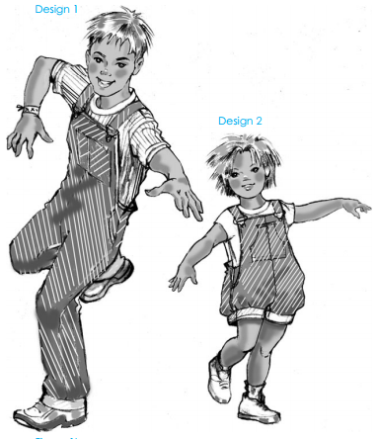Lowest price*

|  |  |  |  |  |  |  |  |  |
| --- | --- | --- | --- | --- | --- | --- | --- | --- |
| S. No. | Class.  No. | Category | Gender | Prdt. | Style | Website | Brand | Price |
| 1 | 2.1.24 | Kids | Male | Jumpsuit | Bib Overall | Flipkart | AD & AV | 585 |
| 2 | 2.1.24 | Kids | Male | Jumpsuit | Bib Overall | Myntra | Palm Tree | 599 |
| 3 | 2.1.24 | Kids | Male | Jumpsuit | Bib Overall | Amazon | SML Original | 625 |
| 4 | 2.1.24 | Kids | Male | Jumpsuit | Bib Overall | Amazon | Cherokee | 699 |
| 5 | 2.1.24 | Kids | Male | Jumpsuit | Bib Overall | Snapdeal | Little Kangaroo | 699 |

*Average price*

|  |  |  |  |  |  |  |  |  |
| --- | --- | --- | --- | --- | --- | --- | --- | --- |
| S. No. | Class.  No. | Category | Gender | Prdt. | Style | Website | Brand | Price |
| 1 | 2.1.24 | Kids | Male | Jumpsuit | Bib Overall | Myntra | Pantaloons | 1109 |
| 2 | 2.1.24 | Kids | Male | Jumpsuit | Bib Overall | Myntra | Gini & Jony | 1099 |
| 3 | 2.1.24 | Kids | Male | Jumpsuit | Bib Overall | Jabong | Indian Terrain Jr | 1299 |
| 4 | 2.1.24 | Kids | Male | Jumpsuit | Bib Overall | Snapdeal | Liliput | 1399 |
| 5 | 2.1.24 | Kids | Male | Jumpsuit | Bib Overall | Amazon | Benext | 1099 |

**KURTA**

*Lowest price*

|  |  |  |  |  |  |  |  |  |
| --- | --- | --- | --- | --- | --- | --- | --- | --- |
| S. No. | Class.  No. | Category | Gender | Prdt. | Style | Website | Brand | Price |
| 1 | 2.1.25 | Kids | Male | Kurta | Kurta | Amazon | Ftcbazaar | 599 |
| 2 | 2.1.25 | Kids | Male | Kurta | Kurta | Flipkart | AJ Dezines | 799 |
| 3 | 2.1.25 | Kids | Male | Kurta | Kurta | Flipkart | Jen Creations | 1800 |
| 4 | 2.1.25 | Kids | Male | Kurta | Kurta | Snapdeal | Shree Shubam | 1335 |
| 5 | 2.1.25 | Kids | Male | Kurta | Kurta | Jabong | Arshia | 1398 |

***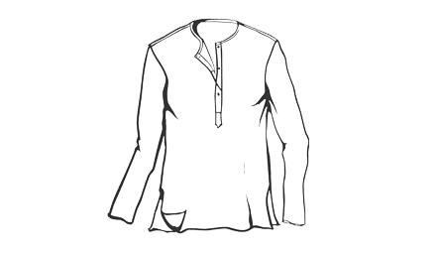***

*Average price*

|  |  |  |  |  |  |  |  |  |
| --- | --- | --- | --- | --- | --- | --- | --- | --- |
| S. No. | Class.  No. | Category | Gender | Prdt. | Style | Website | Brand | Price |
| 1 | 2.1.25 | Kids | Male | Kurta | Kurta | Myntra | AJ Dezines | 1799 |
| 2 | 2.1.25 | Kids | Male | Kurta | Kurta | Myntra | K&U | 1259 |
| 3 | 2.1.25 | Kids | Male | Kurta | Kurta | Jabong | Tiber Taber | 1950 |
| 4 | 2.1.25 | Kids | Male | Kurta | Kurta | Snapdeal | Jeethnics | 1299 |
| 5 | 2.1.25 | Kids | Male | Kurta | Kurta | Snapdeal | Liliput | 1645 |

**KIDS GIRLS**

**PINAFORE**

|  |  |  |  |  |  |  |  |  |
| --- | --- | --- | --- | --- | --- | --- | --- | --- |
| S. No. | Class.  No. | Category | Gender | Prdt. | Style | Website | Brand | Price |
|
| 6 | 2.2.1 | Kids | Female | Dress | Pinafore | Amazon | Bossini | 1099 |
| 7 | 2.2.1 | Kids | Female | Dress | Pinafore | Myntra | My lil Berry | 850 |
| 8 | 2.2.1 | Kids | Female | Dress | Pinafore | Myntra | Gini & Jony | 839 |
| 9 | 2.2.1 | Kids | Female | Dress | Pinafore | Flipkart | UCB | 864 |
| 10 | 2.2.1 | Kids | Female | Dress | Pinafore | Jabong | Pikaboo | 849 |

|  |  |  |  |  |  |  |  |  |
| --- | --- | --- | --- | --- | --- | --- | --- | --- |
| S. No. | Class.  No. | Category | Gender | Prdt. | Style | Website | Brand | Price |
|
| 1 | 2.2.1 | Kids | Female | Dress | Pinafore | Myntra | Oxolloxo | 399 |
| 2 | 2.2.1 | Kids | Female | Dress | Pinafore | Flipkart | Lil Orchids | 449 |
| 3 | 2.2.1 | Kids | Female | Dress | Pinafore | Snapdeal | Baby | 492 |
| 4 | 2.2.1 | Kids | Female | Dress | Pinafore | Myntra | Junior Lifestyle | 499 |
| 5 | 2.2.1 | Kids | Female | Dress | Pinafore | Flipkart | AJ Dezines | 499 |

**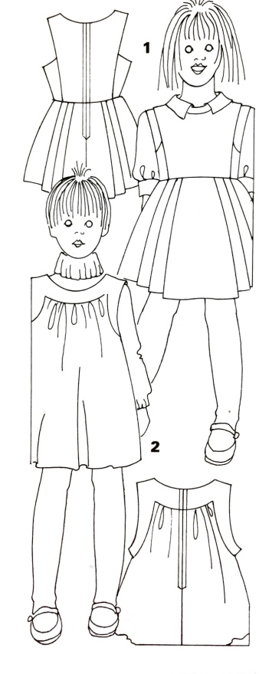 LOWER PRICE**

**AVERAGE PRICE**

**FLARED SKIRT**

LOWER PRICE

|  |  |  |  |  |  |  |  |  |
| --- | --- | --- | --- | --- | --- | --- | --- | --- |
| S. No. | Class.  No. | Category | Gender | Prdt. | Style | Website | Brand | Price |
|
| 11 | 2.2.19 | Kids | Female | Skirt | Flared Skirt | Jabong | Naughty Ninos | 268 |
| 12 | 2.2.19 | Kids | Female | Skirt | Flared Skirt | Flipkart | Little Kangaroo | 280 |
| 13 | 2.2.19 | Kids | Female | Skirt | Flared Skirt | Snapdeal | Junior Lifestyle | 300 |
| 14 | 2.2.19 | Kids | Female | Skirt | Flared Skirt | Myntra | Lil Orchids | 309 |
| 15 | 2.2.19 | Kids | Female | Skirt | Flared Skirt | Amazon | Baby | 366 |

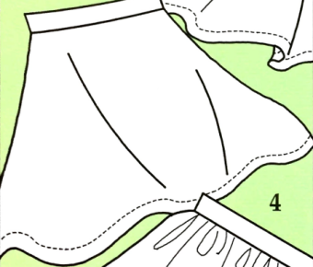

AVERAGE PRICE

|  |  |  |  |  |  |  |  |  |
| --- | --- | --- | --- | --- | --- | --- | --- | --- |
| S. No. | Class.  No. | Category | Gender | Prdt. | Style | Website | Brand | Price |
|
| 16 | 2.2.19 | Kids | Female | Skirt | Flared Skirt | Amazon | UCB | 1200 |
| 17 | 2.2.19 | Kids | Female | Skirt | Flared Skirt | Flipkart | Gini & Jony | 990 |
| 18 | 2.2.19 | Kids | Female | Skirt | Flared Skirt | Snapdeal | Naughty Ninos | 1189 |
| 19 | 2.2.19 | Kids | Female | Skirt | Flared Skirt | Myntra | My lil Berry | 1232 |
| 20 | 2.2.19 | Kids | Female | Skirt | Flared Skirt | Flipkart | Allen Solley Jr. | 1049 |

**Basic Trouser**

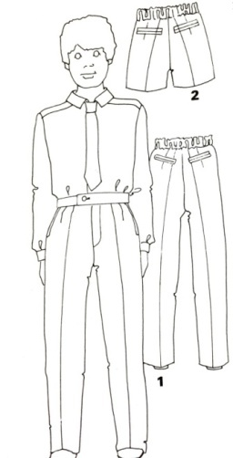LOWER PRICE

|  |  |  |  |  |  |  |  |  |
| --- | --- | --- | --- | --- | --- | --- | --- | --- |
| S. No. | Class.  No. | Category | Gender | Prdt. | Style | Website | Brand | Price |
|
| 21 | 2.2.22 | Kids | Female | Trouser | Basic Trouser | Amazon | Cherokee | 355 |
| 22 | 2.2.22 | Kids | Female | Trouser | Basic Trouser | Flipkart | YK | 359 |
| 23 | 2.2.22 | Kids | Female | Trouser | Basic Trouser | Snapdeal | Cute Cucumber | 375 |
| 24 | 2.2.22 | Kids | Female | Trouser | Basic Trouser | Myntra | Pantaloons | 399 |
| 25 | 2.2.22 | Kids | Female | Trouser | Basic Trouser | Amazon | SML Original | 415 |

|  |  |  |  |  |  |  |  |  |
| --- | --- | --- | --- | --- | --- | --- | --- | --- |
| S. No. | Class.  No. | Category | Gender | Prdt. | Style | Website | Brand | Price |
|
| 26 | 2.2.22 | Kids | Female | Trouser | Basic Trouser | Snapdeal | My lil Berry | 1499 |
| 27 | 2.2.22 | Kids | Female | Trouser | Basic Trouser | Flipkart | UCB | 1399 |
| 28 | 2.2.22 | Kids | Female | Trouser | Basic Trouser | Myntra | Childrend Place | 1300 |
| 29 | 2.2.22 | Kids | Female | Trouser | Basic Trouser | Myntra | Pantaloons | 1099 |
| 30 | 2.2.22 | Kids | Female | Trouser | Basic Trouser | Myntra | Gini & Jony | 1299 |

AVERAGE PRICE

**CULOTTES**

LOWER PRICE

|  |  |  |  |  |  |  |  |  |
| --- | --- | --- | --- | --- | --- | --- | --- | --- |
| S. No. | Class.  No. | Category | Gender | Prdt. | Style | Website | Brand | Price |
|
| 31 | 2.2.24 | Kids | Female | Trouser | Culottes | Amazon | Oxolloxo | 284 |
| 32 | 2.2.24 | Kids | Female | Trouser | Culottes | Snapdeal | My lil Berry | 330 |
| 33 | 2.2.24 | Kids | Female | Trouser | Culottes | Flipkart | Sera | 349 |
| 34 | 2.2.24 | Kids | Female | Trouser | Culottes | Jabong | Lifestyle Junior | 399 |
| 35 | 2.2.24 | Kids | Female | Trouser | Culottes | Myntra | Cute Cucumber | 412 |

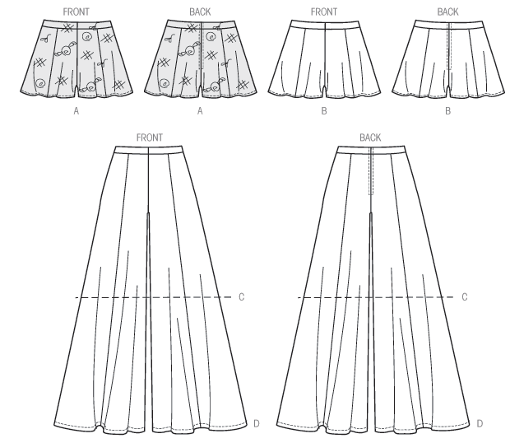

AVERAGE PRICE

|  |  |  |  |  |  |  |  |  |
| --- | --- | --- | --- | --- | --- | --- | --- | --- |
| S. No. | Class.  No. | Category | Gender | Prdt. | Style | Website | Brand | Price |
|
| 36 | 2.2.24 | Kids | Female | Trouser | Culottes | Snapdeal | UCB | 1299 |
| 37 | 2.2.24 | Kids | Female | Trouser | Culottes | Flipkart | Mothercare | 799 |
| 38 | 2.2.24 | Kids | Female | Trouser | Culottes | Myntra | Tommy Hilfiger | 1499 |
| 39 | 2.2.24 | Kids | Female | Trouser | Culottes | Flipkart | Bossini | 1299 |
| 40 | 2.2.24 | Kids | Female | Trouser | Culottes | Myntra | Next | 952 |

\

**DUNGAREE**

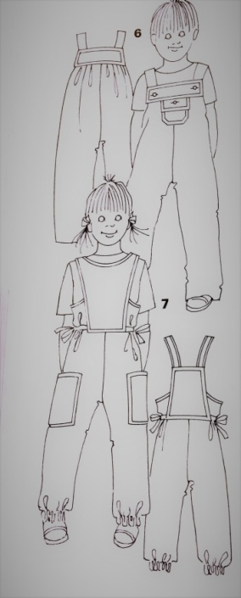 LOWER PRICE

|  |  |  |  |  |  |  |  |  |
| --- | --- | --- | --- | --- | --- | --- | --- | --- |
| S. No. | Class.  No. | Category | Gender | Prdt. | Style | Website | Brand | Price |
|
| 41 | 2.2.25 | Kids | Female | Trouser | Dungaree | Aamzon | Cute Cucumber | 299 |
| 42 | 2.2.25 | Kids | Female | Trouser | Dungaree | Flipkart | Chirpie Pie | 415 |
| 43 | 2.2.25 | Kids | Female | Trouser | Dungaree | Myntra | Junior Lifestyle | 425 |
| 44 | 2.2.25 | Kids | Female | Trouser | Dungaree | Jabong | Sera | 450 |
| 45 | 2.2.25 | Kids | Female | Trouser | Dungaree | Flipkart | Benext | 469 |

AVERAGE PRICE

|  |  |  |  |  |  |  |  |  |
| --- | --- | --- | --- | --- | --- | --- | --- | --- |
| S. No. | Class.  No. | Category | Gender | Prdt. | Style | Website | Brand | Price |
|
| 46 | 2.2.25 | Kids | Female | Trouser | Dungaree | Snapdeal | YK | 1099 |
| 47 | 2.2.25 | Kids | Female | Trouser | Dungaree | Flipkart | Peppermint | 1299 |
| 48 | 2.2.25 | Kids | Female | Trouser | Dungaree | Jabong | Lilliput | 1116 |
| 49 | 2.2.25 | Kids | Female | Trouser | Dungaree | Myntra | Naughty Ninos | 1311 |
| 50 | 2.2.25 | Kids | Female | Trouser | Dungaree | Amazon | Allen Solly | 1259 |

**JEANS**

LOWER PRICE

|  |  |  |  |  |  |  |  |  |
| --- | --- | --- | --- | --- | --- | --- | --- | --- |
| S. No. | Class.  No. | Category | Gender | Prdt. | Style | Website | Brand | Price |
|
| 51 | 2.2.30 | Kids | Female | Trouser | Jean | Amazon | Kuchipoo | 347 |
| 52 | 2.2.30 | Kids | Female | Trouser | Jean | Flipkart | Palm Tree | 349 |
| 53 | 2.2.30 | Kids | Female | Trouser | Jean | Amazon | People | 359 |
| 54 | 2.2.30 | Kids | Female | Trouser | Jean | Flipkart | Baby League | 450 |
| 55 | 2.2.30 | Kids | Female | Trouser | Jean | Snapdeal | YK | 535 |



AVERAGE PRICE

|  |  |  |  |  |  |  |  |  |
| --- | --- | --- | --- | --- | --- | --- | --- | --- |
| S. No. | Class.  No. | Category | Gender | Prdt. | Style | Website | Brand | Price |
|
| 56 | 2.2.30 | Kids | Female | Trouser | Jean | Myntra | Allen Solly Junior | 1019 |
| 57 | 2.2.30 | Kids | Female | Trouser | Jean | Myntra | Peppermint | 999 |
| 58 | 2.2.30 | Kids | Female | Trouser | Jean | Flipkart | Pantaloons | 1800 |
| 59 | 2.2.30 | Kids | Female | Trouser | Jean | Snapdeal | Naughty Ninos | 1699 |
| 60 | 2.2.30 | Kids | Female | Trouser | Jean | Snapdeal | Gini & Jony | 1399 |

**PLEATED TROUSER**

LOWER PRICE

|  |  |  |  |  |  |  |  |  |
| --- | --- | --- | --- | --- | --- | --- | --- | --- |
| S. No. | Class.  No. | Category | Gender | Prdt. | Style | Website | Brand | Price |
|
| 61 | 2.2.31 | Kids | Female | Trouser | Pleated Trouser | Amazon | Cherokee | 357 |
| 62 | 2.2.31 | Kids | Female | Trouser | Pleated Trouser | Myntra | Baby League | 372 |
| 63 | 2.2.31 | Kids | Female | Trouser | Pleated Trouser | Flipkart | Pantaloons | 389 |
| 64 | 2.2.31 | Kids | Female | Trouser | Pleated Trouser | Myntra | Palm Tree | 399 |
| 65 | 2.2.31 | Kids | Female | Trouser | Pleated Trouser | Amazon | SML Original | 417 |



|  |  |  |  |  |  |  |  |  |
| --- | --- | --- | --- | --- | --- | --- | --- | --- |
| S. No. | Class.  No. | Category | Gender | Prdt. | Style | Website | Brand | Price |
|
| 66 | 2.2.31 | Kids | Female | Trouser | Pleated Trouser | Myntra | Bossini | 999 |
| 67 | 2.2.31 | Kids | Female | Trouser | Pleated Trouser | Flipkart | Naughty Ninos | 899 |
| 68 | 2.2.31 | Kids | Female | Trouser | Pleated Trouser | Myntra | UCB | 999 |
| 69 | 2.2.31 | Kids | Female | Trouser | Pleated Trouser | Flipkart | Pantaloons | 1099 |
| 70 | 2.2.31 | Kids | Female | Trouser | Pleated Trouser | Amazon | Gini & Jony | 1049 |

AVERAGE PRICE

**BAGGY PANT**

LOWER PRICE

|  |  |  |  |  |  |  |  |  |
| --- | --- | --- | --- | --- | --- | --- | --- | --- |
| S. No. | Class.  No. | Category | Gender | Prdt. | Style | Website | Brand | Price |
|
| 71 | 2.2.32 | Kids | Female | Trouser | Baggy Pant | Flipkart | Cute Cucumber | 445 |
| 72 | 2.2.32 | Kids | Female | Trouser | Baggy Pant | Myntra | Lil Orchids | 599 |
| 73 | 2.2.32 | Kids | Female | Trouser | Baggy Pant | Myntra | Childrens Place | 499 |
| 74 | 2.2.32 | Kids | Female | Trouser | Baggy Pant | Snapdeal | Palm Tree | 599 |
| 75 | 2.2.32 | Kids | Female | Trouser | Baggy Pant | Flipkart | 612 League | 645 |

AVERAGE PRICE

|  |  |  |  |  |  |  |  |  |
| --- | --- | --- | --- | --- | --- | --- | --- | --- |
| S. No. | Class.  No. | Category | Gender | Prdt. | Style | Website | Brand | Price |
|
| 76 | 2.2.32 | Kids | Female | Trouser | Baggy Pant | Amazon | UCB | 899 |
| 77 | 2.2.32 | Kids | Female | Trouser | Baggy Pant | Snapdeal | Gini & Jony | 979 |
| 78 | 2.2.32 | Kids | Female | Trouser | Baggy Pant | Flipkart | Naughty Ninos | 959 |
| 79 | 2.2.32 | Kids | Female | Trouser | Baggy Pant | Amazon | Next | 872 |
| 80 | 2.2.32 | Kids | Female | Trouser | Baggy Pant | Myntra | Tommy Hilfiger | 979 |

**PLEATED TROUSER**

LOWER PRICE

|  |  |  |  |  |  |  |  |  |
| --- | --- | --- | --- | --- | --- | --- | --- | --- |
| S. No. | Class.  No. | Category | Gender | Prdt. | Style | Website | Brand | Price |
|
| 81 | 2.2.40 | Kids | Female | T-shirt | Round Neck T-shirt | Amazon | 612 League | 399 |
| 82 | 2.2.40 | Kids | Female | T-shirt | Round Neck T-shirt | Flipkart | Cherokee | 350 |
| 83 | 2.2.40 | Kids | Female | T-shirt | Round Neck T-shirt | Amazon | Little Kangaroo | 450 |
| 84 | 2.2.40 | Kids | Female | T-shirt | Round Neck T-shirt | Snapdeal | Childrens Place | 399 |
| 85 | 2.2.40 | Kids | Female | T-shirt | Round Neck T-shirt | Jabong | Palm Tree | 310 |



AVERAGE PRICE

|  |  |  |  |  |  |  |  |  |
| --- | --- | --- | --- | --- | --- | --- | --- | --- |
| S. No. | Class.  No. | Category | Gender | Prdt. | Style | Website | Brand | Price |
|
| 86 | 2.2.40 | Kids | Female | T-shirt | Round Neck T-shirt | Myntra | UCB | 599 |
| 87 | 2.2.40 | Kids | Female | T-shirt | Round Neck T-shirt | Jabong | Lifestyle Junior | 450 |
| 88 | 2.2.40 | Kids | Female | T-shirt | Round Neck T-shirt | Snapdeal | Gini & Jony | 499 |
| 89 | 2.2.40 | Kids | Female | T-shirt | Round Neck T-shirt | Amazon | Bossini | 620 |
| 90 | 2.2.40 | Kids | Female | T-shirt | Round Neck T-shirt | Flipkart | Lilliput | 699 |

**CASUAL SHIRT**

LOWER PRICE

|  |  |  |  |  |  |  |  |  |
| --- | --- | --- | --- | --- | --- | --- | --- | --- |
| S. No. | Class.  No. | Category | Gender | Prdt. | Style | Website | Brand | Price |
|
| 91 | 2.2.41 | Kids | Female | Shirt | Casual Shirt | Flipkart | Cute Cucumber | 180 |
| 92 | 2.2.41 | Kids | Female | Shirt | Casual Shirt | Amazon | SML Original | 220 |
| 93 | 2.2.41 | Kids | Female | Shirt | Casual Shirt | Snapdeal | YK | 229 |
| 94 | 2.2.41 | Kids | Female | Shirt | Casual Shirt | Myntra | Baby League | 250 |
| 95 | 2.2.41 | Kids | Female | Shirt | Casual Shirt | Flipkart | Palm Tree | 260 |

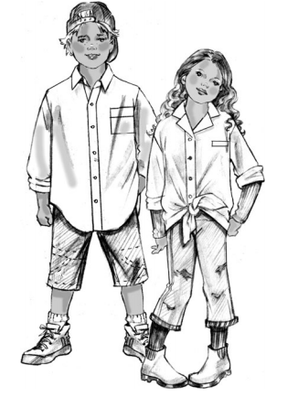

AVERAGE PRICE

|  |  |  |  |  |  |  |  |  |
| --- | --- | --- | --- | --- | --- | --- | --- | --- |
| S. No. | Class.  No. | Category | Gender | Prdt. | Style | Website | Brand | Price |
|
| 96 | 2.2.41 | Kids | Female | Shirt | Casual Shirt | Myntra | Lifestyle Junior | 799 |
| 97 | 2.2.41 | Kids | Female | Shirt | Casual Shirt | Jabong | Allen Solly Jr | 699 |
| 98 | 2.2.41 | Kids | Female | Shirt | Casual Shirt | Myntra | UCB | 625 |
| 99 | 2.2.41 | Kids | Female | Shirt | Casual Shirt | Snapdeal | FS Mini Klub | 799 |
| 100 | 2.2.41 | Kids | Female | Shirt | Casual Shirt | Flipkart | Bossini | 899 |

**BIB OVERALL**

LOWER PRICE

|  |  |  |  |  |  |  |  |  |
| --- | --- | --- | --- | --- | --- | --- | --- | --- |
| S. No. | Class.  No. | Category | Gender | Prdt. | Style | Website | Brand | Price |
|
| 101 | 2.2.45 | Kids | Female | Jumpsuit | Bib Overall | Flipkart | 612 League | 585 |
| 102 | 2.2.45 | Kids | Female | Jumpsuit | Bib Overall | Myntra | Palm Tree | 599 |
| 103 | 2.2.45 | Kids | Female | Jumpsuit | Bib Overall | Amazon | SML Original | 625 |
| 104 | 2.2.45 | Kids | Female | Jumpsuit | Bib Overall | Amazon | Cherokee | 699 |
| 105 | 2.2.45 | Kids | Female | Jumpsuit | Bib Overall | Snapdeal | Little Kangaroo | 699 |



AVERAGE PRICE

|  |  |  |  |  |  |  |  |  |
| --- | --- | --- | --- | --- | --- | --- | --- | --- |
| S. No. | Class.  No. | Category | Gender | Prdt. | Style | Website | Brand | Price |
|
| 106 | 2.2.45 | Kids | Female | Jumpsuit | Bib Overall | Myntra | Pantaloons | 1109 |
| 107 | 2.2.45 | Kids | Female | Jumpsuit | Bib Overall | Myntra | Gini & Jony | 1099 |
| 108 | 2.2.45 | Kids | Female | Jumpsuit | Bib Overall | Jabong | Bossini | 1299 |
| 109 | 2.2.45 | Kids | Female | Jumpsuit | Bib Overall | Snapdeal | Liliput | 1399 |
| 110 | 2.2.45 | Kids | Female | Jumpsuit | Bib Overall | Amazon | FS Mini Klub | 1099 |

**STRAIGHT KURTA**

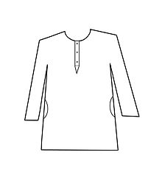LOWER PRICE

|  |  |  |  |  |  |  |  |  |
| --- | --- | --- | --- | --- | --- | --- | --- | --- |
| S. No. | Class.  No. | Category | Gender | Prdt. | Style | Website | Brand | Price |
|
| 111 | 2.2.46 | Kids | Female | Kurta | Straight Kurta | Amazon | Ftcbazaar | 599 |
| 112 | 2.2.46 | Kids | Female | Kurta | Straight Kurta | Flipkart | AJ Dezines | 799 |
| 113 | 2.2.46 | Kids | Female | Kurta | Straight Kurta | Flipkart | Aarthi | 1099 |
| 114 | 2.2.46 | Kids | Female | Kurta | Straight Kurta | Snapdeal | Shree Shubam | 999 |
| 115 | 2.2.46 | Kids | Female | Kurta | Straight Kurta | Jabong | Arshia | 1099 |

AVERAGE PRICE

|  |  |  |  |  |  |  |  |  |
| --- | --- | --- | --- | --- | --- | --- | --- | --- |
| S. No. | Class.  No. | Category | Gender | Prdt. | Style | Website | Brand | Price |
|
| 116 | 2.2.46 | Kids | Female | Kurta | Straight Kurta | Myntra | AJ Dezines | 1499 |
| 117 | 2.2.46 | Kids | Female | Kurta | Straight Kurta | Myntra | K&U | 1259 |
| 118 | 2.2.46 | Kids | Female | Kurta | Straight Kurta | Jabong | Usha Designs | 1299 |
| 119 | 2.2.46 | Kids | Female | Kurta | Straight Kurta | Snapdeal | Jeethnics | 1299 |
| 120 | 2.2.46 | Kids | Female | Kurta | Straight Kurta | Snapdeal | Maya | 1500 |

**LEHENGA CHOLI**

|  |  |  |  |  |  |  |  |  |
| --- | --- | --- | --- | --- | --- | --- | --- | --- |
| S. No. | Class.  No. | Category | Gender | Prdt. | Style | Website | Brand | Price |
|
| 121 | 2.1.49 | Kids | Female | Ethnic wear | Lehenga Choli | Snapdeal | SR Creations | 399 |
| 122 | 2.1.49 | Kids | Female | Ethnic wear | Lehenga Choli | Flipkart | Home Shop | 415 |
| 123 | 2.1.49 | Kids | Female | Ethnic wear | Lehenga Choli | Amazon | Ashirvad | 450 |
| 124 | 2.1.49 | Kids | Female | Ethnic wear | Lehenga Choli | Jabong | Kilkari | 640 |
| 125 | 2.1.49 | Kids | Female | Ethnic wear | Lehenga Choli | Myntra | Trisha | 649 |

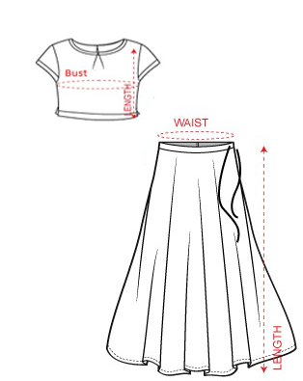LOWER PRICE

AVERAGE PRICE

|  |  |  |  |  |  |  |  |  |
| --- | --- | --- | --- | --- | --- | --- | --- | --- |
| S. No. | Class.  No. | Category | Gender | Prdt. | Style | Website | Brand | Price |
|
| 126 | 2.1.49 | Kids | Female | Ethnic wear | Lehenga Choli | Myntra | Aarika | 1199 |
| 127 | 2.1.49 | Kids | Female | Ethnic wear | Lehenga Choli | Myntra | Kanakdora | 1599 |
| 128 | 2.1.49 | Kids | Female | Ethnic wear | Lehenga Choli | Jabong | Biba | 1799 |
| 129 | 2.1.49 | Kids | Female | Ethnic wear | Lehenga Choli | Snapdeal | PS Peaches | 1999 |
| 130 | 2.1.49 | Kids | Female | Ethnic wear | Lehenga Choli | Snapdeal | Kay | 1399 |

**MENS**

**CASUAL SHIRT**

LOWER PRICE

|  |  |  |  |  |  |  |  |  |
| --- | --- | --- | --- | --- | --- | --- | --- | --- |
| S. No. | Class.  No. | Category | Gender | Prdt. | Style | Website | Brand | Price |
|
| 1 | 3.1.1 | Adult | Male | Shirt | Casual shirt | Amazon | ZAKOD | 199 |
| 2 | 3.1.1 | Adult | Male | Shirt | Casual shirt | Flipkart | Oshano | 208 |
| 3 | 3.1.1 | Adult | Male | Shirt | Casual shirt | Aamazon | Eprilla | 245 |
| 4 | 3.1.1 | Adult | Male | Shirt | Casual shirt | Flipkart | US Adventure | 249 |
| 5 | 3.1.1 | Adult | Male | Shirt | Casual shirt | Amazon | Millennium | 249 |

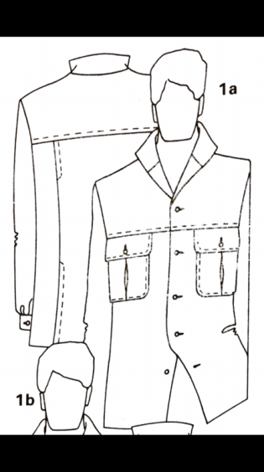

|  |  |  |  |  |  |  |  |  |
| --- | --- | --- | --- | --- | --- | --- | --- | --- |
| S. No. | Class.  No. | Category | Gender | Prdt. | Style | Website | Brand | Price |
| 6 | 3.1.1 | Adult | Male | Shirt | Casual shirt | Jabong | Venfield | 1499 |
| 7 | 3.1.1 | Adult | Male | Shirt | Casual shirt | Myntra | John Player | 1199 |
| 8 | 3.1.1 | Adult | Male | Shirt | Casual shirt | Snapdeal | Wrangler | 1399 |
| 9 | 3.1.1 | Adult | Male | Shirt | Casual shirt | Flipkart | Derby | 1499 |
| 10 | 3.1.1 | Adult | Male | Shirt | Casual shirt | Flipkart | Peter England | 1199 |

AVERAGE PRICE

**BASIC WORK SHIRT**

LOWER PRICE

|  |  |  |  |  |  |  |  |  |
| --- | --- | --- | --- | --- | --- | --- | --- | --- |
| S. No. | Class.  No. | Category | Gender | Prdt. | Style | Website | Brand | Price |
|
| 11 | 3.1.3 | Adult | Male | Shirt | Basic work shirt | Aamzon | LEAF | 299 |
| 12 | 3.1.3 | Adult | Male | Shirt | Basic work shirt | Jabong | IVOC | 349 |
| 13 | 3.1.3 | Adult | Male | Shirt | Basic work shirt | Jabong | Hancock | 396 |
| 14 | 3.1.3 | Adult | Male | Shirt | Basic work shirt | Jabong | Urban Nomad | 399 |
| 15 | 3.1.3 | Adult | Male | Shirt | Basic work shirt | Amazon | Big Tree | 399 |

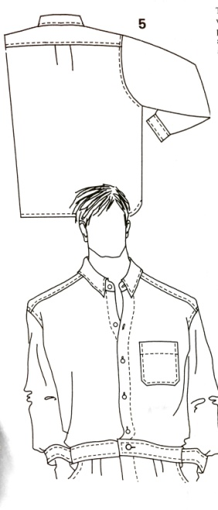

|  |  |  |  |  |  |  |  |  |
| --- | --- | --- | --- | --- | --- | --- | --- | --- |
| S. No. | Class.  No. | Category | Gender | Prdt. | Style | Website | Brand | Price |
|
| 16 | 3.1.3 | Adult | Male | Shirt | Basic work shirt | Amazon | Basics | 1199 |
| 17 | 3.1.3 | Adult | Male | Shirt | Basic work shirt | Flipkart | Jack & Jones | 1299 |
| 18 | 3.1.3 | Adult | Male | Shirt | Basic work shirt | Jabong | Wrangler | 999 |
| 19 | 3.1.3 | Adult | Male | Shirt | Basic work shirt | Jabong | Black Berry | 1195 |
| 20 | 3.1.3 | Adult | Male | Shirt | Basic work shirt | Amazon | Arrow | 1259 |

AVERAGE PRICE

**FITTED JACKET**

LOWER PRICE

|  |  |  |  |  |  |  |  |  |
| --- | --- | --- | --- | --- | --- | --- | --- | --- |
| S. No. | Class.  No. | Category | Gender | Prdt. | Style | Website | Brand | Price |
|
| 21 | 3.1.4 | Adult | Male | Jacket | Fitted Jacket | Snapdeal | Domyos | 799 |
| 22 | 3.1.4 | Adult | Male | Jacket | Fitted Jacket | Abof | Abof | 798 |
| 23 | 3.1.4 | Adult | Male | Jacket | Fitted Jacket | Abof | Abof | 998 |
| 24 | 3.1.4 | Adult | Male | Jacket | Fitted Jacket | Abof | Campus Sutra | 1000 |
| 25 | 3.1.4 | Adult | Male | Jacket | Fitted Jacket | Amazon | Saint Men | 1120 |

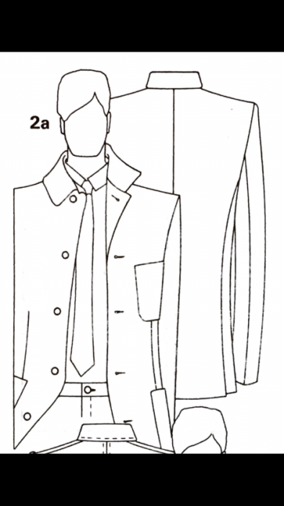

AVERAGE PRICE

|  |  |  |  |  |  |  |  |  |
| --- | --- | --- | --- | --- | --- | --- | --- | --- |
| S. No. | Class.  No. | Category | Gender | Prdt. | Style | Website | Brand | Price |
|
| 26 | 3.1.4 | Adult | Male | Jacket | Fitted Jacket | Abof | Abof | 1498 |
| 27 | 3.1.4 | Adult | Male | Jacket | Fitted Jacket | Abof | Wrangler | 1599 |
| 28 | 3.1.4 | Adult | Male | Jacket | Fitted Jacket | Myntra | Peter England | 1620 |
| 29 | 3.1.4 | Adult | Male | Jacket | Fitted Jacket | Flipkart | Jack & Jones | 1349 |
| 30 | 3.1.4 | Adult | Male | Jacket | Fitted Jacket | Amazon | Jack & Jones | 1599 |

**JEAN JACKET**

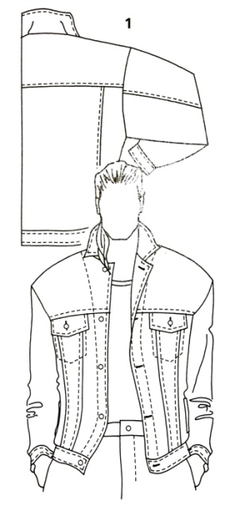

LOWER PRICE

|  |  |  |  |  |  |  |  |  |
| --- | --- | --- | --- | --- | --- | --- | --- | --- |
| S. No. | Class.  No. | Category | Gender | Prdt. | Style | Website | Brand | Price |
|
| 31 | 3.1.7 | Adult | Male | Jacket | Jean Jacket | Amazon | Yepme | 599 |
| 32 | 3.1.7 | Adult | Male | Jacket | Jean Jacket | Amazon | Fugazee | 699 |
| 33 | 3.1.7 | Adult | Male | Jacket | Jean Jacket | Snapdeal | Yepme | 759 |
| 34 | 3.1.7 | Adult | Male | Jacket | Jean Jacket | Snapdeal | Theme | 989 |
| 35 | 3.1.7 | Adult | Male | Jacket | Jean Jacket | Snapdeal | Rigo | 999 |

AVERAGE PRICE

|  |  |  |  |  |  |  |  |  |
| --- | --- | --- | --- | --- | --- | --- | --- | --- |
| S. No. | Class.  No. | Category | Gender | Prdt. | Style | Website | Brand | Price |
|
| 36 | 3.1.7 | Adult | Male | Jacket | Jean Jacket | Amazon | Jack & Jones | 1749 |
| 37 | 3.1.7 | Adult | Male | Jacket | Jean Jacket | Amazon | Pepe Jeans | 1710 |
| 38 | 3.1.7 | Adult | Male | Jacket | Jean Jacket | Flipkart | Pepe Jeans | 1800 |
| 39 | 3.1.7 | Adult | Male | Jacket | Jean Jacket | Snapdeal | John Player | 1500 |
| 40 | 3.1.7 | Adult | Male | Jacket | Jean Jacket | Snapdeal | Venfield | 1500 |

**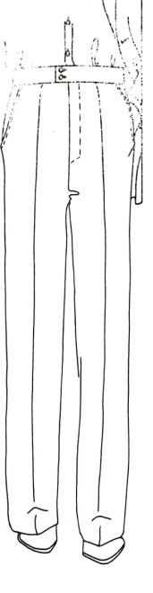BASIC TROUSER**

LOWER PRICE

|  |  |  |  |  |  |  |  |  |
| --- | --- | --- | --- | --- | --- | --- | --- | --- |
| S. No | Class.  No. | Category | Gender | Prdt. | Style | Website | Brand | Price |
|
| 41 | 3.1.12 | Adult | Male | Trouser | Basic Trouser | Jabong | BUKKL | 395 |
| 42 | 3.1.12 | Adult | Male | Trouser | Basic Trouser | Flipkart | American-Elm | 489 |
| 43 | 3.1.12 | Adult | Male | Trouser | Basic Trouser | Jabong | Canary London | 450 |
| 44 | 3.1.12 | Adult | Male | Trouser | Basic Trouser | Jabong | Duke | 497 |
| 45 | 3.1.12 | Adult | Male | Trouser | Basic Trouser | Snapdeal | American-Elm | 491 |

AVERAGE PRICE

|  |  |  |  |  |  |  |  |  |
| --- | --- | --- | --- | --- | --- | --- | --- | --- |
| S. No. | Class.  No. | Category | Gender | Prdt. | Style | Website | Brand | Price |
|
| 46 | 3.1.12 | Adult | Male | Trouser | Basic Trouser | Amazon | Urban Touch | 1305 |
| 47 | 3.1.12 | Adult | Male | Trouser | Basic Trouser | Flipkart | Basics | 1119 |
| 48 | 3.1.12 | Adult | Male | Trouser | Basic Trouser | Snapdeal | Basics | 1259 |
| 49 | 3.1.12 | Adult | Male | Trouser | Basic Trouser | Myntra | Basics | 1499 |
| 50 | 3.1.12 | Adult | Male | Trouser | Basic Trouser | Jabong | Indian Terrain | 1550 |

**PLEATED TROUSER**

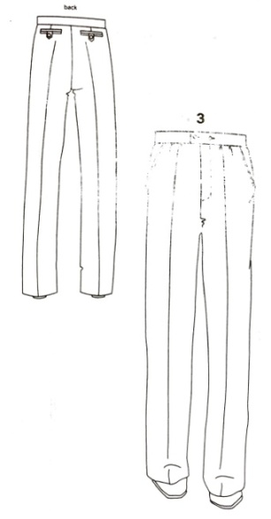LOWER PRICE

|  |  |  |  |  |  |  |  |  |
| --- | --- | --- | --- | --- | --- | --- | --- | --- |
| S. No. | Class.  No. | Category | Gender | Prdt. | Style | Website | Brand | Price |
|
| 51 | 3.1.14 | Adult | Male | Trouser | Pleated Trouser | Snapdeal | Tarkshyam | 499 |
| 52 | 3.1.14 | Adult | Male | Trouser | Pleated Trouser | Snapdeal | Matalino | 499 |
| 53 | 3.1.14 | Adult | Male | Trouser | Pleated Trouser | Snapdeal | Rich Perk | 503 |
| 54 | 3.1.14 | Adult | Male | Trouser | Pleated Trouser | Amazon | Canary | 543 |
| 55 | 3.1.14 | Adult | Male | Trouser | Pleated Trouser | Flipkart | Hartmann | 654 |

AVERAGE PRICE

|  |  |  |  |  |  |  |  |  |
| --- | --- | --- | --- | --- | --- | --- | --- | --- |
| S. No. | Class.  No. | Category | Gender | Prdt. | Style | Website | Brand | Price |
|
| 56 | 3.1.14 | Adult | Male | Trouser | Pleated Trouser | Amazon | Derby | 1039 |
| 57 | 3.1.14 | Adult | Male | Trouser | Pleated Trouser | Snapdeal | Mufti | 1200 |
| 58 | 3.1.14 | Adult | Male | Trouser | Pleated Trouser | Snapdeal | Wrangler | 1429 |
| 59 | 3.1.14 | Adult | Male | Trouser | Pleated Trouser | Myntra | Basics | 1599 |
| 60 | 3.1.14 | Adult | Male | Trouser | Pleated Trouser | Myntra | Jack & Jones | 1429 |

**JEANS**

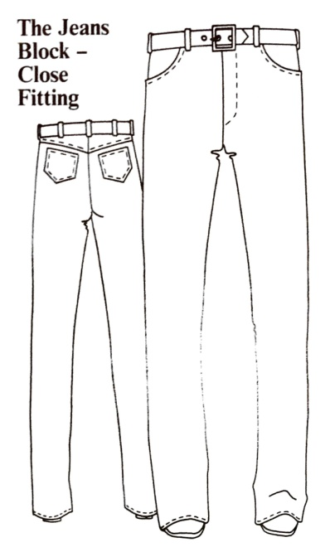LOWER PRICE

AVERAGE PRICE

|  |  |  |  |  |  |  |  |  |
| --- | --- | --- | --- | --- | --- | --- | --- | --- |
| S. No. | Class.  No. | Category | Gender | Prdt. | Style | Website | Brand | Price |
|
| 61 | 3.1.16 | Adult | Male | Trouser | Jeans | Amazon | Urban District | 297 |
| 62 | 3.1.16 | Adult | Male | Trouser | Jeans | Snapdeal | Gandsta | 345 |
| 63 | 3.1.16 | Adult | Male | Trouser | Jeans | Snapdeal | Urbano | 385 |
| 64 | 3.1.16 | Adult | Male | Trouser | Jeans | Amazon | Maxxone | 389 |
| 65 | 3.1.16 | Adult | Male | Trouser | Jeans | Flipkart | UK Blues | 398 |

|  |  |  |  |  |  |  |  |  |
| --- | --- | --- | --- | --- | --- | --- | --- | --- |
| S. No. | Class.  No. | Category | Gender | Prdt. | Style | Website | Brand | Price |
|
| 66 | 3.1.16 | Adult | Male | Trouser | Jeans | Amazon | Derby | 959 |
| 67 | 3.1.16 | Adult | Male | Trouser | Jeans | Snapdeal | Urban Touch | 1200 |
| 68 | 3.1.16 | Adult | Male | Trouser | Jeans | Flipkart | Black Berry | 1999 |
| 69 | 3.1.16 | Adult | Male | Trouser | Jeans | Myntra | Basics | 1200 |
| 70 | 3.1.16 | Adult | Male | Trouser | Jeans | Jabong | Jack & Jones | 1599 |

**DOUBLE BREASTED SUIT**

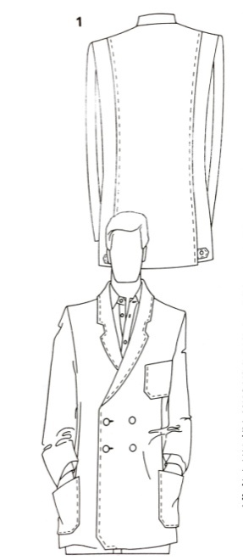LOWER PRICE

|  |  |  |  |  |  |  |  |  |
| --- | --- | --- | --- | --- | --- | --- | --- | --- |
| S. No. | Class.  No. | Category | Gender | Prdt. | Style | Website | Brand | Price |
|
| 71 | 3.1.24 | Adult | Male | Jacket | Double Breasted Suit | Myntra | Mast & Harbour | 1499 |
| 72 | 3.1.24 | Adult | Male | Jacket | Double Breasted Suit | Flipkart | Mast & Harbour | 1649 |
| 73 | 3.1.24 | Adult | Male | Jacket | Double Breasted Suit | Snapdeal | Lee Marc | 1695 |
| 74 | 3.1.24 | Adult | Male | Jacket | Double Breasted Suit | Snapdeal | La Mode | 1813 |
| 75 | 3.1.24 | Adult | Male | Jacket | Double Breasted Suit | Flipkart | Mast & Harbour | 1924 |

AVERAGE PRICE

|  |  |  |  |  |  |  |  |  |
| --- | --- | --- | --- | --- | --- | --- | --- | --- |
| S. No. | Class.  No. | Category | Gender | Prdt. | Style | Website | Brand | Price |
|
| 75 | 3.1.24 | Adult | Male | Jacket | Double Breasted Suit | Flipkart | Mast & Harbour | 3499 |
| 76 | 3.1.24 | Adult | Male | Jacket | Double Breasted Suit | Myntra | Mast & Harbour | 2800 |
| 77 | 3.1.24 | Adult | Male | Jacket | Double Breasted Suit | Amazon | Peter England | 3399 |
| 78 | 3.1.24 | Adult | Male | Jacket | Double Breasted Suit | Flipkart | Azio | 2999 |
| 79 | 3.1.24 | Adult | Male | Jacket | Double Breasted Suit | Snapdeal | Jack & Jones | 3499 |
| 80 | 3.1.24 | Adult | Male | Jacket | Double Breasted Suit | Snapdeal | Mufti | 4999 |

**STRAIGHT KURTA**

LOWER PRICE

|  |  |  |  |  |  |  |  |  |  |
| --- | --- | --- | --- | --- | --- | --- | --- | --- | --- |
| S. No. | Class.  No. | Category | Gender | Prdt. | Style | Website | Brand | Price |  |
|  |
| 81 | 3.1.30 | Adult | Male | Kurta | Straight Kurta | Flipkart | Human steps | 275 |
| 82 | 3.1.30 | Adult | Male | Kurta | Straight Kurta | Flipkart | Yepme | 284 |
| 83 | 3.1.30 | Adult | Male | Kurta | Straight Kurta | Amazon | Janish | 299 |
| 84 | 3.1.30 | Adult | Male | Kurta | Straight Kurta | Snapdeal | Yepme | 319 |
| 85 | 3.1.30 | Adult | Male | Kurta | Straight Kurta | Snapdeal | Sahana | 369 |

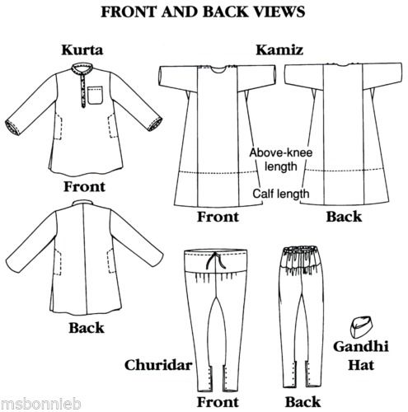

AVERAGE PRICE

|  |  |  |  |  |  |  |  |  |
| --- | --- | --- | --- | --- | --- | --- | --- | --- |
| S. No. | Class.  No. | Category | Gender | Prdt. | Style | Website | Brand | Price |
|
| 86 | 3.1.30 | Adult | Male | Kurta | Straight Kurta | Amazon | Irin | 1449 |
| 87 | 3.1.30 | Adult | Male | Kurta | Straight Kurta | Flipkart | Svanik | 1099 |
| 88 | 3.1.30 | Adult | Male | Kurta | Straight Kurta | Snapdeal | JBN | 1335 |
| 89 | 3.1.30 | Adult | Male | Kurta | Straight Kurta | Myntra | Mufti | 1079 |
| 90 | 3.1.30 | Adult | Male | Kurta | Straight Kurta | Jabong | Black Berry | 1398 |

**SHERWANI**

LOWER PRICE

|  |  |  |  |  |  |  |  |  |
| --- | --- | --- | --- | --- | --- | --- | --- | --- |
| S. No. | Class.  No. | Category | Gender | Prdt. | Style | Website | Brand | Price |
|
| 91 | 3.1.31 | Adult | Male | Sherwani | Sherwani | Amazon | Royal Men | 599 |
| 92 | 3.1.31 | Adult | Male | Sherwani | Sherwani | Amazon | Royal Men | 799 |
| 93 | 3.1.3 | Adult | Male | Sherwani | Sherwani | Flipkart | Young Fashion | 1800 |
| 94 | 3.1.31 | Adult | Male | Sherwani | Sherwani | Snapdeal | Vastramay | 1335 |
| 95 | 3.1.31 | Adult | Male | Sherwani | Sherwani | Flipkart | Khaan Saab | 1398 |

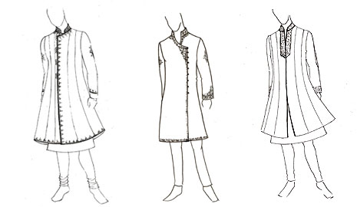

AVERAGE PRICE

|  |  |  |  |  |  |  |  |  |
| --- | --- | --- | --- | --- | --- | --- | --- | --- |
| S. No. | Class.  No. | Category | Gender | Prdt. | Style | Website | Brand | Price |
|
| 96 | 3.1.31 | Adult | Male | Sherwani | Sherwani | Flipkart | Royal | 2500 |
| 97 | 3.1.31 | Adult | Male | Sherwani | Sherwani | Amazon | Kandy | 2349 |
| 98 | 3.1.31 | Adult | Male | Sherwani | Sherwani | Jabong | Mufti | 2999 |
| 99 | 3.1.31 | Adult | Male | Sherwani | Sherwani | Myntra | RJ Designers | 2999 |
| 100 | 3.1.31 | Adult | Male | Sherwani | Sherwani | Jabong | NYN | 2599 |

**WOMENS**

**BASIC SHIRT**

LOWER PRICE

**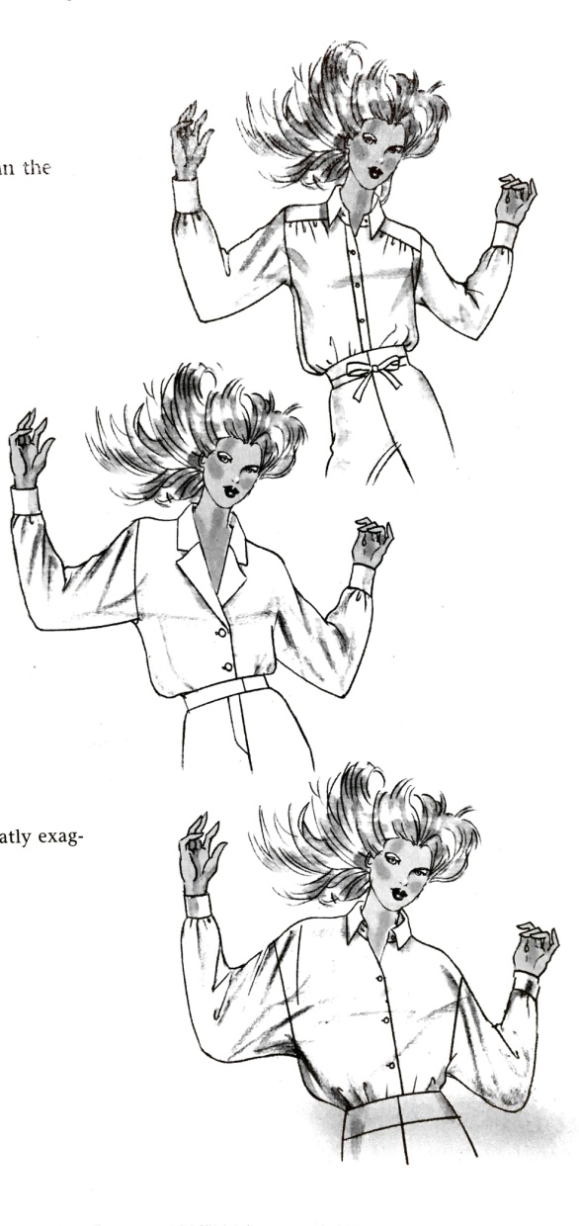**

|  |  |  |  |  |  |  |  |  |
| --- | --- | --- | --- | --- | --- | --- | --- | --- |
| S. No. | Class.  No. | Category | Gender | Prdt. | Style | Website | Brand | Price |
|
| 1 | 3.2.2 | Adult | Female | Top | Basic shirt | Snapdeal | Nemis | 269 |
| 2 | 3.2.2 | Adult | Female | Top | Basic shirt | Snapdeal | Gudi | 290 |
| 3 | 3.2.2 | Adult | Female | Top | Basic shirt | Snapdeal | Hashtag | 291 |
| 4 | 3.2.2 | Adult | Female | Top | Basic shirt | Snapdeal | Alfa | 298 |
| 5 | 3.2.2 | Adult | Female | Top | Basic shirt | Snapdeal | Stilestreet | 299 |

AVERAGE PRICE

|  |  |  |  |  |  |  |  |  |
| --- | --- | --- | --- | --- | --- | --- | --- | --- |
| S. No. | Class.  No. | Category | Gender | Prdt. | Style | Website | Brand | Price |
|
| 6 | 3.2.2 | Adult | Female | Top | Basic shirt | Snapdeal | Vero Moda | 1019 |
| 7 | 3.2.2 | Adult | Female | Top | Basic shirt | Snapdeal | UCB | 1312 |
| 8 | 3.2.2 | Adult | Female | Top | Basic shirt | Myntra | Roadster | 1199 |
| 9 | 3.2.2 | Adult | Female | Top | Basic shirt | Jabong | Park Avenue | 1199 |
| 10 | 3.2.2 | Adult | Female | Top | Basic shirt | Jabong | Tokyo Talkies | 1259 |

**PEASANT BLOUSE**

LOWER PRICE

|  |  |  |  |  |  |  |  |  |
| --- | --- | --- | --- | --- | --- | --- | --- | --- |
| S. No. | Class.  No. | Category | Gender | Prdt. | Style | Website | Brand | Price |
|
| 11 | 3.2.5 | Adult | Female | Top | Peasant Blouse | Flipkart | Kalava | 279 |
| 12 | 3.2.5 | Adult | Female | Top | Peasant Blouse | Flipkart | Goodwill | 284 |
| 13 | 3.2.5 | Adult | Female | Top | Peasant Blouse | Flipkart | Merch21 | 284 |
| 14 | 3.2.5 | Adult | Female | Top | Peasant Blouse | Jabong | G&M | 288 |
| 15 | 3.2.5 | Adult | Female | Top | Peasant Blouse | Flipkart | Prime | 359 |

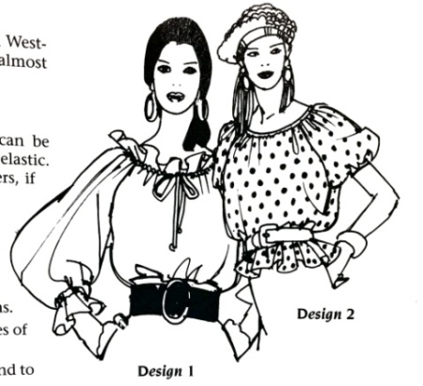

AVERAGE PRICE

|  |  |  |  |  |  |  |  |  |
| --- | --- | --- | --- | --- | --- | --- | --- | --- |
| S. No | Class.  No. | Category | Gender | Prdt. | Style | Website | Brand | Price |
|
| 16 | 3.2.5 | Adult | Female | Top | Peasant Blouse | Jabong | Faballey | 770 |
| 17 | 3.2.5 | Adult | Female | Top | Peasant Blouse | Myntra | DressBerry | 659 |
| 18 | 3.2.5 | Adult | Female | Top | Peasant Blouse | Myntra | All About You | 1099 |
| 19 | 3.2.5 | Adult | Female | Top | Peasant Blouse | Snapdeal | Pink Pret | 899 |
| 20 | 3.2.5 | Adult | Female | Top | Peasant Blouse | Flipkart | Vero Moda | 1108 |

**CLASSIC TAILORED TROUSER**

LOWER PRICE

|  |  |  |  |  |  |  |  |  |
| --- | --- | --- | --- | --- | --- | --- | --- | --- |
| S. No. | Class.  No. | Category | Gender | Prdt. | Style | Website | Brand | Price |
|
| 21 | 3.2.13 | Adult | Female | Trouser | Classic Tailored Trouser | Snapdeal | Cashewnut | 331 |
| 22 | 3.2.13 | Adult | Female | Trouser | Classic Tailored Trouser | Snapdeal | Hashtag | 337 |
| 23 | 3.2.13 | Adult | Female | Trouser | Classic Tailored Trouser | Abof | Atayant | 345 |
| 24 | 3.2.13 | Adult | Female | Trouser | Classic Tailored Trouser | Flipkart | Faballey | 400 |
| 25 | 3.2.13 | Adult | Female | Trouser | Classic Tailored Trouser | Jabong | AK Fashion | 400 |

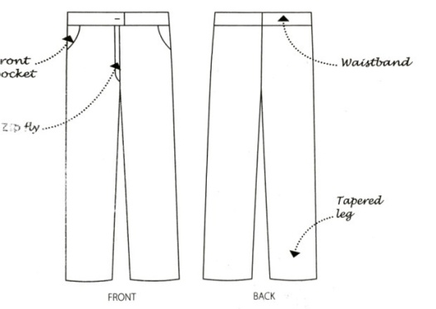

AVERAGE PRICE

|  |  |  |  |  |  |  |  |  |
| --- | --- | --- | --- | --- | --- | --- | --- | --- |
| S. No. | Class.  No. | Category | Gender | Prdt. | Style | Website | Brand | Price |
|
| 26 | 3.2.13 | Adult | Female | Trouser | Classic Tailored Trouser | Snapdeal | Park Avenue | 1250 |
| 27 | 3.2.13 | Adult | Female | Trouser | Classic Tailored Trouser | Snapdeal | Vero Moda | 1396 |
| 28 | 3.2.13 | Adult | Female | Trouser | Classic Tailored Trouser | Snapdeal | Pepe Jeans | 1599 |
| 29 | 3.2.13 | Adult | Female | Trouser | Classic Tailored Trouser | Jabong | Tom Tailor | 1650 |
| 30 | 3.2.13 | Adult | Female | Trouser | Classic Tailored Trouser | Snapdeal | Next | 1500 |

**CLASSIC PALAZZO**

LOWER PRICE

|  |  |  |  |  |  |  |  |  |
| --- | --- | --- | --- | --- | --- | --- | --- | --- |
| S. No. | Class.  No. | Category | Gender | Prdt. | Style | Website | Brand | Price |
|
| 31 | 3.2.15 | Adult | Female | Trouser | Classic Palazzo | Amazon | PI World | 199 |
| 32 | 3.2.15 | Adult | Female | Trouser | Classic Palazzo | Flipkart | Fashion Guru | 199 |
| 33 | 3.2.15 | Adult | Female | Trouser | Classic Palazzo | Snapdeal | Mojo | 249 |
| 34 | 3.2.15 | Adult | Female | Trouser | Classic Palazzo | Amazon | Janish | 249 |
| 35 | 3.2.15 | Adult | Female | Trouser | Classic Palazzo | Snapdeal | Me & Fashion | 260 |

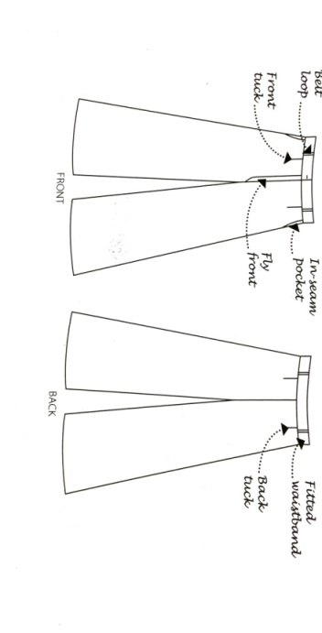

AVERAGE PRICE

|  |  |  |  |  |  |  |  |  |
| --- | --- | --- | --- | --- | --- | --- | --- | --- |
| S. No. | Class.  No. | Category | Gender | Prdt. | Style | Website | Brand | Price |
|
| 36 | 3.2.15 | Adult | Female | Trouser | Classic Palazzo | Abof | Rangmanch | 899 |
| 37 | 3.2.15 | Adult | Female | Trouser | Classic Palazzo | Abof | Aurelia | 599 |
| 38 | 3.2.15 | Adult | Female | Trouser | Classic Palazzo | Jabong | Sassafras | 839 |
| 39 | 3.2.15 | Adult | Female | Trouser | Classic Palazzo | Snapdeal | Global Desi | 850 |
| 40 | 3.2.15 | Adult | Female | Trouser | Classic Palazzo | Flipkart | Jaipur Kurti | 589 |

**JEANS WITH V YOKE**

LOWER PRICE

|  |  |  |  |  |  |  |  |  |
| --- | --- | --- | --- | --- | --- | --- | --- | --- |
| S. No. | Class.  No. | Category | Gender | Prdt. | Style | Website | Brand | Price |
|
| 41 | 3.2.26 | Adult | Female | Trouser | Jeans with V-yoke | Jabong | Timbre | 332 |
| 42 | 3.2.26 | Adult | Female | Trouser | Jeans with V-yoke | Flipkart | Flyjohn | 594 |
| 43 | 3.2.26 | Adult | Female | Trouser | Jeans with V-yoke | Jabong | Lyriks | 596 |
| 44 | 3.2.26 | Adult | Female | Trouser | Jeans with V-yoke | Jabong | American-Elm | 599 |
| 45 | 3.2.26 | Adult | Female | Trouser | Jeans with V-yoke | Snapdeal | Black Soul | 779 |

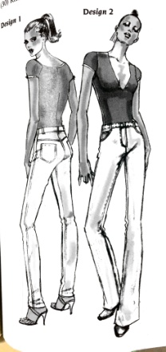

AVERAGE PRICE

|  |  |  |  |  |  |  |  |  |
| --- | --- | --- | --- | --- | --- | --- | --- | --- |
| S. No. | Class.  No. | Category | Gender | Prdt. | Style | Website | Brand | Price |
|
| 46 | 3.2.26 | Adult | Female | Trouser | Jeans with V-yoke | Amazon | Levis | 1305 |
| 47 | 3.2.26 | Adult | Female | Trouser | Jeans with V-yoke | Flipkart | Lee | 1119 |
| 48 | 3.2.26 | Adult | Female | Trouser | Jeans with V-yoke | Snapdeal | Wrangler | 1259 |
| 49 | 3.2.26 | Adult | Female | Trouser | Jeans with V-yoke | Myntra | Pepe Jeans | 1499 |
| 50 | 3.2.26 | Adult | Female | Trouser | Jeans with V-yoke | Jabong | Flying Machine | 1550 |

**DOUBLE BREASTED JACKET**

LOWER PRICE

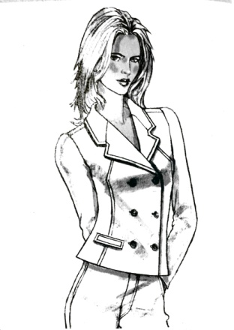

|  |  |  |  |  |  |  |  |  |
| --- | --- | --- | --- | --- | --- | --- | --- | --- |
| S. No. | Class.  No. | Category | Gender | Prdt. | Style | Website | Brand | Price |
|
| 51 | 3.2.38 | Adult | Female | Jacket | Double Breasted Jacket | Flipkart | Kotty | 798 |
| 52 | 3.2.38 | Adult | Female | Jacket | Double Breasted Jacket | Snapdeal | Sassafras | 899 |
| 53 | 3.2.38 | Adult | Female | Jacket | Double Breasted Jacket | Flipkart | Glitzy Girls | 900 |
| 54 | 3.2.38 | Adult | Female | Jacket | Double Breasted Jacket | Amazon | Harpa | 989 |
| 55 | 3.2.38 | Adult | Female | Jacket | Double Breasted Jacket | Flipkart | Tokyo Talkies | 1259 |

|  |  |  |  |  |  |  |  |  |
| --- | --- | --- | --- | --- | --- | --- | --- | --- |
| S. No. | Class.  No. | Category | Gender | Prdt. | Style | Website | Brand | Price |
|
| 56 | 3.2.38 | Adult | Female | Jacket | Double Breasted Jacket | Amazon | Park Avenue | 2279 |
| 57 | 3.2.38 | Adult | Female | Jacket | Double Breasted Jacket | Snapdeal | Cashewnut | 2295 |
| 58 | 3.2.38 | Adult | Female | Jacket | Double Breasted Jacket | Myntra | Vero Moda | 2247 |
| 59 | 3.2.38 | Adult | Female | Jacket | Double Breasted Jacket | Amazon | Annabelle | 2399 |
| 60 | 3.2.38 | Adult | Female | Jacket | Double Breasted Jacket | Abof | Abof | 1397 |

**EMPIRE LINE DRESS**

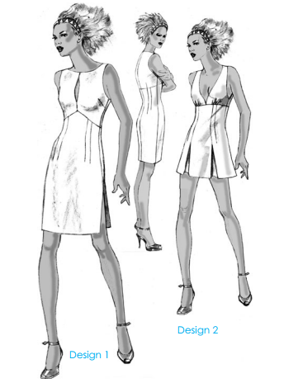LOWER PRICE

|  |  |  |  |  |  |  |  |  |
| --- | --- | --- | --- | --- | --- | --- | --- | --- |
| S. No. | Class.  No. | Category | Gender | Prdt. | Style | Website | Brand | Price |
|
| 61 | 3.2.48 | Adult | Female | Dress | Empire line dress | Flipkart | TeeMoods | 313 |
| 62 | 3.2.48 | Adult | Female | Dress | Empire line dress | Jabong | Rainbow | 329 |
| 63 | 3.2.48 | Adult | Female | Dress | Empire line dress | Flipkart | Crease & Clips | 371 |
| 64 | 3.2.48 | Adult | Female | Dress | Empire line dress | Flipkart | Cottinfab | 379 |
| 65 | 3.2.48 | Adult | Female | Dress | Empire line dress | Amazon | Saarvi | 399 |

AVERAGE PRICE

|  |  |  |  |  |  |  |  |  |
| --- | --- | --- | --- | --- | --- | --- | --- | --- |
| S. No. | Class.  No. | Category | Gender | Prdt. | Style | Website | Brand | Price |
|
| 66 | 3.2.48 | Adult | Female | Dress | Empire line dress | Amazon | Chemistry | 974 |
| 67 | 3.2.48 | Adult | Female | Dress | Empire line dress | Flipkart | Pepe Jeans | 999 |
| 68 | 3.2.48 | Adult | Female | Dress | Empire line dress | Myntra | Sera | 1194 |
| 69 | 3.2.48 | Adult | Female | Dress | Empire line dress | Myntra | Mast&Harbour | 1099 |
| 70 | 3.2.48 | Adult | Female | Dress | Empire line dress | Jabong | Faballey | 1100 |

**A-LINE SKIRT**

|  |  |  |  |  |  |  |  |  |
| --- | --- | --- | --- | --- | --- | --- | --- | --- |
| S. No. | Class.  No. | Category | Gender | Prdt. | Style | Website | Brand | Price |
|
| 71 | 3.2.52 | Adult | Female | Skirt | A-line skirt | Myntra | Drapes | 499 |
| 72 | 3.2.52 | Adult | Female | Skirt | A-line skirt | Flipkart | Mast&Harbour | 500 |
| 73 | 3.2.52 | Adult | Female | Skirt | A-line skirt | Snapdeal | Lee Marc | 523 |
| 74 | 3.2.52 | Adult | Female | Skirt | A-line skirt | Snapdeal | La Mode | 550 |
| 75 | 3.2.52 | Adult | Female | Skirt | A-line skirt | Flipkart | Mast&Harbour | 600 |

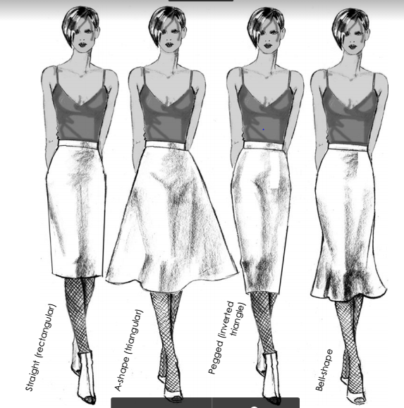LOWER PRICE

|  |  |  |  |  |  |  |  |  |
| --- | --- | --- | --- | --- | --- | --- | --- | --- |
| S. No. | Class.  No. | Category | Gender | Prdt. | Style | Website | Brand | Price |
|
| 76 | 3.2.52 | Adult | Female | Skirt | A-line skirt | Myntra | Mast&Harbour | 1499 |
| 77 | 3.2.52 | Adult | Female | Skirt | A-line skirt | Amazon | Peter England | 1649 |
| 78 | 3.2.52 | Adult | Female | Skirt | A-line skirt | Flipkart | Azio | 1695 |
| 79 | 3.2.52 | Adult | Female | Skirt | A-line skirt | Snapdeal | Jack & Jones | 1813 |
| 80 | 3.2.52 | Adult | Female | Skirt | A-line skirt | Snapdeal | Mufti | 1924 |

AVERAGE PRICE

**STRAIGHT KURTA**

LOWER PRICE

|  |  |  |  |  |  |  |  |  |
| --- | --- | --- | --- | --- | --- | --- | --- | --- |
| S. No. | Class.  No. | Category | Gender | Prdt. | Style | Website | Brand | Price |
|
| 81 | 3.2.68 | Adult | Female | Kurta | Straight Kurta | Flipkart | Drapes | 239 |
| 82 | 3.2.68 | Adult | Female | Kurta | Straight Kurta | Flipkart | Azia | 239 |
| 83 | 3.2.68 | Adult | Female | Kurta | Straight Kurta | Amazon | Tystha | 245 |
| 84 | 3.2.68 | Adult | Female | Kurta | Straight Kurta | Myntra | Melange | 319 |
| 85 | 3.2.68 | Adult | Female | Kurta | Straight Kurta | Snapdeal | Biba | 349 |



AVERAGE PRICE

|  |  |  |  |  |  |  |  |  |
| --- | --- | --- | --- | --- | --- | --- | --- | --- |
| S. No. | Class.  No. | Category | Gender | Prdt. | Style | Website | Brand | Price |
|
| 86 | 3.2.68 | Adult | Female | Kurta | Straight Kurta | Amazon | Akkriti | 1099 |
| 87 | 3.2.68 | Adult | Female | Kurta | Straight Kurta | Myntra | W | 1529 |
| 88 | 3.2.68 | Adult | Female | Kurta | Straight Kurta | Snapdeal | Biba | 1299 |
| 89 | 3.2.68 | Adult | Female | Kurta | Straight Kurta | Myntra | Rangmanch | 999 |
| 90 | 3.2.68 | Adult | Female | Kurta | Straight Kurta | Jabong | Sangria | 1099 |

**SALWAR SUIT**

|  |  |  |  |  |  |  |  |  |
| --- | --- | --- | --- | --- | --- | --- | --- | --- |
| S. No. | Class.  No. | Category | Gender | Prdt. | Style | Website | Brand | Price |
|
| 1 | 3.2.73 | Adult | Female | Ethnic wear | Salwar Suit | Amazon | Araham | 599 |
| 92 | 3.2.73 | Adult | Female | Ethnic wear | Salwar Suit | Amazon | Vishmbhar | 615 |
| 93 | 3.2.73 | Adult | Female | Ethnic wear | Salwar Suit | Flipkart | Young Fashion | 650 |
| 94 | 3.2.73 | Adult | Female | Ethnic wear | Salwar Suit | Snapdeal | Salwaar studio | 655 |
| 95 | 3.2.73 | Adult | Female | Ethnic wear | Salwar Suit | Flipkart | Vaamsi | 665 |

LOWER PRICE

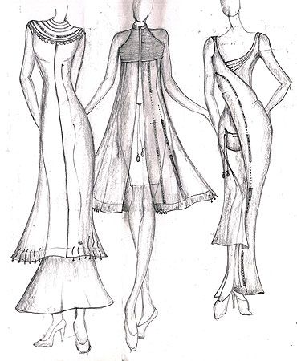

AVERAGE PRICE

|  |  |  |  |  |  |  |  |  |
| --- | --- | --- | --- | --- | --- | --- | --- | --- |
| S. No. | Class.  No. | Category | Gender | Prdt. | Style | Website | Brand | Price |
|
| 96 | 3.2.73 | Adult | Female | Ethnic wear | Salwar Suit | Flipkart | Biba | 2500 |
| 97 | 3.2.73 | Adult | Female | Ethnic wear | Salwar Suit | Amazon | Global Desi | 2799 |
| 98 | 3.2.73 | Adult | Female | Ethnic wear | Salwar Suit | Jabong | Aurelia | 2299 |
| 99 | 3.2.73 | Adult | Female | Ethnic wear | Salwar Suit | Myntra | W | 2999 |
| 100 | 3.2.73 | Adult | Female | Ethnic wear | Salwar Suit | Jabong | Rangmanch | 2599 |

1. **ANALYSIS OF PRICING OF INFANT BOYS GARMENTS**

|  |  |  |  |  |  |  |  |  |  |  |  |  |  |  |  |  |  |
| --- | --- | --- | --- | --- | --- | --- | --- | --- | --- | --- | --- | --- | --- | --- | --- | --- | --- |
| S. No. | Class. No. | Category | Gender | Product | Style | Website | Brand | Blend | Price Range | Price in INR | Dis. Price  in INR | Dis. % | X - Available Sizes | | | | |
| 0-3  M | 3-6 M | 6-12 M | 12-18 M | 18-24 M |
| 1 | 1.1.2 | Infant | Male | Trouser | Dungaree Trouser | Amazon | Ahhaa | C | LP | 899 | 449 | 50 | X | X |  | X | X |
| 2 | 1.1.2 | Infant | Male | Trouser | Dungaree Trouser | Amazon | Tales & Stories | C | LP | 999 | 449 | 55 |  | X | X | X | X |
| 3 | 1.1.2 | Infant | Male | Trouser | Dungaree Trouser | First Cry | Johny Johny | C | LP | 799 | 449 | 44 | X | X | X |  | X |
| 4 | 1.1.2 | Infant | Male | Trouser | Dungaree Trouser | Snapdeal | Kothari | C-P | LP | 999 | 499 | 50 |  | X | X | X | X |
| 5 | 1.1.2 | Infant | Male | Trouser | Dungaree Trouser | Flipkart | Babee2 | C-P | LP | 999 | 499 | 50 | X |  | X | X |  |
| 6 | 1.1.2 | Infant | Male | Trouser | Dungaree Trouser | Myntra | My Little Lamp | C-P | AP | 1999 | 690 | 65 | X | X | X | X | X |
| 7 | 1.1.2 | Infant | Male | Trouser | Dungaree Trouser | Amazon | Kuchipoo | C | AP | 799 | 699 | 13 | X | X | X | X |  |
| 8 | 1.1.2 | Infant | Male | Trouser | Dungaree Trouser | Snapdeal | Peridot | C | AP | 699 | 699 | 0 | X | X | X | X | X |
| 9 | 1.1.2 | Infant | Male | Trouser | Dungaree Trouser | Flipkart | Tony Boy | C | AP | 750 | 750 | 0 |  |  | X | X | X |
| 10 | 1.1.2 | Infant | Male | Trouser | Dungaree Trouser | First Cry | Gini & Jony | C | AP | 1999 | 750 | 62 | X | X | X |  |  |
| 11 | 1.1.3 | Infant | Male | Trouser | Trouser-extra fullness | Flipkart | Prejon | C | LP | 599 | 349 | 42 | X | X | X | X |  |
| 12 | 1.1.3 | Infant | Male | Trouser | Trouser-extra fullness | First Cry | Camey | C-P | LP | 599 | 349 | 42 |  | X | X | X | X |
| 13 | 1.1.3 | Infant | Male | Trouser | Trouser-extra fullness | Snapdeal | FS Mini Klub | C | LP | 1099 | 350 | 68 | X | X |  | X | X |
| 14 | 1.1.3 | Infant | Male | Trouser | Trouser-extra fullness | Amazon | Fingers | C | LP | 999 | 350 | 65 |  | X | X | X |  |
| 15 | 1.1.3 | Infant | Male | Trouser | Trouser-extra fullness | Amazon | Rudra Fashion | C | LP | 999 | 399 | 60 | X | X | X | X | X |
| 16 | 1.1.3 | Infant | Male | Trouser | Trouser-extra fullness | Amazon | Miss U | C | AP | 999 | 999 | 0 |  |  | X | X | X |
| 17 | 1.1.3 | Infant | Male | Trouser | Trouser-extra fullness | Snapdeal | Baby World | C | AP | 1099 | 899 | 18 | X | X | X | X |  |
| 18 | 1.1.3 | Infant | Male | Trouser | Trouser-extra fullness | Flipkart | Icable | C | AP | 999 | 999 | 0 |  | X | X | X | X |
| 19 | 1.1.3 | Infant | Male | Trouser | Trouser-extra fullness | Myntra | FS Mini Klub | C | AP | 1299 | 1099 | 15 | X | X | X | X |  |
| 20 | 1.1.3 | Infant | Male | Trouser | Trouser-extra fullness | Jabong | Kuchipoo | C | AP | 1299 | 1299 | 0 | X | X |  | X | X |
| 21 | 1.1.4 | Infant | Male | Pant Deri. | Easy Fitting Romper | Flipkart | Ahad | C | LP | 385 | 231 | 40 | X | X | X | X |  |
| 22 | 1.1.4 | Infant | Male | Pant Deri. | Easy Fitting Romper | First Cry | Fingers | C | LP | 799 | 249 | 69 | X | X | X | X | X |
| 23 | 1.1.4 | Infant | Male | Pant Deri. | Easy Fitting Romper | Amazon | Kaboo's | C | LP | 249 | 249 | 0 | X |  | X | X | X |
| 24 | 1.1.4 | Infant | Male | Pant Deri. | Easy Fitting Romper | Flipkart | Kandy | C | LP | 400 | 249 | 38 | X | X | X |  | X |
| 25 | 1.1.4 | Infant | Male | Pant Deri. | Easy Fitting Romper | Snapdeal | Little Studio | C | LP | 320 | 320 | 0 |  | X | X | X |  |
| 26 | 1.1.4 | Infant | Male | Pant Deri. | Easy Fitting Romper | Flipkart | Camey | C | AP | 649 | 449 | 31 | X | X | X |  | X |
| 27 | 1.1.4 | Infant | Male | Pant Deri. | Easy Fitting Romper | Snapdeal | Donut | C | AP | 899 | 449 | 50 | X | X | X | X | X |
| 28 | 1.1.4 | Infant | Male | Pant Deri. | Easy Fitting Romper | First Cry | Bateezworld | C | AP | 799 | 543 | 32 | X | X | X | X |  |
| 29 | 1.1.4 | Infant | Male | Pant Deri. | Easy Fitting Romper | Myntra | FS Mini Klub | C | AP | 1099 | 599 | 45 | X | X | X | X | X |
| 30 | 1.1.4 | Infant | Male | Pant Deri. | Easy Fitting Romper | First Cry | Mothercare | C | AP | 599 | 599 | 0 | X | X | X | X | X |
| 31 | 1.1.5 | Infant | Male | Pant Deri. | Placket Fasting Romper | Amazon | B&B | C | LP | 699 | 299 | 57 | X | X | X | X |  |
| 32 | 1.1.5 | Infant | Male | Pant Deri. | Placket Fasting Romper | Snapdeal | Sand Beach | C | LP | 799 | 299 | 63 |  |  | X | X | X |
| 33 | 1.1.5 | Infant | Male | Pant Deri. | Placket Fasting Romper | Flipkart | Icable | C-P | LP | 799 | 315 | 61 | X |  | X | X |  |
| 34 | 1.1.5 | Infant | Male | Pant Deri. | Placket Fasting Romper | Snapdeal | Little Studio | C | LP | 320 | 320 | 0 |  | X |  | X | X |
| 35 | 1.1.5 | Infant | Male | Pant Deri. | Placket Fasting Romper | Amazon | FS Mini Klub | C | LP | 699 | 325 | 54 | X | X | X |  | X |
| 36 | 1.1.5 | Infant | Male | Pant Deri. | Placket Fasting Romper | First Cry | Baby World | C | AP | 1399 | 699 | 50 | X | X |  | X | X |
| 37 | 1.1.5 | Infant | Male | Pant Deri. | Placket Fasting Romper | Snapdeal | Little Studio | C | AP | 699 | 699 | 0 | X | X | X |  | X |
| 38 | 1.1.5 | Infant | Male | Pant Deri. | Placket Fasting Romper | Amazon | Phenovo | C | AP | 1300 | 650 | 50 | X | X | X | X | X |
| 39 | 1.1.5 | Infant | Male | Pant Deri. | Placket Fasting Romper | Myntra | Mothercare | C | AP | 1300 | 699 | 46 | X | X |  | X | X |
| 40 | 1.1.5 | Infant | Male | Pant Deri. | Placket Fasting Romper | Flipkart | Lil Penguin | C | AP | 1099 | 695 | 37 | X |  | X | X |  |
| 41 | 1.1.6 | Infant | Male | Pant Deri. | Romper With Yoke | Flipkart | Ahad | C | LP | 260 | 156 | 40 |  | X | X | X |  |
| 42 | 1.1.6 | Infant | Male | Pant Deri. | Romper With Yoke | Snapdeal | Little Studio | C | LP | 205 | 165 | 20 | X |  | X | X | X |
| 43 | 1.1.6 | Infant | Male | Pant Deri. | Romper With Yoke | Flipkart | Awesome | C | LP | 280 | 180 | 36 |  | X | X | X |  |
| 44 | 1.1.6 | Infant | Male | Pant Deri. | Romper With Yoke | Amazon | Pride | C | LP | 399 | 199 | 50 | X | X |  | X | X |
| 45 | 1.1.6 | Infant | Male | Pant Deri. | Romper With Yoke | Amazon | Indirand | C | LP | 399 | 199 | 50 | X |  | X | X | X |
| 46 | 1.1.6 | Infant | Male | Pant Deri. | Romper With Yoke | Myntra | Kothari | C | AP | 310 | 310 | 0 | X | X | X | X | X |
| 47 | 1.1.6 | Infant | Male | Pant Deri. | Romper With Yoke | Snapdeal | Camey | C | AP | 549 | 300 | 45 | X | X |  | X | X |
| 48 | 1.1.6 | Infant | Male | Pant Deri. | Romper With Yoke | First Cry | Baby Bucket | C | AP | 720 | 360 | 50 |  | X | X | X | X |
| 49 | 1.1.6 | Infant | Male | Pant Deri. | Romper With Yoke | Amazon | FS Mini Klub | C | AP | 320 | 320 | 0 | X |  | X | X | X |
| 50 | 1.1.6 | Infant | Male | Pant Deri. | Romper With Yoke | Flipkart | Chicabelle | C | AP | 599 | 347 | 42 | X |  | X | X | X |
| 51 | 1.1.8 | Infant | Male | Jacket | Over jacket | First Cry | FS Mini Klub | C-P | LP | 449 | 224 | 50 | X | X | X | X |  |
| 52 | 1.1.8 | Infant | Male | Jacket | Over jacket | Amazon | Camey | C | LP | 264 | 264 | 0 | X | X | X | X | X |
| 53 | 1.1.8 | Infant | Male | Jacket | Over jacket | Snapdeal | Autumn | C | LP | 297 | 297 | 0 | X |  | X | X | X |
| 54 | 1.1.8 | Infant | Male | Jacket | Over jacket | Flipkart | Johny Johny | C-P | LP | 499 | 299 | 40 | X | X | X |  | X |
| 55 | 1.1.8 | Infant | Male | Jacket | Over jacket | Snapdeal | Ahad | C | LP | 299 | 299 | 0 |  | X | X | X |  |
| 56 | 1.1.8 | Infant | Male | Jacket | Over jacket | Myntra | Gini & Jony | C | AP | 1299 | 910 | 30 | X | X | X |  | X |
| 57 | 1.1.8 | Infant | Male | Jacket | Over jacket | Myntra | Little Kangaroos | C-P | AP | 1699 | 680 | 60 |  | X | X | X | X |
| 58 | 1.1.8 | Infant | Male | Jacket | Over jacket | Snapdeal | FS Mini Klub | C-P | AP | 1399 | 700 | 50 | X |  | X | X |  |
| 59 | 1.1.8 | Infant | Male | Jacket | Over jacket | Jabong | Palm Tree | C-P | AP | 1099 | 876 | 20 | X | X | X | X | X |
| 60 | 1.1.8 | Infant | Male | Jacket | Over jacket | First Cry | Mothercare | C-P | AP | 1299 | 974 | 25 | X | X | X | X | X |
| 61 | 1.1.9 | Infant | Male | Pant Deri. | Gathered Knicker | Flipkart | Mahadi | C | LP | 199 | 99 | 50 | X | X | X | X |  |
| 62 | 1.1.9 | Infant | Male | Pant Deri. | Gathered Knicker | Flipkart | Harsha | C | LP | 139 | 125 | 10 |  |  | X | X | X |
| 63 | 1.1.9 | Infant | Male | Pant Deri. | Gathered Knicker | Amazon | Donuts | C | LP | 299 | 150 | 50 | X |  | X | X |  |
| 64 | 1.1.9 | Infant | Male | Pant Deri. | Gathered Knicker | Myntra | Chirpie | C | LP | 170 | 170 | 0 |  | X |  | X | X |
| 65 | 1.1.9 | Infant | Male | Pant Deri. | Gathered Knicker | Snapdeal | Johny Johny | C | LP | 199 | 199 | 0 | X | X | X |  | X |
| 66 | 1.1.9 | Infant | Male | Pant Deri. | Gathered Knicker | Myntra | UCB | C | AP | 899 | 449 | 50 | X | X | X |  | X |
| 67 | 1.1.9 | Infant | Male | Pant Deri. | Gathered Knicker | First Cry | Gini & Jony | C | AP | 499 | 399 | 20 | X | X |  | X | X |
| 68 | 1.1.9 | Infant | Male | Pant Deri. | Gathered Knicker | Flipkart | Carters | C | AP | 699 | 374 | 46 | X | X |  | X | X |
| 69 | 1.1.9 | Infant | Male | Pant Deri. | Gathered Knicker | Myntra | YK | C | AP | 499 | 399 | 20 |  | X | X |  | X |
| 70 | 1.1.9 | Infant | Male | Pant Deri. | Gathered Knicker | Amazon | FS Mini Klub | C | AP | 699 | 349 | 50 |  |  | X | X | X |
| 71 | 1.1.10 | Infant | Male | Trouser | Easy Fitting Trouser | Myntra | YK | C-P | LP | 599 | 179 | 70 | X | X | X |  | X |
| 72 | 1.1.10 | Infant | Male | Trouser | Easy Fitting Trouser | Amazon | PTP | C-L | LP | 199 | 199 | 0 | X |  | X | X | X |
| 73 | 1.1.10 | Infant | Male | Trouser | Easy Fitting Trouser | Amazon | Just Kids | C-P | LP | 610 | 399 | 35 | X | X | X |  | X |
| 74 | 1.1.10 | Infant | Male | Trouser | Easy Fitting Trouser | Flipkart | Baby World | C | LP | 550 | 250 | 55 | X |  | X | X | X |
| 75 | 1.1.10 | Infant | Male | Trouser | Easy Fitting Trouser | Snapdeal | Mankoose | L | LP | 385 | 269 | 30 |  | X | X | X |  |
| 76 | 1.1.10 | Infant | Male | Trouser | Easy Fitting Trouser | Amazon | FS Mini Klub | L | AP | 699 | 699 | 0 |  | X |  | X | X |
| 77 | 1.1.10 | Infant | Male | Trouser | Easy Fitting Trouser | Myntra | Mothercare | C | AP | 899 | 539 | 40 | X |  | X | X | X |
| 78 | 1.1.10 | Infant | Male | Trouser | Easy Fitting Trouser | Flipkart | UCB | L | AP | 1499 | 550 | 63 |  | X | X | X | X |
| 79 | 1.1.10 | Infant | Male | Trouser | Easy Fitting Trouser | First Cry | Jack & Jones | C-L | AP | 1399 | 535 | 62 | X | X |  |  | X |
| 80 | 1.1.10 | Infant | Male | Trouser | Easy Fitting Trouser | Snapdeal | Mufti | C-P | AP | 1299 | 575 | 56 | X |  | X | X |  |
| 81 | 1.1.11 | Infant | Male | Jacket | Basic Jacket | First Cry | FS Mini Klub | C | LP | 499 | 275 | 45 |  | X | X | X |  |
| 82 | 1.1.11 | Infant | Male | Jacket | Basic Jacket | Flipkart | Johny Johny | C | LP | 999 | 284 | 72 | X |  | X | X |  |
| 83 | 1.1.11 | Infant | Male | Jacket | Basic Jacket | Amazon | Tales & Stories | C-P | LP | 599 | 299 | 50 |  |  | X | X | X |
| 84 | 1.1.11 | Infant | Male | Jacket | Basic Jacket | Myntra | YK | C | LP | 799 | 319 | 60 | X | X | X |  | X |
| 85 | 1.1.11 | Infant | Male | Jacket | Basic Jacket | Snapdeal | Baby World | C | LP | 899 | 369 | 59 |  | X | X | X | X |
| 86 | 1.1.11 | Infant | Male | Jacket | Basic Jacket | Amazon | Irin | Silk | AP | 1449 | 999 | 31 | X | X | X | X |  |
| 87 | 1.1.11 | Infant | Male | Jacket | Basic Jacket | Flipkart | Svanik | P | AP | 1099 | 897 | 18 | X | X | X |  | X |
| 88 | 1.1.11 | Infant | Male | Jacket | Basic Jacket | Snapdeal | JBN | Silk | AP | 1335 | 999 | 25 | X |  |  | X | X |
| 89 | 1.1.11 | Infant | Male | Jacket | Basic Jacket | Myntra | Mufti | C | AP | 1099 | 799 | 27 | X | X | X |  | X |
| 90 | 1.1.11 | Infant | Male | Jacket | Basic Jacket | Myntra | Black Berry | C | AP | 1399 | 899 | 36 | X |  | X | X | X |
| 91 | 1.1.15 | Infant | Male | Shirt | Shirt | Flipkart | FS Mini Klub | C | LP | 799 | 350 | 56 | X | X | X |  | X |
| 92 | 1.1.15 | Infant | Male | Shirt | Shirt | Snapdeal | Viraj | C | LP | 699 | 380 | 46 | X | X | X | X |  |
| 93 | 1.1.15 | Infant | Male | Shirt | Shirt | First Cry | Tales & Stories | C | LP | 399 | 399 | 0 |  | X | X | X | X |
| 94 | 1.1.15 | Infant | Male | Shirt | Shirt | Myntra | FS Mini Klub | C | LP | 999 | 400 | 60 | X |  | X | X | X |
| 95 | 1.1.15 | Infant | Male | Shirt | Shirt | Amazon | Tales & Stories | C | LP | 899 | 450 | 50 |  | X | X | X | X |
| 96 | 1.1.15 | Infant | Male | Shirt | Shirt | Myntra | UCB | C | AP | 999 | 899 | 10 | X | X | X |  | X |
| 97 | 1.1.15 | Infant | Male | Shirt | Shirt | Amazon | Carters | C | AP | 1034 | 799 | 23 | X | X |  | X | X |
| 98 | 1.1.15 | Infant | Male | Shirt | Shirt | First Cry | Gini & Jony | C | AP | 999 | 999 | 0 |  | X | X | X | X |
| 99 | 1.1.15 | Infant | Male | Shirt | Shirt | Flipkart | Allen Solly Jr. | C | AP | 999 | 999 | 0 | X | X | X | X |  |
| 100 | 1.1.15 | Infant | Male | Shirt | Shirt | Snapdeal | Lilliput | C | AP | 1145 | 801 | 30 | X | X | X | X | X |

Fig. 10 Pie chart showing number of garments found in each site for LP Fig.11 Pie chart showing number of garments found in each site for AP

Thus, Amazon has a large variety of clothing in a lower price range and Myntra has a large variety of clothing in the average price range.

Fig 12: Prices of Garments for Infant Boys

Fig 13: No. of products from selected brands

1. **ANALYSIS OF PRICING OF INFANT GIRLS GARMENTS**

|  |  |  |  |  |  |  |  |  |  |  |  |  |  |  |  |  |  |
| --- | --- | --- | --- | --- | --- | --- | --- | --- | --- | --- | --- | --- | --- | --- | --- | --- | --- |
| S. No. | Class. No. | Category | Gender | Product | Style | Website | Brand | Blend | Price Range | Price in INR | Dis. Price  in INR | Dis. % | X - Available Sizes | | | | |
| 0-3 M | 3-6 M | 6-12 M | 12-18 M | 18-24 M |
| 1 | 1.2.2 | Infant | Female | Skirt | Gathered Skirt | Flipkart | Harsha | Crepe | LP | 120 | 120 | 0 | X | X |  | X | X |
| 2 | 1.2.2 | Infant | Female | Skirt | Gathered Skirt | Amazon | Mahadi | C | LP | 145 | 145 | 0 |  | X | X | X |  |
| 3 | 1.2.2 | Infant | Female | Skirt | Gathered Skirt | Snapdeal | Ahad | C | LP | 340 | 210 | 38 | X | X | X |  | X |
| 4 | 1.2.2 | Infant | Female | Skirt | Gathered Skirt | Snapdeal | Lil Orchid | C-P | LP | 999 | 242 | 76 |  |  | X | X | X |
| 5 | 1.2.2 | Infant | Female | Skirt | Gathered Skirt | Amazon | Phenovo | C-P | LP | 999 | 269 | 73 | X | X |  | X | X |
| 6 | 1.2.2 | Infant | Female | Skirt | Gathered Skirt | Myntra | Gini & Jony | C-P | AP | 499 | 423 | 15 | X | X | X | X | X |
| 7 | 1.2.2 | Infant | Female | Skirt | Gathered Skirt | Amazon | FS Mini Klub | Silk | AP | 799 | 400 | 50 | X | X | X | X | X |
| 8 | 1.2.2 | Infant | Female | Skirt | Gathered Skirt | First Cry | Babyhug | Chiffon | AP | 399 | 399 | 0 | X | X | X | X | X |
| 9 | 1.2.2 | Infant | Female | Skirt | Gathered Skirt | Snapdeal | UCB | C | AP | 899 | 449 | 50 | X | X | X | X |  |
| 10 | 1.2.2 | Infant | Female | Skirt | Gathered Skirt | Myntra | Mothercare | V | AP | 799 | 439 | 45 | X | X | X | X | X |
| 11 | 1.2.4 | Infant | Female | Dress | Basic Dress | Snapdeal | Marisons | P | LP | 220 | 187 | 15 | X | X | X | X |  |
| 12 | 1.2.4 | Infant | Female | Dress | Basic Dress | Snapdeal | Ahad | C-P | LP | 190 | 190 | 0 | X | X |  | X | X |
| 13 | 1.2.4 | Infant | Female | Dress | Basic Dress | Amazon | Needy Butterfly | C | LP | 208 | 208 | 0 |  | X | X |  | X |
| 14 | 1.2.4 | Infant | Female | Dress | Basic Dress | Amazon | Jagam's | C | LP | 899 | 359 | 60 | X | X | X | X | X |
| 15 | 1.2.4 | Infant | Female | Dress | Basic Dress | Myntra | YK | C | LP | 799 | 399 | 50 | X | X | X |  | X |
| 16 | 1.2.4 | Infant | Female | Dress | Basic Dress | Amazon | Ishika Garments | C | AP | 999 | 542 | 46 |  | X | X | X | X |
| 17 | 1.2.4 | Infant | Female | Dress | Basic Dress | First Cry | Mothercare | C | AP | 1495 | 748 | 50 | X | X | X | X | X |
| 18 | 1.2.4 | Infant | Female | Dress | Basic Dress | Flipkart | Donut | V | AP | 649 | 649 | 0 | X | X | X |  | X |
| 19 | 1.2.4 | Infant | Female | Dress | Basic Dress | Myntra | Gini & Jony | C | AP | 899 | 761 | 15 | X | X | X | X | X |
| 20 | 1.2.4 | Infant | Female | Dress | Basic Dress | Snapdeal | Liliput | V | AP | 995 | 696 | 30 | X | X | X | X | X |
| 21 | 1.2.5 | Infant | Female | Top | Basic Blouse | Amazon | Donut | C | LP | 299 | 120 | 60 | X | X | X | X | X |
| 22 | 1.2.5 | Infant | Female | Top | Basic Blouse | Flipkart | Little Kangaroos | V | LP | 250 | 149 | 40 |  |  | X | X | X |
| 23 | 1.2.5 | Infant | Female | Top | Basic Blouse | Amazon | FS Mini Klub | C-P | LP | 149 | 149 | 0 | X | X | X |  | X |
| 24 | 1.2.5 | Infant | Female | Top | Basic Blouse | Amazon | Baby World | C | LP | 300 | 160 | 47 | X | X | X | X | X |
| 25 | 1.2.5 | Infant | Female | Top | Basic Blouse | First Cry | Babyhug | C-P | LP | 350 | 165 | 53 |  | X | X | X | X |
| 26 | 1.2.5 | Infant | Female | Top | Basic Blouse | Myntra | Mothercare | C | AP | 999 | 379 | 62 | X | X |  |  | X |
| 27 | 1.2.5 | Infant | Female | Top | Basic Blouse | Snapdeal | Lilliput | C | AP | 999 | 491 | 51 | X | X | X | X |  |
| 28 | 1.2.5 | Infant | Female | Top | Basic Blouse | Flipkart | Gini & Jony | C | AP | 1299 | 420 | 68 | X |  | X | X | X |
| 29 | 1.2.5 | Infant | Female | Top | Basic Blouse | Myntra | UCB | C | AP | 375 | 375 | 0 | X | X | X | X | X |
| 30 | 1.2.5 | Infant | Female | Top | Basic Blouse | Snapdeal | My lil Berry | C | AP | 500 | 400 | 20 | X | X | X | X | X |
| 31 | 1.2.10 | Infant | Female | Dress | Pinafore | First Cry | FS Mini Klub | C | LP | 250 | 125 | 50 |  | X | X | X | X |
| 32 | 1.2.10 | Infant | Female | Dress | Pinafore | Snapdeal | Chirpie Pie | C | LP | 249 | 125 | 50 | X | X | X |  | X |
| 33 | 1.2.10 | Infant | Female | Dress | Pinafore | Flipkart | Baby World | C-P | LP | 149 | 149 | 0 |  | X | X | X |  |
| 34 | 1.2.10 | Infant | Female | Dress | Pinafore | Snapdeal | Little Studio | C | LP | 399 | 199 | 50 | X | X | X | X |  |
| 35 | 1.2.10 | Infant | Female | Dress | Pinafore | Amazon | FS Mini Klub | C | LP | 398 | 217 | 45 |  | X | X | X | X |
| 36 | 1.2.10 | Infant | Female | Dress | Pinafore | Snapdeal | Ishika Garments | C | AP | 795 | 556 | 30 | X | X | X | X | X |
| 37 | 1.2.10 | Infant | Female | Dress | Pinafore | Snapdeal | My lil Berry | C | AP | 599 | 599 | 0 | X | X | X | X | X |
| 38 | 1.2.10 | Infant | Female | Dress | Pinafore | Myntra | Juniors | C | AP | 1299 | 775 | 40 | X | X | X | X | X |
| 39 | 1.2.10 | Infant | Female | Dress | Pinafore | First Cry | Gini & Jony | C | AP | 999 | 499 | 50 | X | X | X | X | X |
| 40 | 1.2.10 | Infant | Female | Dress | Pinafore | Flipkart | Compana | C | AP | 1139 | 839 | 26 | X | X |  | X | X |
| 41 | 1.2.12 | Infant | Female | Trouser | Dungaree Trouser | Amazon | Kandy | C | LP | 899 | 449 | 50 |  | X | X | X | X |
| 42 | 1.2.12 | Infant | Female | Trouser | Dungaree Trouser | Amazon | Tales & Stories | C | LP | 999 | 525 | 47 | X | X | X |  | X |
| 43 | 1.2.12 | Infant | Female | Trouser | Dungaree Trouser | First Cry | Liliput | C | LP | 799 | 550 | 31 | X |  | X | X | X |
| 44 | 1.2.12 | Infant | Female | Trouser | Dungaree Trouser | Snapdeal | Adores | C-P | LP | 999 | 555 | 44 | X | X | X | X | X |
| 45 | 1.2.12 | Infant | Female | Trouser | Dungaree Trouser | Flipkart | Fingers | C-P | LP | 999 | 570 | 43 | X |  | X | X | X |
| 46 | 1.2.12 | Infant | Female | Trouser | Dungaree Trouser | Myntra | My Little Lamp | C-P | AP | 1999 | 699 | 65 | X | X |  | X | X |
| 47 | 1.2.12 | Infant | Female | Trouser | Dungaree Trouser | Amazon | Kuchipoo | C | AP | 799 | 799 | 0 | X |  | X | X | X |
| 48 | 1.2.12 | Infant | Female | Trouser | Dungaree Trouser | Snapdeal | Peridot | C | AP | 699 | 699 | 0 | X | X | X | X |  |
| 49 | 1.2.12 | Infant | Female | Trouser | Dungaree Trouser | Flipkart | Little Kangaroos | C | AP | 750 | 650 | 13 | X | X | X | X |  |
| 50 | 1.2.12 | Infant | Female | Trouser | Dungaree Trouser | Jabong | Gini & Jony | C | AP | 1999 | 750 | 62 | X | X |  | X | X |
| 51 | 1.2.13 | Infant | Female | Trouser | Trouser-extra fullness | Flipkart | Adores | C | LP | 599 | 349 | 42 | X | X | X | X | X |
| 52 | 1.2.13 | Infant | Female | Trouser | Trouser-extra fullness | Flipkart | Ahad | C-P | LP | 599 | 349 | 42 | X | X | X | X |  |
| 53 | 1.2.13 | Infant | Female | Trouser | Trouser-extra fullness | Snapdeal | FS Mini Klub | C | LP | 1099 | 350 | 68 | X | X | X | X | X |
| 54 | 1.2.13 | Infant | Female | Trouser | Trouser-extra fullness | Amazon | Fingers | C | LP | 999 | 350 | 65 | X |  | X | X |  |
| 55 | 1.2.13 | Infant | Female | Trouser | Trouser-extra fullness | Amazon | Lifestyle Junior | C | LP | 999 | 399 | 60 |  | X | X | X | X |
| 56 | 1.2.13 | Infant | Female | Trouser | Trouser-extra fullness | Amazon | Miss U | C | AP | 799 | 799 | 0 | X | X | X | X | X |
| 57 | 1.2.13 | Infant | Female | Trouser | Trouser-extra fullness | Snapdeal | UCB | C | AP | 1099 | 899 | 18 | X | X |  | X | X |
| 58 | 1.2.13 | Infant | Female | Trouser | Trouser-extra fullness | First Cry | Little Kangaroos | C | AP | 999 | 999 | 0 | X | X | X | X | X |
| 59 | 1.2.13 | Infant | Female | Trouser | Trouser-extra fullness | Myntra | FS Mini Klub | C | AP | 1415 | 1199 | 15 | X | X | X | X |  |
| 60 | 1.2.13 | Infant | Female | Trouser | Trouser-extra fullness | Jabong | Gini & Jony | C | AP | 1099 | 1099 | 0 | X | X | X | X | X |
| 61 | 1.2.14 | Infant | Female | Romper | Easy Fitting Romper | Flipkart | Ahad | C | LP | 385 | 231 | 40 | X | X | X |  | X |
| 62 | 1.2.14 | Infant | Female | Romper | Easy Fitting Romper | First Cry | Fingers | C | LP | 799 | 249 | 69 |  | X | X | X | X |
| 63 | 1.2.14 | Infant | Female | Romper | Easy Fitting Romper | Amazon | Kaboo's | C | LP | 249 | 249 | 0 |  | X | X |  | X |
| 64 | 1.2.14 | Infant | Female | Romper | Easy Fitting Romper | Flipkart | Kandy | C | LP | 400 | 249 | 38 | X | X | X | X | X |
| 65 | 1.2.14 | Infant | Female | Romper | Easy Fitting Romper | Snapdeal | Little Studio | C | LP | 320 | 320 | 0 | X |  | X | X | X |
| 66 | 1.2.14 | Infant | Female | Romper | Easy Fitting Romper | Flipkart | Camey | C | AP | 649 | 449 | 31 | X | X | X |  | X |
| 67 | 1.2.14 | Infant | Female | Romper | Easy Fitting Romper | Snapdeal | Donut | C | AP | 899 | 449 | 50 | X |  | X | X | X |
| 68 | 1.2.14 | Infant | Female | Romper | Easy Fitting Romper | Snapdeal | Bateezworld | C | AP | 799 | 543 | 32 | X | X | X | X | X |
| 69 | 1.2.14 | Infant | Female | Romper | Easy Fitting Romper | Myntra | FS Mini Klub | C | AP | 1099 | 599 | 45 | X | X | X | X | X |
| 70 | 1.2.14 | Infant | Female | Romper | Easy Fitting Romper | First Cry | Mothercare | C | AP | 599 | 599 | 0 | X | X | X | X |  |
| 71 | 1.2.15 | Infant | Female | Romper | Placket Fasting Romper | Amazon | B&B | C | LP | 699 | 299 | 57 | X | X | X |  | X |
| 72 | 1.2.15 | Infant | Female | Romper | Placket Fasting Romper | Snapdeal | Sand Beach | C | LP | 799 | 299 | 63 |  | X | X | X | X |
| 73 | 1.2.15 | Infant | Female | Romper | Placket Fasting Romper | Flipkart | Icable | C-P | LP | 799 | 315 | 61 | X | X | X | X |  |
| 74 | 1.2.15 | Infant | Female | Romper | Placket Fasting Romper | Snapdeal | Little Studio | C | LP | 320 | 320 | 0 | X | X | X | X | X |
| 75 | 1.2.15 | Infant | Female | Romper | Placket Fasting Romper | Amazon | FS Mini Klub | C | LP | 699 | 325 | 54 | X | X | X | X |  |
| 76 | 1.2.15 | Infant | Female | Romper | Placket Fasting Romper | First Cry | Baby World | C | AP | 1399 | 699 | 50 | X | X |  | X | X |
| 77 | 1.2.15 | Infant | Female | Romper | Placket Fasting Romper | Snapdeal | Little Studio | C | AP | 699 | 699 | 0 |  | X | X | X | X |
| 78 | 1.2.15 | Infant | Female | Romper | Placket Fasting Romper | Amazon | Phenovo | C | AP | 1300 | 650 | 50 | X | X |  | X | X |
| 79 | 1.2.15 | Infant | Female | Romper | Placket Fasting Romper | Myntra | Mothercare | C | AP | 1300 | 699 | 46 | X | X | X | X | X |
| 80 | 1.2.15 | Infant | Female | Romper | Placket Fasting Romper | Flipkart | Lil Penguin | C | AP | 1099 | 695 | 37 | X | X | X | X |  |
| 81 | 1.2.16 | Infant | Female | Romper | Romper With Yoke | Flipkart | Ahad | C | LP | 260 | 156 | 40 | X | X | X | X |  |
| 82 | 1.2.16 | Infant | Female | Romper | Romper With Yoke | Snapdeal | Little Studio | C | LP | 205 | 165 | 20 | X | X | X | X | X |
| 83 | 1.2.16 | Infant | Female | Romper | Romper With Yoke | Flipkart | Awesome | C | LP | 280 | 180 | 36 | X | X | X | X |  |
| 84 | 1.2.16 | Infant | Female | Romper | Romper With Yoke | Amazon | Pride | C | LP | 399 | 199 | 50 | X | X | X | X | X |
| 85 | 1.2.16 | Infant | Female | Romper | Romper With Yoke | Amazon | Indirand | C | LP | 399 | 199 | 50 | X | X | X | X | X |
| 86 | 1.2.16 | Infant | Female | Romper | Romper With Yoke | Myntra | Kothari | C | AP | 310 | 310 | 0 | X | X | X |  | X |
| 87 | 1.2.16 | Infant | Female | Romper | Romper With Yoke | Snapdeal | Camey | C | AP | 549 | 300 | 45 | X | X | X | X | X |
| 88 | 1.2.16 | Infant | Female | Romper | Romper With Yoke | First Cry | Baby Bucket | C | AP | 720 | 360 | 50 | X | X | X | X | X |
| 89 | 1.2.16 | Infant | Female | Romper | Romper With Yoke | Amazon | FS Mini Klub | C | AP | 320 | 320 | 0 | X | X | X | X | X |
| 90 | 1.2.16 | Infant | Female | Romper | Romper With Yoke | Flipkart | Chicabelle | C | AP | 599 | 347 | 42 | X | X | X | X | X |
| 91 | 1.1.17 | Infant | Female | Trouser | Easy Fitting Trouser | Myntra | YK | C-P | LP | 499 | 199 | 60 | X | X | X |  | X |
| 92 | 1.1.17 | Infant | Female | Trouser | Easy Fitting Trouser | Amazon | PTP | C-L | LP | 199 | 199 | 0 |  | X | X | X | X |
| 93 | 1.1.17 | Infant | Female | Trouser | Easy Fitting Trouser | Amazon | Just Kids | C-P | LP | 499 | 220 | 56 | X | X | X | X |  |
| 94 | 1.1.17 | Infant | Female | Trouser | Easy Fitting Trouser | Flipkart | Baby World | C | LP | 420 | 250 | 40 |  | X | X | X | X |
| 95 | 1.1.17 | Infant | Female | Trouser | Easy Fitting Trouser | First Cry | Aarika | L | LP | 499 | 299 | 40 | X |  | X | X |  |
| 96 | 1.1.17 | Infant | Female | Trouser | Easy Fitting Trouser | Amazon | FS Mini Klub | L | AP | 699 | 699 | 0 | X | X | X | X | X |
| 97 | 1.1.17 | Infant | Female | Trouser | Easy Fitting Trouser | Myntra | Mothercare | C | AP | 899 | 539 | 40 | X | X | X | X | X |
| 98 | 1.1.17 | Infant | Female | Trouser | Easy Fitting Trouser | Flipkart | UCB | L | AP | 1499 | 600 | 60 | X | X |  | X | X |
| 99 | 1.1.17 | Infant | Female | Trouser | Easy Fitting Trouser | Snapdeal | Adores | C-L | AP | 1399 | 650 | 54 | X | X | X | X | X |
| 100 | 1.1.17 | Infant | Female | Trouser | Easy Fitting Trouser | Snapdeal | Beebay | C-P | AP | 1299 | 575 | 56 | X | X | X | X | X |
| 101 | 1.2.23 | Infant | Female | Shirt | Casual Shirt | Flipkart | FS Mini Klub | C | LP | 599 | 350 | 42 |  | X | X | X | X |
| 102 | 1.2.24 | Infant | Female | Shirt | Casual Shirt | Snapdeal | Adores | C | LP | 699 | 355 | 49 | X | X | X | X |  |
| 103 | 1.2.25 | Infant | Female | Shirt | Casual Shirt | Snapdeal | Kandy | C | LP | 759 | 360 | 53 |  | X | X | X | X |
| 104 | 1.2.26 | Infant | Female | Shirt | Casual Shirt | Myntra | FS Mini Klub | C | LP | 375 | 375 | 0 | X | X | X | X |  |
| 105 | 1.2.27 | Infant | Female | Shirt | Casual Shirt | Amazon | Beebay | C | LP | 499 | 399 | 20 |  | X |  | X | X |
| 106 | 1.2.28 | Infant | Female | Shirt | Casual Shirt | Myntra | UCB | C | AP | 999 | 899 | 10 | X | X | X | X | X |
| 107 | 1.2.29 | Infant | Female | Shirt | Casual Shirt | Amazon | Aarika | C | AP | 899 | 899 | 0 | X | X | X | X | X |
| 108 | 1.2.30 | Infant | Female | Shirt | Casual Shirt | First Cry | Gini & Jony | C | AP | 550 | 550 | 0 | X | X | X | X | X |
| 109 | 1.2.31 | Infant | Female | Shirt | Casual Shirt | Flipkart | Allen Solly Jr. | C | AP | 699 | 699 | 0 | X |  | X | X |  |
| 110 | 1.2.32 | Infant | Female | Shirt | Casual Shirt | Snapdeal | Lilliput | C | AP | 1145 | 770 | 33 | X | X | X | X | X |

Fig 14. Pie chart showing number of garments found in each site for LP Fig. 15 Pie chart showing number of garments found in each site for AP

Thus, Amazon has a large variety of clothing in a lower price range and Snapdeal has a large variety of clothing in the average price range.

Fig 16: Prices of Garments for Infant Girls

Fig 17: No of products from selected brands

**19. ANALYSIS OF PRICING OF KIDS BOYS GARMENTS**

|  |  |  |  |  |  |  |  |  |  |  |  |  |  |  |  |  |  |  |  |
| --- | --- | --- | --- | --- | --- | --- | --- | --- | --- | --- | --- | --- | --- | --- | --- | --- | --- | --- | --- |
| S. No. | Class.  No. | Category | Gender | Product | Style | Website | Brand | Blend | Range | Price in INR | Dis. Price  in INR | Dis. % | X - Available Sizes | | | | | | |
| 2 | 4 | 6 | 8 | 10 | 12 | 14 |
| 1 | 2.1.1 | Kids | Male | Jacket | Classic Blazer | Flipkart | Little Kangaroo | C-P | LP | 899 | 899 | 0 | X | X |  | X |  | X |  |
| 2 | 2.1.1 | Kids | Male | Jacket | Classic Blazer | Flipkart | Rib Fashion | C | LP | 2250 | 886 | 61 | X | X | X |  | X | X | X |
| 3 | 2.1.1 | Kids | Male | Jacket | Classic Blazer | Snapdeal | AD & AV | C | LP | 2999 | 999 | 67 |  | X | X | X |  | X |  |
| 4 | 2.1.1 | Kids | Male | Jacket | Classic Blazer | Amazon | Kids 17 | C-P | LP | 2699 | 1085 | 60 | X | X | X | X |  | X |  |
| 5 | 2.1.1 | Kids | Male | Jacket | Classic Blazer | Flipkart | AJ Dezines | C | LP | 2400 | 1099 | 54 |  |  | X | X | X |  |  |
| 6 | 2.1.1 | Kids | Male | Jacket | Classic Blazer | Snapdeal | US Polo | C | AP | 1999 | 1552 | 22 | X |  | X | X |  | X |  |
| 7 | 2.1.1 | Kids | Male | Jacket | Classic Blazer | Flipkart | Tommy Hilfiger | C | AP | 3999 | 2099 | 48 | X |  | X | X |  | X | X |
| 8 | 2.1.1 | Kids | Male | Jacket | Classic Blazer | Snapdeal | Gini & Jony | C | AP | 1999 | 1999 | 0 |  | X |  | X | X | X |  |
| 9 | 2.1.1 | Kids | Male | Jacket | Classic Blazer | Myntra | JD Creations | C-P | AP | 2000 | 1499 | 25 | X |  | X | X | X | X |  |
| 10 | 2.1.1 | Kids | Male | Jacket | Classic Blazer | Snapdeal | Naveens | C | AP | 2250 | 1599 | 29 | X |  | X |  | X | X | X |
| 11 | 2.1.5 | Kids | Male | Jacket | Casual Jacket | Flipkart | SML Original | C | LP | 599 | 299 | 50 |  | X | X | X | X | X | X |
| 12 | 2.1.5 | Kids | Male | Jacket | Casual jacket | Flipkart | Grasshopper | C | LP | 749 | 300 | 60 |  |  | X |  | X | X |  |
| 13 | 2.1.5 | Kids | Male | Jacket | Casual jacket | Amazon | Palm Tree | C | LP | 700 | 350 | 50 | X |  | X | X |  | X |  |
| 14 | 2.1.5 | Kids | Male | Jacket | Casual jacket | Flipkart | Little Kangaroo | C-P | LP | 899 | 360 | 60 | X |  | X | X | X |  | X |
| 15 | 2.1.5 | Kids | Male | Jacket | Casual jacket | Amazon | Motu Patlu | C-P | LP | 379 | 379 | 0 |  | X |  | X | X | X |  |
| 16 | 2.1.5 | Kids | Male | Jacket | Casual jacket | Amazon | US Polo | C | AP | 2999 | 1349 | 55 | X |  | X | X | X | X |  |
| 17 | 2.1.5 | Kids | Male | Jacket | Casual jacket | Flipkart | Full Collins | C | AP | 2799 | 1329 | 53 | X |  | X |  | X |  | X |
| 18 | 2.1.5 | Kids | Male | Jacket | Casual jacket | Snapdeal | Gini & Jony | C-P | AP | 1499 | 1345 | 10 | X | X | X | X | X | X | X |
| 19 | 2.1.5 | Kids | Male | Jacket | Casual jacket | Myntra | US Polo | C | AP | 3199 | 1599 | 50 |  | X | X | X |  | X |  |
| 20 | 2.1.5 | Kids | Male | Jacket | Casual jacket | Flipkart | UCB | C-P | AP | 2799 | 1513 | 46 |  | X | X | X | X | X | X |
| 21 | 2.1.7 | Kids | Male | Dungaree | Dungaree | Aamzon | Cherokee | C-S | LP | 299 | 299 | 0 | X |  | X |  | X | X |  |
| 22 | 2.1.7 | Kids | Male | Dungaree | Dungaree | Flipkart | Chirpie Pie | C-P | LP | 699 | 349 | 50 |  | X | X |  | X |  |  |
| 23 | 2.1.7 | Kids | Male | Dungaree | Dungaree | Myntra | Junior Lifestyle | C | LP | 990 | 396 | 60 |  |  |  | X | X |  | X |
| 24 | 2.1.7 | Kids | Male | Dungaree | Dungaree | Jabong | Children Place | C-S | LP | 1099 | 399 | 64 |  | X | X | X |  | X |  |
| 25 | 2.1.7 | Kids | Male | Dungaree | Dungaree | Flipkart | Benext | C-P-S | LP | 1400 | 399 | 72 | X |  | X |  | X | X |  |
| 26 | 2.1.7 | Kids | Male | Dungaree | Dungaree | Snapdeal | Benext | C-S | AP | 1600 | 1099 | 31 | X | X | X | X | X | X | X |
| 27 | 2.1.7 | Kids | Male | Dungaree | Dungaree | Flipkart | Tales and stories | C | AP | 1299 | 1299 | 0 | X |  | X |  | X | X |  |
| 28 | 2.1.7 | Kids | Male | Dungaree | Dungaree | Jabong | Lilliput | C-P-S | AP | 1595 | 1116 | 30 |  | X |  | X | X | X |  |
| 29 | 2.1.7 | Kids | Male | Dungaree | Dungaree | Myntra | Cherry Crumble | C-S | AP | 1749 | 1311 | 25 | X | X | X | X | X | X | X |
| 30 | 2.1.7 | Kids | Male | Dungaree | Dungaree | Amazon | Allen Solly | C | AP | 1799 | 1259 | 30 |  |  | X |  | X | X | X |
| 31 | 2.1.8 | Kids | Male | Trouser | Basic Trouser | Amazon | Cherokee | C | LP | 749 | 347 | 54 |  | X | X |  | X | X | X |
| 32 | 2.1.8 | Kids | Male | Trouser | Basic Trouser | Flipkart | YK | C | LP | 999 | 350 | 65 | X | X | X | X | X | X |  |
| 33 | 2.1.8 | Kids | Male | Trouser | Basic Trouser | Snapdeal | Fame Forver | C | LP | 899 | 375 | 58 | X | X | X | X |  | X |  |
| 34 | 2.1.8 | Kids | Male | Trouser | Basic Trouser | Myntra | Poppers | C-P | LP | 399 | 399 | 0 |  | X |  | X | X | X | X |
| 35 | 2.1.8 | Kids | Male | Trouser | Basic Trouser | Amazon | SML Original | C | LP | 1199 | 399 | 67 |  | X | X | X |  | X | X |
| 36 | 2.1.8 | Kids | Male | Trouser | Basic Trouser | Snapdeal | US Polo | C | AP | 1599 | 1599 | 0 | X | X | X | X | X | X | X |
| 37 | 2.1.8 | Kids | Male | Trouser | Basic Trouser | Flipkart | UCB | C | AP | 2499 | 1499 | 40 | X | X | X |  | X | X | X |
| 38 | 2.1.8 | Kids | Male | Trouser | Basic Trouser | Myntra | Childrend Place | C | AP | 1700 | 1300 | 24 | X | X | X | X | X |  |  |
| 39 | 2.1.8 | Kids | Male | Trouser | Basic Trouser | Myntra | Pantaloons | C-P | AP | 1899 | 1599 | 16 |  | X | X | X | X | X | X |
| 40 | 2.1.8 | Kids | Male | Trouser | Basic Trouser | Myntra | Gini & Jony | L | AP | 3599 | 1620 | 55 | X | X |  |  | X | X |  |
| 41 | 2.1.11 | Kids | Male | Pant Deri. | Play Shorts | Amazon | SML Original | C | LP | 749 | 199 | 73 | X | X |  | X | X | X | X |
| 42 | 2.1.11 | Kids | Male | Pant Deri. | Play Shorts | Myntra | Cilfton | P | LP | 199 | 199 | 0 |  | X |  | X | X | X |  |
| 43 | 2.1.11 | Kids | Male | Pant Deri. | Play Shorts | Snapdeal | Bio Kid | C | LP | 249 | 224 | 10 | X |  | X |  | X | X |  |
| 44 | 2.1.11 | Kids | Male | Pant Deri. | Play Shorts | Myntra | Lifestyle Junior | C-P | LP | 899 | 375 | 58 |  | X |  | X | X | X |  |
| 45 | 2.1.11 | Kids | Male | Pant Deri. | Play Shorts | Myntra | Gini & Jony | C | LP | 499 | 299 | 40 | X |  | X | X | X | X |  |
| 46 | 2.1.11 | Kids | Male | Pant Deri. | Play Shorts | Snapdeal | UCB | C | AP | 1299 | 649 | 50 |  | X | X | X | X | X |  |
| 47 | 2.1.11 | Kids | Male | Pant Deri. | Play Shorts | Flipkart | Puma | C | AP | 1099 | 604 | 45 | X | X |  | X | X | X |  |
| 48 | 2.1.11 | Kids | Male | Pant Deri. | Play Shorts | Myntra | Gini & Jony | C | AP | 1299 | 650 | 50 | X | X | X |  | X |  | X |
| 49 | 2.1.11 | Kids | Male | Pant Deri. | Play Shorts | Flipkart | US Polo | C-P | AP | 1100 | 719 | 35 |  | X |  | X | X |  | X |
| 50 | 2.1.11 | Kids | Male | Pant Deri. | Play Shorts | Myntra | Palm Tree | C-P | AP | 650 | 650 | 0 |  | X | X | X | X | X |  |
| 51 | 2.1.15 | Kids | Male | Trouser | Jean | Amazon | Kuchipoo | C-S | LP | 1000 | 347 | 65 |  | X |  | X | X |  | X |
| 52 | 2.1.15 | Kids | Male | Trouser | Jean | Amazon | Cherokee | C-S-P | LP | 600 | 349 | 42 |  |  | X | X | X |  |  |
| 53 | 2.1.15 | Kids | Male | Trouser | Jean | Flipkart | People | C-P | LP | 799 | 359 | 55 | X | X | X | X | X | X |  |
| 54 | 2.1.15 | Kids | Male | Trouser | Jean | Flipkart | Guchu | C-S | LP | 1299 | 450 | 65 | X |  | X | X | X |  |  |
| 55 | 2.1.15 | Kids | Male | Trouser | Jean | Snapdeal | AD & AV | C-S-P | LP | 1199 | 535 | 55 |  | X | X | X | X | X | X |
| 56 | 2.1.15 | Kids | Male | Trouser | Jean | Amazon | Allen Solly Junior | C-S | AP | 1699 | 1019 | 40 |  |  | X | X | X | X | X |
| 57 | 2.1.15 | Kids | Male | Trouser | Jean | Myntra | US Polo | C-S | AP | 1399 | 699 | 50 | X | X |  | X | X | X | X |
| 58 | 2.1.15 | Kids | Male | Trouser | Jean | Flipkart | Pantaloons | C-S-P | AP | 3599 | 1800 | 50 | X | X | X |  | X | X |  |
| 59 | 2.1.15 | Kids | Male | Trouser | Jean | Snapdeal | Indian Terrain Jr | C-S | AP | 1699 | 1699 | 0 |  | X |  | X | X | X | X |
| 60 | 2.1.15 | Kids | Male | Trouser | Jean | Snapdeal | Gini & Jony | C-S | AP | 1399 | 1399 | 0 | X | X | X | X | X |  | X |
| 61 | 2.1.16 | Kids | Male | Trouser | Pleated Trouser | Amazon | Cherokee | C-P | LP | 749 | 400 | 47 | X | X |  | X | X | X | X |
| 62 | 2.1.16 | Kids | Male | Trouser | Pleated Trouser | Flipkart | Coffee Bean | C | LP | 1199 | 419 | 65 | X | X |  | X |  |  | X |
| 63 | 2.1.16 | Kids | Male | Trouser | Pleated Trouser | Myntra | Fame Forver | C | LP | 899 | 419 | 53 |  | X | X | X |  | X |  |
| 64 | 2.1.16 | Kids | Male | Trouser | Pleated Trouser | Snapdeal | AD & AV | P | LP | 1295 | 518 | 60 | X |  | X | X | X | X |  |
| 65 | 2.1.16 | Kids | Male | Trouser | Pleated Trouser | Amazon | SML Original | C | LP | 1199 | 530 | 56 | X | X | X | X |  | X | X |
| 66 | 2.1.16 | Kids | Male | Trouser | Pleated Trouser | Myntra | Indian Terrain Jr | C | AP | 1399 | 999 | 29 | X | X | X | X |  |  |  |
| 67 | 2.1.16 | Kids | Male | Trouser | Pleated Trouser | Flipkart | UCB | C | AP | 1299 | 1035 | 20 | X | X | X | X | X | X | X |
| 68 | 2.1.16 | Kids | Male | Trouser | Pleated Trouser | Myntra | Childrens Place | C | AP | 1799 | 1079 | 40 |  | X | X | X | X | X |  |
| 69 | 2.1.16 | Kids | Male | Trouser | Pleated Trouser | Flipkart | Pantaloons | C-P | AP | 1899 | 1299 | 32 | X |  | X | X | X | X |  |
| 70 | 2.1.16 | Kids | Male | Trouser | Pleated Trouser | Amazon | Gini & Jony | C-P | AP | 2099 | 1195 | 43 |  | X | X | X |  | X | X |
| 71 | 2.1.17 | Kids | Male | Trouser | Baggy Pant | Flipkart | Boys League | C | LP | 445 | 222 | 50 | X | X |  | X | X | X | X |
| 72 | 2.1.17 | Kids | Male | Trouser | Baggy Pant | Snapdeal | YK | C | LP | 599 | 239 | 60 |  |  |  | X | X | X |  |
| 73 | 2.1.17 | Kids | Male | Trouser | Baggy Pant | Snapdeal | Childrens Place | C | LP | 499 | 249 | 50 | X | X |  | X | X | X |  |
| 74 | 2.1.17 | Kids | Male | Trouser | Baggy Pant | Myntra | Palm Tree | C | LP | 599 | 299 | 50 | X |  | X | X |  | X | X |
| 75 | 2.1.17 | Kids | Male | Trouser | Baggy Pant | Myntra | 612 League | C | LP | 645 | 322 | 50 |  | X | X | X | X |  |  |
| 76 | 2.1.17 | Kids | Male | Trouser | Baggy Pant | Amazon | UCB | C | AP | 1499 | 995 | 34 |  | X | X |  | X |  | X |
| 77 | 2.1.17 | Kids | Male | Trouser | Baggy Pant | Snapdeal | Barcelona | C-S | AP | 1499 | 899 | 40 | X | X | X |  | X | X | X |
| 78 | 2.1.17 | Kids | Male | Trouser | Baggy Pant | Flipkart | Indian Terrain Jr | C-L | AP | 1299 | 999 | 23 | X |  | X | X | X | X |  |
| 79 | 2.1.17 | Kids | Male | Trouser | Baggy Pant | Jabong | Gini & Jony | C-P-S | AP | 899 | 899 | 0 | X | X |  | X | X |  | X |
| 80 | 2.1.17 | Kids | Male | Trouser | Baggy Pant | Jabong | Tommy Hilfiger | C | AP | 1599 | 1100 | 31 | X | X | X | X | X | X | X |
| 81 | 2.1.18 | Kids | Male | T-shirt | Round Neck T-shirt | Amazon | SML Original | C-S | LP | 250 | 199 | 20 | X | X |  | X |  | X | X |
| 82 | 2.1.18 | Kids | Male | T-shirt | Round Neck T-shirt | Amazon | Cherokee | C | LP | 350 | 220 | 37 |  |  | X |  | X | X |  |
| 83 | 2.1.18 | Kids | Male | T-shirt | Round Neck T-shirt | Flipkart | Little Kangaroo | C | LP | 450 | 255 | 43 |  |  | X | X |  | X | X |
| 84 | 2.1.18 | Kids | Male | T-shirt | Round Neck T-shirt | Snapdeal | Childrens Place | C | LP | 699 | 279 | 60 | X | X | X |  | X | X |  |
| 85 | 2.1.18 | Kids | Male | T-shirt | Round Neck T-shirt | Flipkart | Palm Tree | C | LP | 299 | 299 | 0 |  |  | X | X | X |  | X |
| 86 | 2.1.18 | Kids | Male | T-shirt | Round Neck T-shirt | Myntra | UCB | C-S | AP | 1099 | 599 | 45 | X |  | X | X |  | X | X |
| 87 | 2.1.18 | Kids | Male | T-shirt | Round Neck T-shirt | Jabong | Lifestyle Junior | C-P | AP | 999 | 450 | 55 | X | X |  | X | X | X |  |
| 88 | 2.1.18 | Kids | Male | T-shirt | Round Neck T-shirt | Snapdeal | Gini & Jony | C | AP | 750 | 499 | 33 | X | X |  | X | X | X | X |
| 89 | 2.1.18 | Kids | Male | T-shirt | Round Neck T-shirt | Amazon | Benext | C | AP | 620 | 620 | 0 | X | X | X | X |  | X | X |
| 90 | 2.1.18 | Kids | Male | T-shirt | Round Neck T-shirt | Flipkart | Lilliput | C | AP | 799 | 699 | 13 |  | X | X |  | X | X | X |
| 91 | 2.1.19 | Kids | Male | Shirt | Casual Shirt | Flipkart | Grasshopper | C | LP | 350 | 199 | 43 | X | X |  | X | X | X |  |
| 92 | 2.1.19 | Kids | Male | Shirt | Casual Shirt | Amazon | SML Original | C-P | LP | 499 | 220 | 56 | X |  | X | X |  | X | X |
| 93 | 2.1.19 | Kids | Male | Shirt | Casual Shirt | Snapdeal | YK | C | LP | 270 | 229 | 15 |  | X | X | X | X | X |  |
| 94 | 2.1.19 | Kids | Male | Shirt | Casual Shirt | Myntra | AD & AV | C | LP | 250 | 250 | 0 |  | X | X | X | X |  | X |
| 95 | 2.1.19 | Kids | Male | Shirt | Casual Shirt | Flipkart | Little Kangaroo | C | LP | 600 | 260 | 57 | X | X | X |  | X | X | X |
| 96 | 2.1.19 | Kids | Male | Shirt | Casual Shirt | Myntra | Indian Terrain Jr | L | AP | 1599 | 799 | 50 | X | X |  | X | X | X |  |
| 97 | 2.1.19 | Kids | Male | Shirt | Casual Shirt | Jabong | Allen Solly Jr | C | AP | 1299 | 699 | 46 |  | X | X | X | X |  |  |
| 98 | 2.1.19 | Kids | Male | Shirt | Casual Shirt | Myntra | Gini & Jony | C | AP | 1099 | 625 | 43 | X | X | X | X | X | X | X |
| 99 | 2.1.19 | Kids | Male | Shirt | Casual Shirt | Snapdeal | Lilliput | C | AP | 799 | 799 | 0 | X |  | X | X | X | X | X |
| 100 | 2.1.19 | Kids | Male | Shirt | Casual Shirt | Flipkart | Pantaloons | C | AP | 1099 | 899 | 18 | X | X |  | X | X | X |  |
| 101 | 2.1.24 | Kids | Male | Jumpsuit | Bib Overall | Flipkart | AD & AV | C | LP | 899 | 585 | 35 | X | X | X | X |  | X | X |
| 102 | 2.1.24 | Kids | Male | Jumpsuit | Bib Overall | Myntra | Palm Tree | C-S | LP | 999 | 599 | 40 | X | X |  | X |  | X |  |
| 103 | 2.1.24 | Kids | Male | Jumpsuit | Bib Overall | Amazon | SML Original | C-P-S | LP | 1099 | 625 | 43 |  | X | X | X | X |  | X |
| 104 | 2.1.24 | Kids | Male | Jumpsuit | Bib Overall | Amazon | Cherokee | C-S | LP | 799 | 699 | 13 | X | X | X |  | X | X |  |
| 105 | 2.1.24 | Kids | Male | Jumpsuit | Bib Overall | Snapdeal | Little Kangaroo | C-S | LP | 899 | 699 | 22 |  | X | X | X | X | X | X |
| 106 | 2.1.24 | Kids | Male | Jumpsuit | Bib Overall | Myntra | Pantaloons | C-P-S | AP | 2800 | 1109 | 60 | X | X | X |  | X |  | X |
| 107 | 2.1.24 | Kids | Male | Jumpsuit | Bib Overall | Myntra | Gini & Jony | C-P-S | AP | 2199 | 1099 | 50 |  | X | X | X |  | X | X |
| 108 | 2.1.24 | Kids | Male | Jumpsuit | Bib Overall | Jabong | Indian Terrain Jr | C-S | AP | 2499 | 1299 | 48 |  | X | X | X | X | X |  |
| 109 | 2.1.24 | Kids | Male | Jumpsuit | Bib Overall | Snapdeal | Liliput | C | AP | 1799 | 1399 | 22 | X | X | X | X | X |  | X |
| 110 | 2.1.24 | Kids | Male | Jumpsuit | Bib Overall | Amazon | Benext | C-S | AP | 2795 | 1099 | 61 |  | X |  | X | X | X | X |
| 111 | 2.1.25 | Kids | Male | Kurta | Kurta | Amazon | Ftcbazaar | P-Silk | LP | 599 | 599 | 0 |  | X | X | X |  | X | X |
| 112 | 2.1.25 | Kids | Male | Kurta | Kurta | Flipkart | AJ Dezines | C-L | LP | 799 | 799 | 0 | X | X |  | X | X | X |  |
| 113 | 2.1.25 | Kids | Male | Kurta | Kurta | Flipkart | Jen Creations | P | LP | 2250 | 1800 | 20 |  | X |  | X | X | X | X |
| 114 | 2.1.25 | Kids | Male | Kurta | Kurta | Snapdeal | Shree Shubam | C-P | LP | 3499 | 1335 | 62 | X | X |  | X | X | X |  |
| 115 | 2.1.25 | Kids | Male | Kurta | Kurta | Jabong | Arshia | C | LP | 2795 | 1398 | 50 |  | X |  | X | X | X |  |
| 116 | 2.1.25 | Kids | Male | Kurta | Kurta | Myntra | AJ Dezines | C-P | AP | 3699 | 1799 | 51 | X |  | X | X | X | X |  |
| 117 | 2.1.25 | Kids | Male | Kurta | Kurta | Myntra | K&U | Silk | AP | 2399 | 1259 | 48 |  | X | X |  | X |  | X |
| 118 | 2.1.25 | Kids | Male | Kurta | Kurta | Jabong | Tiber Taber | Silk | AP | 1950 | 1950 | 0 | X |  | X | X | X |  | X |
| 119 | 2.1.25 | Kids | Male | Kurta | Kurta | Snapdeal | Jeethnics | Silk | AP | 2599 | 1299 | 50 | X | X | X | X | X | X | X |
| 120 | 2.1.25 | Kids | Male | Kurta | Kurta | Snapdeal | Liliput | C-P | AP | 1645 | 1645 | 0 | X | X | X |  | X | X |  |

Fig 18 Pie chart showing number of garments found in each site for LP Fig. 19 Pie chart showing number of garments found in each site for AP

Thus, Amazon and Flipkart have a large variety of clothing in a lower price range and Myntra has a large variety of clothing in the average price range.

Fig. 20 Prices of garments of kids boys

Fig. 21 No of products sold from selected brands

1. **ANALYSIS OF PRICING OF KIDS GIRLS GARMENTS**

|  |  |  |  |  |  |  |  |  |  |  |  |  |  |  |  |  |  |  |  |
| --- | --- | --- | --- | --- | --- | --- | --- | --- | --- | --- | --- | --- | --- | --- | --- | --- | --- | --- | --- |
| S. No. | Class.  No. | Category | Gender | Prdt. | Style | Website | Brand | Blend | Price Range | Price in INR | Dis. Price  in INR | Dis. % | X - Available Sizes | | | | | | |
| 2 | 4 | 6 | 8 | 10 | 12 | 14 |
| 1 | 2.2.1 | Kids | Female | Dress | Pinafore | Myntra | Oxolloxo | C-P | LP | 999 | 399 | 60 | X | X |  | X | X | X |  |
| 2 | 2.2.1 | Kids | Female | Dress | Pinafore | Flipkart | Lil Orchids | V | LP | 1050 | 449 | 57 |  | X | X | X |  | X | X |
| 3 | 2.2.1 | Kids | Female | Dress | Pinafore | Snapdeal | Baby | C | LP | 845 | 492 | 67 | X | X | X |  | X | X | X |
| 4 | 2.2.1 | Kids | Female | Dress | Pinafore | Myntra | Junior Lifestyle | C-P | LP | 999 | 499 | 50 | X |  | X | X |  | X | X |
| 5 | 2.2.1 | Kids | Female | Dress | Pinafore | Flipkart | AJ Dezines | V | LP | 699 | 499 | 29 | X | X | X |  | X | X | X |
| 6 | 2.2.1 | Kids | Female | Dress | Pinafore | Amazon | Bossini | C | AP | 1099 | 1099 | 0 | X | X | X | X | X |  | X |
| 7 | 2.2.1 | Kids | Female | Dress | Pinafore | Myntra | My lil Berry | C | AP | 850 | 850 | 0 | X | X |  | X | X | X |  |
| 8 | 2.2.1 | Kids | Female | Dress | Pinafore | Myntra | Gini & Jony | C | AP | 1199 | 839 | 30 | X |  | X | X |  | X | X |
| 9 | 2.2.1 | Kids | Female | Dress | Pinafore | Flipkart | UCB | C-P | AP | 1599 | 864 | 46 | X | X | X | X | X |  | X |
| 10 | 2.2.1 | Kids | Female | Dress | Pinafore | Jabong | Pikaboo | C | AP | 849 | 849 | 0 | X | X | X |  | X | X |  |
| 11 | 2.2.19 | Kids | Female | Skirt | Flared Skirt | Jabong | Naughty Ninos | C | LP | 595 | 268 | 55 | X |  | X | X | X |  | X |
| 12 | 2.2.19 | Kids | Female | Skirt | Flared Skirt | Flipkart | Little Kangaroo | V | LP | 399 | 280 | 30 | X | X |  | X | X | X |  |
| 13 | 2.2.19 | Kids | Female | Skirt | Flared Skirt | Snapdeal | Junior Lifestyle | C | LP | 599 | 300 | 50 |  | X | X | X |  | X | X |
| 14 | 2.2.19 | Kids | Female | Skirt | Flared Skirt | Myntra | Lil Orchids | C-P | LP | 1199 | 309 | 74 | X | X |  | X | X |  | X |
| 15 | 2.2.19 | Kids | Female | Skirt | Flared Skirt | Amazon | Baby | C | LP | 795 | 366 | 54 | X |  | X | X | X | X | X |
| 16 | 2.2.19 | Kids | Female | Skirt | Flared Skirt | Amazon | UCB | V | AP | 1999 | 1200 | 40 | X |  |  | X | X | X |  |
| 17 | 2.2.19 | Kids | Female | Skirt | Flared Skirt | Flipkart | Gini & Jony | P | AP | 1099 | 990 | 10 |  | X | X | X |  | X | X |
| 18 | 2.2.19 | Kids | Female | Skirt | Flared Skirt | Snapdeal | Naughty Ninos | P | AP | 1699 | 1189 | 30 | X | X | X |  | X | X |  |
| 19 | 2.2.19 | Kids | Female | Skirt | Flared Skirt | Myntra | My lil Berry | C | AP | 1450 | 1232 | 15 | X | X | X |  | X | X | X |
| 20 | 2.2.19 | Kids | Female | Skirt | Flared Skirt | Flipkart | Allen Solley Jr. | C | AP | 2099 | 1049 | 50 |  | X | X | X |  |  | X |
| 21 | 2.2.22 | Kids | Female | Trouser | Basic Trouser | Amazon | Cherokee | C | LP | 749 | 355 | 53 | X | X |  | X | X | X | X |
| 22 | 2.2.22 | Kids | Female | Trouser | Basic Trouser | Flipkart | YK | C | LP | 899 | 359 | 60 | X | X | X |  | X | X | X |
| 23 | 2.2.22 | Kids | Female | Trouser | Basic Trouser | Snapdeal | Cute Cucumber | C | LP | 899 | 375 | 58 | X | X |  | X | X | X | X |
| 24 | 2.2.22 | Kids | Female | Trouser | Basic Trouser | Myntra | Pantaloons | C-P | LP | 399 | 399 | 0 | X | X | X | X |  | X | X |
| 25 | 2.2.22 | Kids | Female | Trouser | Basic Trouser | Amazon | SML Original | C | LP | 1199 | 415 | 65 | X | X |  | X | X |  | X |
| 26 | 2.2.22 | Kids | Female | Trouser | Basic Trouser | Snapdeal | My lil Berry | C | AP | 1599 | 1499 | 6 | X | X |  | X | X | X |  |
| 27 | 2.2.22 | Kids | Female | Trouser | Basic Trouser | Flipkart | UCB | C | AP | 2499 | 1399 | 44 |  | X | X |  | X | X |  |
| 28 | 2.2.22 | Kids | Female | Trouser | Basic Trouser | Myntra | Childrend Place | C | AP | 1700 | 1300 | 24 | X |  | X | X |  | X |  |
| 29 | 2.2.22 | Kids | Female | Trouser | Basic Trouser | Myntra | Pantaloons | C-P | AP | 1899 | 1099 | 42 |  | X | X | X | X |  | X |
| 30 | 2.2.22 | Kids | Female | Trouser | Basic Trouser | Myntra | Gini & Jony | C-P | AP | 3599 | 1299 | 64 | X |  | X | X |  | X | X |
| 31 | 2.2.24 | Kids | Female | Trouser | Culottes | Amazon | Oxolloxo | C | LP | 949 | 284 | 70 | X | X | X |  | X | X |  |
| 32 | 2.2.24 | Kids | Female | Trouser | Culottes | Snapdeal | My lil Berry | P | LP | 550 | 330 | 40 | X | X | X |  | X | X |  |
| 33 | 2.2.24 | Kids | Female | Trouser | Culottes | Flipkart | Sera | C | LP | 699 | 349 | 50 |  | X | X | X |  | X | X |
| 34 | 2.2.24 | Kids | Female | Trouser | Culottes | Jabong | Lifestyle Junior | C-P | LP | 799 | 399 | 50 |  | X | X |  | X | X |  |
| 35 | 2.2.24 | Kids | Female | Trouser | Culottes | Myntra | Cute Cucumber | C | LP | 1030 | 412 | 60 | X |  | X | X |  | X | X |
| 36 | 2.2.24 | Kids | Female | Trouser | Culottes | Snapdeal | UCB | C | AP | 2599 | 1299 | 50 | X | X |  | X | X |  | X |
| 37 | 2.2.24 | Kids | Female | Trouser | Culottes | Flipkart | Mothercare | C | AP | 1299 | 799 | 38 | X |  | X | X |  | X | X |
| 38 | 2.2.24 | Kids | Female | Trouser | Culottes | Myntra | Tommy Hilfiger | C | AP | 2999 | 1499 | 50 | X | X | X | X | X | X |  |
| 39 | 2.2.24 | Kids | Female | Trouser | Culottes | Flipkart | Bossini | C-P | AP | 2599 | 1299 | 50 | X |  | X | X | X |  | X |
| 40 | 2.2.24 | Kids | Female | Trouser | Culottes | Myntra | Next | C-P | AP | 1190 | 952 | 20 | X | X |  | X | X |  | X |
| 41 | 2.2.25 | Kids | Female | Trouser | Dungaree | Aamzon | Cute Cucumber | C | LP | 299 | 299 | 0 |  | X | X |  | X | X |  |
| 42 | 2.2.25 | Kids | Female | Trouser | Dungaree | Flipkart | Chirpie Pie | C-P | LP | 699 | 415 | 41 | X | X |  | X | X |  | X |
| 43 | 2.2.25 | Kids | Female | Trouser | Dungaree | Myntra | Junior Lifestyle | C | LP | 899 | 425 | 53 | X |  | X | X |  | X |  |
| 44 | 2.2.25 | Kids | Female | Trouser | Dungaree | Jabong | Sera | C | LP | 799 | 450 | 44 |  | X | X | X | X |  | X |
| 45 | 2.2.25 | Kids | Female | Trouser | Dungaree | Flipkart | Benext | C | LP | 600 | 469 | 22 |  | X | X |  | X | X | X |
| 46 | 2.2.25 | Kids | Female | Trouser | Dungaree | Snapdeal | YK | C | AP | 499 | 499 | 0 | X |  | X | X | X | X |  |
| 47 | 2.2.25 | Kids | Female | Trouser | Dungaree | Flipkart | Peppermint | C | AP | 1299 | 1299 | 0 |  | X | X | X |  | X |  |
| 48 | 2.2.25 | Kids | Female | Trouser | Dungaree | Jabong | Lilliput | C | AP | 1595 | 1116 | 30 | X | X |  | X | X | X | X |
| 49 | 2.2.25 | Kids | Female | Trouser | Dungaree | Myntra | Naughty Ninos | C | AP | 1311 | 1311 | 0 |  | X | X | X | X | X | X |
| 50 | 2.2.25 | Kids | Female | Trouser | Dungaree | Amazon | Allen Solly | C | AP | 1799 | 1259 | 30 | X |  | X | X | X | X |  |
| 51 | 2.2.30 | Kids | Female | Trouser | Jean | Amazon | Kuchipoo | C-S | LP | 1000 | 347 | 65 |  | X |  |  | X | X | X |
| 52 | 2.2.30 | Kids | Female | Trouser | Jean | Flipkart | Palm Tree | C-S | LP | 600 | 349 | 42 | X | X | X | X |  | X | X |
| 53 | 2.2.30 | Kids | Female | Trouser | Jean | Amazon | People | C-P-S | LP | 799 | 359 | 55 |  | X | X | X | X | X |  |
| 54 | 2.2.30 | Kids | Female | Trouser | Jean | Flipkart | Baby League | C-S | LP | 1299 | 450 | 65 | X |  | X | X | X |  | X |
| 55 | 2.2.30 | Kids | Female | Trouser | Jean | Snapdeal | YK | C-P-S | LP | 1199 | 535 | 55 |  | X | X | X | X | X | X |
| 56 | 2.2.30 | Kids | Female | Trouser | Jean | Myntra | Allen Solly Junior | C-P-S | AP | 1699 | 1019 | 40 | X |  | X | X | X | X |  |
| 57 | 2.2.30 | Kids | Female | Trouser | Jean | Myntra | Peppermint | C-S | AP | 1399 | 699 | 50 |  | X | X | X | X |  | X |
| 58 | 2.2.30 | Kids | Female | Trouser | Jean | Flipkart | Pantaloons | C-P-S | AP | 3599 | 1800 | 50 | X |  | X | X | X |  | X |
| 59 | 2.2.30 | Kids | Female | Trouser | Jean | Snapdeal | Naughty Ninos | C-S | AP | 1699 | 1699 | 0 | X | X |  | X | X |  | X |
| 60 | 2.2.30 | Kids | Female | Trouser | Jean | Snapdeal | Gini & Jony | C-S | AP | 1399 | 1399 | 0 | X | X |  | X | X | X |  |
| 61 | 2.2.31 | Kids | Female | Trouser | Pleated Trouser | Amazon | Cherokee | C | LP | 795 | 357 | 55 | X |  | X | X | X |  | X |
| 62 | 2.2.31 | Kids | Female | Trouser | Pleated Trouser | Myntra | Baby League | C | LP | 372 | 372 | 0 | X |  | X | X | X |  | X |
| 63 | 2.2.31 | Kids | Female | Trouser | Pleated Trouser | Flipkart | Pantaloons | C | LP | 499 | 389 | 22 |  | X | X |  | X | X | X |
| 64 | 2.2.31 | Kids | Female | Trouser | Pleated Trouser | Myntra | Palm Tree | P | LP | 699 | 399 | 43 |  | X | X | X | X | X | X |
| 65 | 2.2.31 | Kids | Female | Trouser | Pleated Trouser | Amazon | SML Original | C | LP | 695 | 417 | 40 | X | X |  | X | X | X |  |
| 66 | 2.2.31 | Kids | Female | Trouser | Pleated Trouser | Myntra | Bossini | C | AP | 1399 | 999 | 29 |  | X | X | X | X |  | X |
| 67 | 2.2.31 | Kids | Female | Trouser | Pleated Trouser | Flipkart | Naughty Ninos | C | AP | 1299 | 899 | 31 |  | X | X |  | X | X | X |
| 68 | 2.2.31 | Kids | Female | Trouser | Pleated Trouser | Myntra | UCB | L | AP | 1999 | 999 | 50 | X |  | X | X | X | X |  |
| 69 | 2.2.31 | Kids | Female | Trouser | Pleated Trouser | Flipkart | Pantaloons | C-P | AP | 1099 | 1099 | 0 |  | X | X | X |  | X |  |
| 70 | 2.2.31 | Kids | Female | Trouser | Pleated Trouser | Amazon | Gini & Jony | C-P | AP | 1499 | 1049 | 30 | X | X |  | X | X | X | X |
| 71 | 2.2.32 | Kids | Female | Trouser | Baggy Pant | Flipkart | Cute Cucumber | C | LP | 445 | 222 | 50 |  | X | X | X | X | X | X |
| 72 | 2.2.32 | Kids | Female | Trouser | Baggy Pant | Myntra | Lil Orchids | C-S | LP | 599 | 239 | 60 | X |  | X | X | X | X |  |
| 73 | 2.2.32 | Kids | Female | Trouser | Baggy Pant | Myntra | Childrens Place | C | LP | 499 | 249 | 50 |  | X |  |  | X | X | X |
| 74 | 2.2.32 | Kids | Female | Trouser | Baggy Pant | Snapdeal | Palm Tree | C-S | LP | 599 | 299 | 50 | X | X | X | X |  | X | X |
| 75 | 2.2.32 | Kids | Female | Trouser | Baggy Pant | Flipkart | 612 League | C | LP | 645 | 322 | 50 |  | X | X | X | X | X |  |
| 76 | 2.2.32 | Kids | Female | Trouser | Baggy Pant | Amazon | UCB | C | AP | 1499 | 899 | 40 | X | X | X |  | X | X | X |
| 77 | 2.2.32 | Kids | Female | Trouser | Baggy Pant | Snapdeal | Gini & Jony | C-S | AP | 1399 | 979 | 30 |  | X | X | X | X | X | X |
| 78 | 2.2.32 | Kids | Female | Trouser | Baggy Pant | Flipkart | Naughty Ninos | C-L | AP | 1599 | 959 | 40 | X | X | X | X | X | X | X |
| 79 | 2.2.32 | Kids | Female | Trouser | Baggy Pant | Amazon | Next | C-P-S | AP | 1090 | 872 | 20 | X | X | X | X | X | X | X |
| 80 | 2.2.32 | Kids | Female | Trouser | Baggy Pant | Myntra | Tommy Hilfiger | C | AP | 1399 | 979 | 30 | X |  | X | X | X |  | X |
| 81 | 2.2.40 | Kids | Female | T-shirt | Round Neck T-shirt | Amazon | 612 League | C-S | LP | 399 | 179 | 55 | X | X | X |  | X | X |  |
| 82 | 2.2.40 | Kids | Female | T-shirt | Round Neck T-shirt | Flipkart | Cherokee | C | LP | 350 | 187 | 47 | X | X | X |  | X | X | X |
| 83 | 2.2.40 | Kids | Female | T-shirt | Round Neck T-shirt | Amazon | Little Kangaroo | C | LP | 450 | 200 | 56 | X | X | X | X |  |  | X |
| 84 | 2.2.40 | Kids | Female | T-shirt | Round Neck T-shirt | Snapdeal | Childrens Place | C-S | LP | 399 | 217 | 46 |  | X | X | X |  | X | X |
| 85 | 2.2.40 | Kids | Female | T-shirt | Round Neck T-shirt | Jabong | Palm Tree | C | LP | 310 | 250 | 19 |  | X | X | X | X |  |  |
| 86 | 2.2.40 | Kids | Female | T-shirt | Round Neck T-shirt | Myntra | UCB | C-S | AP | 1099 | 599 | 45 | X | X | X | X | X | X | X |
| 87 | 2.2.40 | Kids | Female | T-shirt | Round Neck T-shirt | Jabong | Lifestyle Junior | C-P | AP | 999 | 450 | 55 | X | X | X | X | X | X |  |
| 88 | 2.2.40 | Kids | Female | T-shirt | Round Neck T-shirt | Snapdeal | Gini & Jony | C | AP | 750 | 499 | 33 | X |  | X | X | X | X | X |
| 89 | 2.2.40 | Kids | Female | T-shirt | Round Neck T-shirt | Amazon | Bossini | C | AP | 620 | 620 | 0 | X | X | X | X |  | X | X |
| 90 | 2.2.40 | Kids | Female | T-shirt | Round Neck T-shirt | Flipkart | Lilliput | C | AP | 799 | 699 | 13 |  | X | X | X | X |  | X |
| 91 | 2.2.41 | Kids | Female | Shirt | Casual Shirt | Flipkart | Cute Cucumber | C | LP | 359 | 180 | 50 | X |  | X | X | X |  | X |
| 92 | 2.2.41 | Kids | Female | Shirt | Casual Shirt | Amazon | SML Original | C-P | LP | 499 | 220 | 56 | X |  | X | X |  | X | X |
| 93 | 2.2.41 | Kids | Female | Shirt | Casual Shirt | Snapdeal | YK | C | LP | 270 | 229 | 15 |  | X | X | X | X | X | X |
| 94 | 2.2.41 | Kids | Female | Shirt | Casual Shirt | Myntra | Baby League | C | LP | 250 | 250 | 0 | X | X | X |  | X | X |  |
| 95 | 2.2.41 | Kids | Female | Shirt | Casual Shirt | Flipkart | Palm Tree | C | LP | 600 | 260 | 57 | X | X | X | X | X |  | X |
| 96 | 2.2.41 | Kids | Female | Shirt | Casual Shirt | Myntra | Lifestyle Junior | L | AP | 1599 | 799 | 50 |  | X | X | X | X | X | X |
| 97 | 2.2.41 | Kids | Female | Shirt | Casual Shirt | Jabong | Allen Solly Jr | C | AP | 1299 | 699 | 46 | X |  | X | X | X | X |  |
| 98 | 2.2.41 | Kids | Female | Shirt | Casual Shirt | Myntra | UCB | C | AP | 1099 | 625 | 43 |  | X |  |  | X | X | X |
| 99 | 2.2.41 | Kids | Female | Shirt | Casual Shirt | Snapdeal | FS Mini Klub | C | AP | 799 | 799 | 0 | X | X | X | X |  | X | X |
| 100 | 2.2.41 | Kids | Female | Shirt | Casual Shirt | Flipkart | Bossini | C | AP | 1099 | 899 | 18 |  | X | X | X | X | X |  |
| 101 | 2.2.45 | Kids | Female | Jumpsuit | Bib Overall | Flipkart | 612 League | C-S | LP | 899 | 585 | 35 | X | X | X |  | X | X |  |
| 102 | 2.2.45 | Kids | Female | Jumpsuit | Bib Overall | Myntra | Palm Tree | C | LP | 999 | 599 | 40 |  | X | X | X | X | X | X |
| 103 | 2.2.45 | Kids | Female | Jumpsuit | Bib Overall | Amazon | SML Original | C-S | LP | 1099 | 625 | 43 | X | X | X | X | X | X | X |
| 104 | 2.2.45 | Kids | Female | Jumpsuit | Bib Overall | Amazon | Cherokee | C-S | LP | 799 | 699 | 13 | X | X | X | X | X | X | X |
| 105 | 2.2.45 | Kids | Female | Jumpsuit | Bib Overall | Snapdeal | Little Kangaroo | C | LP | 899 | 699 | 22 | X |  | X | X | X |  | X |
| 106 | 2.2.45 | Kids | Female | Jumpsuit | Bib Overall | Myntra | Pantaloons | C-S | AP | 2800 | 1109 | 60 | X | X | X |  | X | X |  |
| 107 | 2.2.45 | Kids | Female | Jumpsuit | Bib Overall | Myntra | Gini & Jony | C-S | AP | 2199 | 1099 | 50 | X | X | X |  | X | X |  |
| 108 | 2.2.45 | Kids | Female | Jumpsuit | Bib Overall | Jabong | Bossini | C | AP | 2499 | 1299 | 48 | X | X | X | X |  |  | X |
| 109 | 2.2.45 | Kids | Female | Jumpsuit | Bib Overall | Snapdeal | Liliput | C-S | AP | 1799 | 1399 | 22 |  | X | X | X |  | X |  |
| 110 | 2.2.45 | Kids | Female | Jumpsuit | Bib Overall | Amazon | FS Mini Klub | C-S | AP | 2795 | 1099 | 61 |  | X | X | X | X |  | X |
| 111 | 2.2.46 | Kids | Female | Kurta | Straight Kurta | Amazon | Ftcbazaar | P-Silk | LP | 599 | 599 | 0 | X | X | X | X | X | X |  |
| 112 | 2.2.46 | Kids | Female | Kurta | Straight Kurta | Flipkart | AJ Dezines | L | LP | 799 | 799 | 0 | X | X | X | X | X | X |  |
| 113 | 2.2.46 | Kids | Female | Kurta | Straight Kurta | Flipkart | Aarthi | P | LP | 2250 | 1099 | 51 | X |  | X | X | X | X | X |
| 114 | 2.2.46 | Kids | Female | Kurta | Straight Kurta | Snapdeal | Shree Shubam | C-P | LP | 2499 | 999 | 60 | X | X | X | X |  | X | X |
| 115 | 2.2.46 | Kids | Female | Kurta | Straight Kurta | Jabong | Arshia | C | LP | 1399 | 1099 | 21 |  | X | X | X | X |  | X |
| 116 | 2.2.46 | Kids | Female | Kurta | Straight Kurta | Myntra | AJ Dezines | C-P | AP | 2699 | 1499 | 44 | X | X | X | X |  | X | X |
| 117 | 2.2.46 | Kids | Female | Kurta | Straight Kurta | Myntra | K&U | Silk | AP | 2399 | 1259 | 48 | X |  | X | X |  | X | X |
| 118 | 2.2.46 | Kids | Female | Kurta | Straight Kurta | Jabong | Usha Designs | V | AP | 1950 | 1299 | 33 | X | X |  | X | X |  | X |
| 119 | 2.2.46 | Kids | Female | Kurta | Straight Kurta | Snapdeal | Jeethnics | V | AP | 2599 | 1299 | 50 | X | X |  | X | X | X | X |
| 120 | 2.2.46 | Kids | Female | Kurta | Straight Kurta | Snapdeal | Maya | C-P | AP | 1500 | 1500 | 0 | X | X |  | X | X |  |  |
| 121 | 2.1.49 | Kids | Female | Ethnic wear | Lehenga Choli | Snapdeal | SR Creations | P-Silk | LP | 799 | 399 | 50 | X |  | X | X |  | X | X |
| 122 | 2.1.49 | Kids | Female | Ethnic wear | Lehenga Choli | Flipkart | Home Shop | V | LP | 625 | 415 | 34 |  | X | X | X |  | X | X |
| 123 | 2.1.49 | Kids | Female | Ethnic wear | Lehenga Choli | Amazon | Ashirvad | P | LP | 750 | 450 | 40 |  | X | X |  | X | X |  |
| 124 | 2.1.49 | Kids | Female | Ethnic wear | Lehenga Choli | Jabong | Kilkari | C-P | LP | 1599 | 640 | 60 | X | X | X |  | X | X |  |
| 125 | 2.1.49 | Kids | Female | Ethnic wear | Lehenga Choli | Myntra | Trisha | C | LP | 1299 | 649 | 50 | X | X |  | X | X |  | X |
| 126 | 2.1.49 | Kids | Female | Ethnic wear | Lehenga Choli | Myntra | Aarika | C-P | AP | 2638 | 1199 | 55 |  | X |  | X | X | X | X |
| 127 | 2.1.49 | Kids | Female | Ethnic wear | Lehenga Choli | Myntra | Kanakdora | Silk | AP | 1599 | 1599 | 0 | X | X | X | X | X | X | X |
| 128 | 2.1.49 | Kids | Female | Ethnic wear | Lehenga Choli | Jabong | Biba | Silk | AP | 3599 | 1799 | 50 | X | X | X | X | X | X |  |
| 129 | 2.1.49 | Kids | Female | Ethnic wear | Lehenga Choli | Snapdeal | PS Peaches | Silk | AP | 3999 | 1999 | 50 | X | X | X | X | X |  | X |
| 130 | 2.1.49 | Kids | Female | Ethnic wear | Lehenga Choli | Snapdeal | Kay | C-P | AP | 1999 | 1399 | 30 | X | X | X | X | X | X | X |

Fig.22 Pie chart showing number of garments found in each site for LP Fig.23 Pie chart showing number of garments found in each site for AP

Thus, Amazon has a large variety of clothing in a lower price range and Myntra has a large variety of clothing in the average price range.

Fig 24 Prices of garments of kids girls

Fig. 25 No of products from selected brands

1. **ANALYSIS OF PRICING OF MENS GARMENTS**

|  |  |  |  |  |  |  |  |  |  |  |  |  |  |  |  |  |  |  |  |
| --- | --- | --- | --- | --- | --- | --- | --- | --- | --- | --- | --- | --- | --- | --- | --- | --- | --- | --- | --- |
| . No. | Class.  No. | Category | Gender | Prdt. | Style | Website | Brand | Blend | Price Range | Price in INR | Dis. Price  in INR | Dis. % | X - Available Sizes  Letters are for tops  Numbers are for trousers | | | | | | |
| XS 28 | S 30 | M 32 | L 34 | XL 36 | 2XL 38 | 3XL 40 |
| 1 | 3.1.1 | Adult | Male | Shirt | Casual shirt | Amazon | ZAKOD | C | LP | 199 | 199 | 0 |  | X | X |  | X | X |  |
| 2 | 3.1.1 | Adult | Male | Shirt | Casual shirt | Flipkart | Oshano | C | LP | 999 | 208 | 79 |  | X | X | X | X | X | X |
| 3 | 3.1.1 | Adult | Male | Shirt | Casual shirt | Aamazon | Eprilla | C | LP | 699 | 245 | 64 | X |  |  | X | X | X |  |
| 4 | 3.1.1 | Adult | Male | Shirt | Casual shirt | Flipkart | US Adventure | C-P | LP | 799 | 249 | 68 |  | X | X | X | X | X |  |
| 5 | 3.1.1 | Adult | Male | Shirt | Casual shirt | Amazon | Millennium | C-P | LP | 249 | 249 | 0 | X | X | X |  | X | X |  |
| 6 | 3.1.1 | Adult | Male | Shirt | Casual shirt | Jabong | Venfield | C | AP | 2999 | 1499 | 0 |  | X | X | X | X | X | X |
| 7 | 3.1.1 | Adult | Male | Shirt | Casual shirt | Myntra | John Player | C | AP | 2199 | 1199 | 45 |  | X |  | X | X |  | X |
| 8 | 3.1.1 | Adult | Male | Shirt | Casual shirt | Snapdeal | Wrangler | C | AP | 2999 | 1399 | 53 |  |  | X | X |  | X |  |
| 9 | 3.1.1 | Adult | Male | Shirt | Casual shirt | Flipkart | Derby | C | AP | 1999 | 1499 | 25 |  | X | X |  | X | X |  |
| 10 | 3.1.1 | Adult | Male | Shirt | Casual shirt | Flipkart | Peter England | C | AP | 1199 | 1199 | 0 |  |  | X | X | X |  | X |
| 11 | 3.1.3 | Adult | Male | Shirt | Basic work shirt | Aamzon | LEAF | C | LP | 299 | 299 | 0 |  | X | X | X | X |  |  |
| 12 | 3.1.3 | Adult | Male | Shirt | Basic work shirt | Jabong | IVOC | C-P | LP | 699 | 349 | 50 |  | X | X | X |  | X | X |
| 13 | 3.1.3 | Adult | Male | Shirt | Basic work shirt | Jabong | Hancock | C | LP | 990 | 396 | 60 | X | X |  | X | X |  |  |
| 14 | 3.1.3 | Adult | Male | Shirt | Basic work shirt | Jabong | Urban Nomad | C | LP | 1099 | 399 | 64 |  |  | X | X | X | X |  |
| 15 | 3.1.3 | Adult | Male | Shirt | Basic work shirt | Amazon | Big Tree | C | LP | 1400 | 399 | 72 |  |  | X | X | X |  |  |
| 16 | 3.1.3 | Adult | Male | Shirt | Basic work shirt | Amazon | Basics | C | AP | 2199 | 1199 | 45 |  | X | X | X | X |  |  |
| 17 | 3.1.3 | Adult | Male | Shirt | Basic work shirt | Flipkart | Jack & Jones | C | AP | 1299 | 1299 | 0 |  | X | X | X | X | X | X |
| 18 | 3.1.3 | Adult | Male | Shirt | Basic work shirt | Jabong | Wrangler | C | AP | 999 | 999 | 0 |  | X | X | X | X | X | X |
| 19 | 3.1.3 | Adult | Male | Shirt | Basic work shirt | Jabong | Black Berry | C | AP | 1599 | 1195 | 25 |  | X | X | X | X | X |  |
| 20 | 3.1.3 | Adult | Male | Shirt | Basic work shirt | Amazon | Arrow | C | AP | 1799 | 1259 | 30 |  |  | X | X | X |  |  |
| 21 | 3.1.4 | Adult | Male | Jacket | Fitted Jacket | Snapdeal | Domyos | C-S | LP | 1099 | 799 | 27 |  | X | X |  | X |  |  |
| 22 | 3.1.4 | Adult | Male | Jacket | Fitted Jacket | Abof | Abof | C-S | LP | 1595 | 798 | 50 |  | X | X | X |  |  |  |
| 23 | 3.1.4 | Adult | Male | Jacket | Fitted Jacket | Abof | Abof | C | LP | 1995 | 998 | 50 |  |  | X | X | X |  | X |
| 24 | 3.1.4 | Adult | Male | Jacket | Fitted Jacket | Abof | Campus Sutra | C | LP | 2499 | 1000 | 60 |  |  | X | X | X | X |  |
| 25 | 3.1.4 | Adult | Male | Jacket | Fitted Jacket | Amazon | Saint Men | C-R | LP | 1599 | 1120 | 30 |  | X | X | X | X | X |  |
| 26 | 3.1.4 | Adult | Male | Jacket | Fitted Jacket | Abof | Abof | C | AP | 2995 | 1498 | 50 |  |  | X | X | X |  |  |
| 27 | 3.1.4 | Adult | Male | Jacket | Fitted Jacket | Abof | Wrangler | C | AP | 1599 | 1599 | 0 |  |  |  | X | X | X | X |
| 28 | 3.1.4 | Adult | Male | Jacket | Fitted Jacket | Myntra | Peter England | P | AP | 3599 | 1620 | 55 | X |  | X | X |  |  |  |
| 29 | 3.1.4 | Adult | Male | Jacket | Fitted Jacket | Flipkart | Jack & Jones | P | AP | 1799 | 1349 | 25 | X |  | X | X | X | X |  |
| 30 | 3.1.4 | Adult | Male | Jacket | Fitted Jacket | Amazon | Jack & Jones | C-P | AP | 2999 | 1599 | 47 |  | X |  | X | X | X |  |
| 31 | 3.1.7 | Adult | Male | Jacket | Jean Jacket | Amazon | Yepme | C | LP | 1000 | 599 | 40 |  |  | X | X | X |  |  |
| 32 | 3.1.7 | Adult | Male | Jacket | Jean Jacket | Amazon | Fugazee | C | LP | 1300 | 699 | 46 |  | X |  | X | X |  | X |
| 33 | 3.1.7 | Adult | Male | Jacket | Jean Jacket | Snapdeal | Yepme | C-P | LP | 1899 | 759 | 60 | X | X | X | X | X |  |  |
| 34 | 3.1.7 | Adult | Male | Jacket | Jean Jacket | Snapdeal | Theme | C | LP | 2199 | 989 | 55 |  |  | X | X | X |  |  |
| 35 | 3.1.7 | Adult | Male | Jacket | Jean Jacket | Snapdeal | Rigo | C | LP | 1999 | 999 | 50 | X |  |  | X | X | X | X |
| 36 | 3.1.7 | Adult | Male | Jacket | Jean Jacket | Amazon | Jack & Jones | C | AP | 3400 | 1749 | 49 | X | X | X | X |  | X |  |
| 37 | 3.1.7 | Adult | Male | Jacket | Jean Jacket | Amazon | Pepe Jeans | C | AP | 3700 | 1710 | 54 | X | X | X |  | X |  |  |
| 38 | 3.1.7 | Adult | Male | Jacket | Jean Jacket | Flipkart | Pepe Jeans | C | AP | 3599 | 1800 | 50 | X | X |  | X | X |  | X |
| 39 | 3.1.7 | Adult | Male | Jacket | Jean Jacket | Snapdeal | John Player | C | AP | 1500 | 1500 | 0 |  | X | X | X |  |  |  |
| 40 | 3.1.7 | Adult | Male | Jacket | Jean Jacket | Snapdeal | Venfield | C | AP | 2500 | 1500 | 40 |  | X | X |  | X | X | X |
| 41 | 3.1.12 | Adult | Male | Trouser | Basic Trouser | Jabong | BUKKL | C | LP | 899 | 395 | 56 | X | X | X |  | X |  |  |
| 42 | 3.1.12 | Adult | Male | Trouser | Basic Trouser | Flipkart | American-Elm | C | LP | 1099 | 489 | 56 |  | X | X | X | X |  |  |
| 43 | 3.1.12 | Adult | Male | Trouser | Basic Trouser | Jabong | Canary London | C | LP | 899 | 450 | 50 |  | X | X | X |  | X | X |
| 44 | 3.1.12 | Adult | Male | Trouser | Basic Trouser | Jabong | Duke | C | LP | 995 | 497 | 50 |  | X |  | X | X |  |  |
| 45 | 3.1.12 | Adult | Male | Trouser | Basic Trouser | Snapdeal | American-Elm | C | LP | 1149 | 491 | 57 | X | X |  | X | X |  | X |
| 46 | 3.1.12 | Adult | Male | Trouser | Basic Trouser | Amazon | Urban Touch | C-P | AP | 2899 | 1305 | 55 |  | X | X | X | X |  |  |
| 47 | 3.1.12 | Adult | Male | Trouser | Basic Trouser | Flipkart | Basics | C-S | AP | 1599 | 1119 | 30 | X | X |  | X | X |  |  |
| 48 | 3.1.12 | Adult | Male | Trouser | Basic Trouser | Snapdeal | Basics | C-S | AP | 1799 | 1259 | 30 | X |  | X |  | X |  | X |
| 49 | 3.1.12 | Adult | Male | Trouser | Basic Trouser | Myntra | Basics | C | AP | 2599 | 1499 | 42 | X | X | X | X | X |  |  |
| 50 | 3.1.12 | Adult | Male | Trouser | Basic Trouser | Jabong | Indian Terrain | C | AP | 3099 | 1550 | 50 |  | X | X | X | X | X | X |
| 51 | 3.1.14 | Adult | Male | Trouser | Pleated Trouser | Snapdeal | Tarkshyam | C | LP | 1099 | 499 | 55 | X | X | X | X | X | X |  |
| 52 | 3.1.14 | Adult | Male | Trouser | Pleated Trouser | Snapdeal | Matalino | P | LP | 999 | 499 | 50 |  | X | X | X | X | X | X |
| 53 | 3.1.14 | Adult | Male | Trouser | Pleated Trouser | Snapdeal | Rich Perk | P-V | LP | 1599 | 503 | 69 |  | X | X | X | X | X | X |
| 54 | 3.1.14 | Adult | Male | Trouser | Pleated Trouser | Amazon | Canary | P-V | LP | 1200 | 543 | 55 | X | X | X |  |  |  |  |
| 55 | 3.1.14 | Adult | Male | Trouser | Pleated Trouser | Flipkart | Hartmann | C | LP | 1499 | 654 | 56 |  | X | X | X | X | X |  |
| 56 | 3.1.14 | Adult | Male | Trouser | Pleated Trouser | Amazon | Derby | Linen | AP | 1299 | 1039 | 20 |  |  | X |  | X | X |  |
| 57 | 3.1.14 | Adult | Male | Trouser | Pleated Trouser | Snapdeal | Mufti | C-P | AP | 2399 | 1200 | 50 | X | X | X |  |  |  | X |
| 58 | 3.1.14 | Adult | Male | Trouser | Pleated Trouser | Snapdeal | Wrangler | C-P | AP | 2599 | 1429 | 45 | X | X | X |  |  |  |  |
| 59 | 3.1.14 | Adult | Male | Trouser | Pleated Trouser | Myntra | Basics | C-P | AP | 1999 | 1599 | 20 |  | X | X | X |  | X |  |
| 60 | 3.1.14 | Adult | Male | Trouser | Pleated Trouser | Myntra | Jack & Jones | C-P | AP | 2599 | 1429 | 45 | X | X | X |  | X | X | X |
| 61 | 3.1.16 | Adult | Male | Trouser | Jeans | Amazon | Urban District | C-P-S | LP | 457 | 297 | 35 | X | X | X |  |  |  |  |
| 62 | 3.1.16 | Adult | Male | Trouser | Jeans | Snapdeal | Gandsta | C-L | LP | 1599 | 345 | 78 | X | X | X | X |  |  |  |
| 63 | 3.1.16 | Adult | Male | Trouser | Jeans | Snapdeal | Urbano | C-L | LP | 999 | 385 | 61 | X | X | X | X | X |  | X |
| 64 | 3.1.16 | Adult | Male | Trouser | Jeans | Amazon | Maxxone | C-S-V | LP | 389 | 389 | 0 |  | X | X | X | X |  |  |
| 65 | 3.1.16 | Adult | Male | Trouser | Jeans | Flipkart | UK Blues | C-L | LP | 1000 | 398 | 60 | X | X |  | X |  |  |  |
| 66 | 3.1.16 | Adult | Male | Trouser | Jeans | Amazon | Derby | C-P-S | AP | 1599 | 959 | 40 | X | X | X | X | X | X | X |
| 67 | 3.1.16 | Adult | Male | Trouser | Jeans | Snapdeal | Urban Touch | C | AP | 2999 | 1200 | 60 | X | X | X | X | X | X |  |
| 68 | 3.1.16 | Adult | Male | Trouser | Jeans | Flipkart | Black Berry | C-L | AP | 2999 | 1999 | 33 | X | X |  | X |  | X |  |
| 69 | 3.1.16 | Adult | Male | Trouser | Jeans | Myntra | Basics | C-P-S | AP | 2399 | 1200 | 50 | X | X | X | X | X | X | X |
| 70 | 3.1.16 | Adult | Male | Trouser | Jeans | Jabong | Jack & Jones | C-L | AP | 2999 | 1599 | 47 |  |  | X | X | X | X |  |
| 71 | 3.1.24 | Adult | Male | Jacket | Double Breasted Suit | Myntra | Mast & Harbour | C-P | LP | 2999 | 1499 | 50 |  |  |  |  | X | X | X |
| 72 | 3.1.24 | Adult | Male | Jacket | Double Breasted Suit | Flipkart | Mast & Harbour | C-P | LP | 2999 | 1649 | 45 | X |  |  |  | X | X | X |
| 73 | 3.1.24 | Adult | Male | Jacket | Double Breasted Suit | Snapdeal | Lee Marc | C-P | LP | 2100 | 1695 | 19 | X | X | X | X | X | X | X |
| 74 | 3.1.24 | Adult | Male | Jacket | Double Breasted Suit | Snapdeal | La Mode | C | LP | 3000 | 1813 | 40 | X | X | X |  | X | X |  |
| 75 | 3.1.24 | Adult | Male | Jacket | Double Breasted Suit | Flipkart | Mast & Harbour | P | LP | 3499 | 1924 | 45 |  | X | X | X | X |  |  |
| 76 | 3.1.24 | Adult | Male | Jacket | Double Breasted Suit | Myntra | Mast & Harbour | L | AP | 4999 | 3499 | 30 |  | X | X | X |  |  |  |
| 77 | 3.1.24 | Adult | Male | Jacket | Double Breasted Suit | Amazon | Peter England | C | AP | 3300 | 2800 | 15 |  | X | X | X | X |  |  |
| 78 | 3.1.24 | Adult | Male | Jacket | Double Breasted Suit | Flipkart | Azio | L | AP | 8599 | 3399 | 60 |  | X | X | X |  |  |  |
| 79 | 3.1.24 | Adult | Male | Jacket | Double Breasted Suit | Snapdeal | Jack & Jones | P | AP | 4999 | 2999 | 40 |  |  | X |  | X | X | X |
| 80 | 3.1.24 | Adult | Male | Jacket | Double Breasted Suit | Snapdeal | Mufti | C-P | AP | 4999 | 3499 | 30 |  |  |  | X | X | X |  |
| 81 | 3.1.30 | Adult | Male | Kurta | Straight Kurta | Flipkart | Human steps | C | LP | 499 | 275 | 45 |  |  | X | X | X |  |  |
| 82 | 3.1.30 | Adult | Male | Kurta | Straight Kurta | Flipkart | Yepme | C | LP | 999 | 284 | 72 | X | X |  | X | X |  |  |
| 83 | 3.1.30 | Adult | Male | Kurta | Straight Kurta | Amazon | Janish | C-L | LP | 599 | 299 | 50 | X |  | X |  | X | X | X |
| 84 | 3.1.30 | Adult | Male | Kurta | Straight Kurta | Snapdeal | Yepme | C | LP | 799 | 319 | 60 |  | X |  | X | X |  |  |
| 85 | 3.1.30 | Adult | Male | Kurta | Straight Kurta | Snapdeal | Sahana | C | LP | 899 | 369 | 59 |  |  |  | X | X | X |  |
| 86 | 3.1.30 | Adult | Male | Kurta | Straight Kurta | Amazon | Irin | Silk | AP | 2800 | 1449 | 48 |  | X | X | X | X | X |  |
| 87 | 3.1.30 | Adult | Male | Kurta | Straight Kurta | Flipkart | Svanik | P | AP | 2199 | 1099 | 50 |  | X | X | X |  |  |  |
| 88 | 3.1.30 | Adult | Male | Kurta | Straight Kurta | Snapdeal | JBN | Silk | AP | 2499 | 1335 | 47 |  |  | X | X | X |  |  |
| 89 | 3.1.30 | Adult | Male | Kurta | Straight Kurta | Myntra | Mufti | C | AP | 1799 | 1079 | 40 | X | X | X | X | X | X |  |
| 90 | 3.1.30 | Adult | Male | Kurta | Straight Kurta | Jabong | Black Berry | C | AP | 2795 | 1398 | 50 |  | X |  | X | X |  |  |
| 91 | 3.1.31 | Adult | Male | Sherwani | Sherwani | Amazon | Royal Men | P-Silk | LP | 599 | 599 | 0 |  | X | X | X |  |  |  |
| 92 | 3.1.31 | Adult | Male | Sherwani | Sherwani | Amazon | Royal Men | C-L | LP | 799 | 799 | 0 |  | X | X | X | X |  | X |
| 93 | 3.1.3 | Adult | Male | Sherwani | Sherwani | Flipkart | Young Fashion | P | LP | 2250 | 1800 | 20 |  | X | X | X |  |  |  |
| 94 | 3.1.31 | Adult | Male | Sherwani | Sherwani | Snapdeal | Vastramay | C-P | LP | 3499 | 1335 | 62 | X | X | X |  |  | X | X |
| 95 | 3.1.31 | Adult | Male | Sherwani | Sherwani | Flipkart | Khaan Saab | C | LP | 2795 | 1398 | 50 |  | X | X |  |  | X |  |
| 96 | 3.1.31 | Adult | Male | Sherwani | Sherwani | Flipkart | Royal | C-P | AP | 6999 | 2500 | 64 | X | X | X | X |  |  |  |
| 97 | 3.1.31 | Adult | Male | Sherwani | Sherwani | Amazon | Kandy | Silk | AP | 2349 | 2349 | 0 |  | X | X | X | X |  |  |
| 98 | 3.1.31 | Adult | Male | Sherwani | Sherwani | Jabong | Mufti | Silk | AP | 5599 | 2999 | 46 | X | X | X | X |  |  |  |
| 99 | 3.1.31 | Adult | Male | Sherwani | Sherwani | Myntra | RJ Designers | Silk | AP | 5999 | 2999 | 50 |  |  | X | X | X |  |  |
| 100 | 3.1.31 | Adult | Male | Sherwani | Sherwani | Jabong | NYN | C-P | AP | 4599 | 2599 | 43 | X | X | X | X |  |  |  |

Fig. 26 Pie chart showing number of garments found in each site for LP Fig.27 Pie chart showing number of garments found in each site for AP

Thus, Amazon has a large variety of clothing in a lower price range as well as in average price range.

Fig. 28 Prices of Garments for Mens

Fig 29 No of products from selected brands

1. **ANALYSIS OF PRICING OF INFANT WOMENS GARMENTS**

|  |  |  |  |  |  |  |  |  |  |  |  |  |  |  |  |  |  |  |  |  |
| --- | --- | --- | --- | --- | --- | --- | --- | --- | --- | --- | --- | --- | --- | --- | --- | --- | --- | --- | --- | --- |
| S. No. | Class.  No. | Category | Gender | Prdt. | Style | Website | Brand | Blend | Price Range | Price in INR | Dis. Price  in INR | Dis. % | X - Available Sizes  Letters are for tops  Numbers are for trousers | | | | | | | |
| XS 28 | S 30 | M 32 | L 34 | XL 36 | 2XL 38 | 3XL 40 |
| 1 | 3.2.2 | Adult | Female | Top | Basic shirt | Snapdeal | Nemis | P | LP | 699 | 269 | 62 | X |  | X | X |  | X |  |
| 2 | 3.2.2 | Adult | Female | Top | Basic shirt | Snapdeal | Gudi | C | LP | 1295 | 290 | 78 |  | X |  |  | X |  | X |
| 3 | 3.2.2 | Adult | Female | Top | Basic shirt | Snapdeal | Hashtag | V | LP | 599 | 291 | 51 | X | X | X | X |  |  |  |
| 4 | 3.2.2 | Adult | Female | Top | Basic shirt | Snapdeal | Alfa | V | LP | 899 | 298 | 67 |  | X |  | X | X | X |  |
| 5 | 3.2.2 | Adult | Female | Top | Basic shirt | Snapdeal | Stilestreet | P | LP | 699 | 299 | 57 |  | X |  | X |  | X |  |
| 6 | 3.2.2 | Adult | Female | Top | Basic shirt | Snapdeal | Vero Moda | V | AP | 1699 | 1019 | 40 | X |  | X |  | X |  | X |
| 7 | 3.2.2 | Adult | Female | Top | Basic shirt | Snapdeal | UCB | P | AP | 2199 | 1312 | 40 | X |  | X | X | X |  |  |
| 8 | 3.2.2 | Adult | Female | Top | Basic shirt | Myntra | Roadster | C | AP | 1199 | 1199 | 0 | X | X | X | X | X | X |  |
| 9 | 3.2.2 | Adult | Female | Top | Basic shirt | Jabong | Park Avenue | C | AP | 1499 | 1199 | 20 |  |  | X | X | X | X | X |
| 10 | 3.2.2 | Adult | Female | Top | Basic shirt | Jabong | Tokyo Talkies | C-P | AP | 1399 | 1259 | 10 | X |  | X | X | X |  |  |
| 11 | 3.2.5 | Adult | Female | Top | Peasant Blouse | Flipkart | Kalava | V | LP | 1599 | 279 | 83 |  |  |  | X | X | X |  |
| 12 | 3.2.5 | Adult | Female | Top | Peasant Blouse | Flipkart | Goodwill | C-P | LP | 700 | 284 | 59 | X |  | X |  | X |  | X |
| 13 | 3.2.5 | Adult | Female | Top | Peasant Blouse | Flipkart | Merch21 | C | LP | 699 | 284 | 59 | X | X | X |  |  | X |  |
| 14 | 3.2.5 | Adult | Female | Top | Peasant Blouse | Jabong | G&M | P | LP | 699 | 288 | 59 |  | X | X | X |  |  | X |
| 15 | 3.2.5 | Adult | Female | Top | Peasant Blouse | Flipkart | Prime | C-P | LP | 899 | 359 | 60 | X | X | X |  | X |  |  |
| 16 | 3.2.5 | Adult | Female | Top | Peasant Blouse | Jabong | Faballey | C | AP | 1100 | 770 | 30 | X |  |  | X | X | X |  |
| 17 | 3.2.5 | Adult | Female | Top | Peasant Blouse | Myntra | DressBerry | V | AP | 1199 | 659 | 45 |  | X | X | X | X |  |  |
| 18 | 3.2.5 | Adult | Female | Top | Peasant Blouse | Myntra | All About You | P | AP | 1999 | 1099 | 45 |  |  | X |  | X | X | X |
| 19 | 3.2.5 | Adult | Female | Top | Peasant Blouse | Snapdeal | Pink Pret | P | AP | 2000 | 899 | 55 |  | X | X | X | X |  | X |
| 20 | 3.2.5 | Adult | Female | Top | Peasant Blouse | Flipkart | Vero Moda | P | AP | 1995 | 1108 | 44 |  |  | X | X | X |  |  |
| 21 | 3.2.13 | Adult | Female | Trouser | Classic Tailored Trouser | Snapdeal | Cashewnut | C-P | LP | 599 | 331 | 45 | X |  |  | X | X |  | X |
| 22 | 3.2.13 | Adult | Female | Trouser | Classic Tailored Trouser | Snapdeal | Hashtag | V | LP | 1000 | 337 | 66 |  | X |  | X | X | X |  |
| 23 | 3.2.13 | Adult | Female | Trouser | Classic Tailored Trouser | Abof | Atayant | C | LP | 999 | 345 | 65 | X | X |  | X |  | X |  |
| 24 | 3.2.13 | Adult | Female | Trouser | Classic Tailored Trouser | Flipkart | Faballey | C | LP | 400 | 400 | 0 | X |  | X | X |  | X |  |
| 25 | 3.2.13 | Adult | Female | Trouser | Classic Tailored Trouser | Jabong | AK Fashion | C | LP | 999 | 400 | 60 | X |  | X |  | X | X |  |
| 26 | 3.2.13 | Adult | Female | Trouser | Classic Tailored Trouser | Snapdeal | Park Avenue | C | AP | 2499 | 1250 | 50 |  | X |  | X | X |  |  |
| 27 | 3.2.13 | Adult | Female | Trouser | Classic Tailored Trouser | Snapdeal | Vero Moda | C | AP | 1995 | 1396 | 30 | X | X | X |  | X |  |  |
| 28 | 3.2.13 | Adult | Female | Trouser | Classic Tailored Trouser | Snapdeal | Pepe Jeans | P | AP | 2799 | 1599 | 43 | X | X |  | X |  | X |  |
| 29 | 3.2.13 | Adult | Female | Trouser | Classic Tailored Trouser | Jabong | Tom Tailor | C | AP | 3299 | 1650 | 50 | X |  | X |  | X |  |  |
| 30 | 3.2.13 | Adult | Female | Trouser | Classic Tailored Trouser | Snapdeal | Next | C-P | AP | 2303 | 1500 | 35 | X |  | X |  | X | X |  |
| 31 | 3.2.15 | Adult | Female | Trouser | Classic Palazzo | Amazon | PI World | S | LP | 199 | 199 | 0 | X | X |  | X |  | X |  |
| 32 | 3.2.15 | Adult | Female | Trouser | Classic Palazzo | Flipkart | Fashion Guru | S | LP | 600 | 199 | 67 |  | X | X |  | X |  |  |
| 33 | 3.2.15 | Adult | Female | Trouser | Classic Palazzo | Snapdeal | Mojo | C | LP | 999 | 249 | 75 |  | X |  | X | X |  |  |
| 34 | 3.2.15 | Adult | Female | Trouser | Classic Palazzo | Amazon | Janish | P | LP | 500 | 249 | 50 |  | X | X |  | X | X |  |
| 35 | 3.2.15 | Adult | Female | Trouser | Classic Palazzo | Snapdeal | Me & Fashion | P | LP | 599 | 260 | 57 | X | X |  | X |  | X |  |
| 36 | 3.2.15 | Adult | Female | Trouser | Classic Palazzo | Abof | Rangmanch | V | AP | 899 | 899 | 0 |  | X |  | X |  | X | X |
| 37 | 3.2.15 | Adult | Female | Trouser | Classic Palazzo | Abof | Aurelia | C-P | AP | 599 | 599 | 0 |  | X | X |  | X | X |  |
| 38 | 3.2.15 | Adult | Female | Trouser | Classic Palazzo | Jabong | Sassafras | C | AP | 1399 | 839 | 40 | X | X |  | X | X |  |  |
| 39 | 3.2.15 | Adult | Female | Trouser | Classic Palazzo | Snapdeal | Global Desi | C | AP | 1699 | 850 | 50 | X |  | X |  | X | X |  |
| 40 | 3.2.15 | Adult | Female | Trouser | Classic Palazzo | Flipkart | Jaipur Kurti | V | AP | 1299 | 589 | 55 |  | X |  | X | X | X |  |
| 41 | 3.2.26 | Adult | Female | Trouser | Jeans with V-yoke | Jabong | Timbre | P-S | LP | 999 | 332 | 67 |  |  | X | X | X | X |  |
| 42 | 3.2.26 | Adult | Female | Trouser | Jeans with V-yoke | Flipkart | Flyjohn | C | LP | 1699 | 594 | 65 | X | X | X |  |  | X |  |
| 43 | 3.2.26 | Adult | Female | Trouser | Jeans with V-yoke | Jabong | Lyriks | C | LP | 1499 | 596 | 60 |  | X |  | X |  | X |  |
| 44 | 3.2.26 | Adult | Female | Trouser | Jeans with V-yoke | Jabong | American-Elm | C | LP | 1499 | 599 | 40 |  |  |  | X | X | X | X |
| 45 | 3.2.26 | Adult | Female | Trouser | Jeans with V-yoke | Snapdeal | Black Soul | C | LP | 1299 | 779 | 40 |  |  | X |  | X |  | X |
| 46 | 3.2.26 | Adult | Female | Trouser | Jeans with V-yoke | Amazon | Levis | C-P-S | AP | 2899 | 1305 | 55 |  | X | X | X |  | X |  |
| 47 | 3.2.26 | Adult | Female | Trouser | Jeans with V-yoke | Flipkart | Lee | C-S | AP | 1599 | 1119 | 30 | X |  | X | X | X |  |  |
| 48 | 3.2.26 | Adult | Female | Trouser | Jeans with V-yoke | Snapdeal | Wrangler | C-S | AP | 1799 | 1259 | 30 | X | X |  | X | X |  |  |
| 49 | 3.2.26 | Adult | Female | Trouser | Jeans with V-yoke | Myntra | Pepe Jeans | C-S | AP | 2599 | 1499 | 42 | X | X | X |  | X |  |  |
| 50 | 3.2.26 | Adult | Female | Trouser | Jeans with V-yoke | Jabong | Flying Machine | C-S | AP | 3099 | 1550 | 50 |  | X | X |  | X |  |  |
| 51 | 3.2.38 | Adult | Female | Jacket | Double Breasted Jacket | Flipkart | Kotty | P | LP | 1799 | 798 | 56 | X |  | X | X |  | X |  |
| 52 | 3.2.38 | Adult | Female | Jacket | Double Breasted Jacket | Snapdeal | Sassafras | P | LP | 1799 | 899 | 50 | X | X |  | X | X |  |  |
| 53 | 3.2.38 | Adult | Female | Jacket | Double Breasted Jacket | Flipkart | Glitzy Girls | P-V | LP | 1899 | 900 | 53 |  | X | X |  | X | X | X |
| 54 | 3.2.38 | Adult | Female | Jacket | Double Breasted Jacket | Amazon | Harpa | C | LP | 1799 | 989 | 45 | X |  | X | X | X |  | X |
| 55 | 3.2.38 | Adult | Female | Jacket | Double Breasted Jacket | Flipkart | Tokyo Talkies | C | LP | 2099 | 1259 | 40 |  |  | X | X |  | X |  |
| 56 | 3.2.38 | Adult | Female | Jacket | Double Breasted Jacket | Amazon | Park Avenue | P | AP | 5600 | 2279 | 59 | X |  | X | X |  | X |  |
| 57 | 3.2.38 | Adult | Female | Jacket | Double Breasted Jacket | Snapdeal | Cashewnut | C-P | AP | 2295 | 2295 | 0 | X | X |  | X | X | X |  |
| 58 | 3.2.38 | Adult | Female | Jacket | Double Breasted Jacket | Myntra | Vero Moda | C | AP | 4495 | 2247 | 50 |  | X | X | X |  | X |  |
| 59 | 3.2.38 | Adult | Female | Jacket | Double Breasted Jacket | Amazon | Annabelle | C-P | AP | 3999 | 2399 | 40 | X | X |  | X | X | X |  |
| 60 | 3.2.38 | Adult | Female | Jacket | Double Breasted Jacket | Abof | Abof | C | AP | 2705 | 1397 | 48 | X | X | X | X | X | X | X |
| 61 | 3.2.48 | Adult | Female | Dress | Empire line dress | Flipkart | TeeMoods | V | LP | 1199 | 313 | 74 |  | X | X |  | X | X |  |
| 62 | 3.2.48 | Adult | Female | Dress | Empire line dress | Jabong | Rainbow | P | LP | 1095 | 329 | 70 |  | X | X |  | X |  |  |
| 63 | 3.2.48 | Adult | Female | Dress | Empire line dress | Flipkart | Crease & Clips | V | LP | 949 | 371 | 61 |  | X |  | X | X | X |  |
| 64 | 3.2.48 | Adult | Female | Dress | Empire line dress | Flipkart | Cottinfab | C | LP | 1199 | 379 | 68 |  | X | X | X |  | X |  |
| 65 | 3.2.48 | Adult | Female | Dress | Empire line dress | Amazon | Saarvi | V | LP | 1000 | 399 | 60 |  | X | X |  | X | X |  |
| 66 | 3.2.48 | Adult | Female | Dress | Empire line dress | Amazon | Chemistry | V | AP | 3240 | 974 | 70 | X | X | X | X | X | X |  |
| 67 | 3.2.48 | Adult | Female | Dress | Empire line dress | Flipkart | Pepe Jeans | C | AP | 1999 | 999 | 50 |  | X | X | X | X | X |  |
| 68 | 3.2.48 | Adult | Female | Dress | Empire line dress | Myntra | Sera | C-L | AP | 1194 | 1194 | 0 | X | X | X | X | X |  | X |
| 69 | 3.2.48 | Adult | Female | Dress | Empire line dress | Myntra | Mast&Harbour | P | AP | 1699 | 1099 | 35 | X | X |  | X | X |  | X |
| 70 | 3.2.48 | Adult | Female | Dress | Empire line dress | Jabong | Faballey | N | AP | 2200 | 1100 | 50 | X | X | X | X | X | X |  |
| 71 | 3.2.52 | Adult | Female | Skirt | A-line skirt | Myntra | Drapes | C-P | LP | 1299 | 499 | 50 |  | X | X |  | X | X |  |
| 72 | 3.2.52 | Adult | Female | Skirt | A-line skirt | Flipkart | Mast&Harbour | C-P | LP | 500 | 500 | 45 | X |  | X | X | X | X |  |
| 73 | 3.2.52 | Adult | Female | Skirt | A-line skirt | Snapdeal | Lee Marc | C-P | LP | 699 | 523 | 19 |  | X | X | X |  |  | X |
| 74 | 3.2.52 | Adult | Female | Skirt | A-line skirt | Snapdeal | La Mode | C | LP | 1500 | 550 | 40 |  | X | X | X | X | X |  |
| 75 | 3.2.52 | Adult | Female | Skirt | A-line skirt | Flipkart | Mast&Harbour | P | LP | 600 | 600 | 45 |  | X | X |  | X | X |  |
| 76 | 3.2.52 | Adult | Female | Skirt | A-line skirt | Myntra | Mast&Harbour | L | AP | 2999 | 1499 | 30 | X | X | X | X | X | X |  |
| 77 | 3.2.52 | Adult | Female | Skirt | A-line skirt | Amazon | Peter England | C | AP | 2999 | 1649 | 15 | X | X | X | X | X | X |  |
| 78 | 3.2.52 | Adult | Female | Skirt | A-line skirt | Flipkart | Azio | L | AP | 2100 | 1695 | 60 | X | X | X | X |  | X |  |
| 79 | 3.2.52 | Adult | Female | Skirt | A-line skirt | Snapdeal | Jack & Jones | P | AP | 3000 | 1813 | 40 | X |  | X | X |  | X |  |
| 80 | 3.2.52 | Adult | Female | Skirt | A-line skirt | Snapdeal | Mufti | C-P | AP | 3499 | 1924 | 30 |  | X | X |  | X | X |  |
| 81 | 3.2.68 | Adult | Female | Kurta | Straight Kurta | Flipkart | Drapes | C | LP | 1555 | 239 | 85 |  | X |  | X | X |  |  |
| 82 | 3.2.68 | Adult | Female | Kurta | Straight Kurta | Flipkart | Azia | C-P | LP | 995 | 239 | 76 | X | X |  | X | X | X |  |
| 83 | 3.2.68 | Adult | Female | Kurta | Straight Kurta | Amazon | Tystha | C | LP | 995 | 245 | 75 | X | X | X |  | X |  |  |
| 84 | 3.2.68 | Adult | Female | Kurta | Straight Kurta | Myntra | Melange | C | LP | 799 | 319 | 60 | X | X |  | X |  | X | X |
| 85 | 3.2.68 | Adult | Female | Kurta | Straight Kurta | Snapdeal | Biba | C | LP | 699 | 349 | 50 | X |  | X | X |  | X |  |
| 86 | 3.2.68 | Adult | Female | Kurta | Straight Kurta | Amazon | Akkriti | Silk | AP | 1399 | 1099 | 21 | X |  | X |  | X | X |  |
| 87 | 3.2.68 | Adult | Female | Kurta | Straight Kurta | Myntra | W | C-P | AP | 1699 | 1529 | 10 | X | X | X | X | X |  | X |
| 88 | 3.2.68 | Adult | Female | Kurta | Straight Kurta | Snapdeal | Biba | C-P | AP | 1299 | 1299 | 0 | X |  | X | X |  | X | X |
| 89 | 3.2.68 | Adult | Female | Kurta | Straight Kurta | Myntra | Rangmanch | C | AP | 999 | 999 | 0 | X | X | X | X |  | X |  |
| 90 | 3.2.68 | Adult | Female | Kurta | Straight Kurta | Jabong | Sangria | V | AP | 1499 | 1099 | 27 | X |  | X | X | X |  |  |
| 91 | 3.2.73 | Adult | Female | Ethnic wear | Salwar Suit | Amazon | Araham | P | LP | 599 | 599 | 0 | X | X |  | X |  | X |  |
| 92 | 3.2.73 | Adult | Female | Ethnic wear | Salwar Suit | Amazon | Vishmbhar | L | LP | 799 | 615 | 23 | X |  | X | X | X |  |  |
| 93 | 3.2.73 | Adult | Female | Ethnic wear | Salwar Suit | Flipkart | Young Fashion | P | LP | 1250 | 650 | 48 |  | X | X |  | X | X |  |
| 94 | 3.2.73 | Adult | Female | Ethnic wear | Salwar Suit | Snapdeal | Salwaar studio | C-P | LP | 655 | 655 | 0 |  | X | X |  | X | X | X |
| 95 | 3.2.73 | Adult | Female | Ethnic wear | Salwar Suit | Flipkart | Vaamsi | V | LP | 1500 | 665 | 56 | X |  | X | X |  | X | X |
| 96 | 3.2.73 | Adult | Female | Ethnic wear | Salwar Suit | Flipkart | Biba | C-P | AP | 2599 | 2500 | 3 | X | X | X | X | X |  |  |
| 97 | 3.2.73 | Adult | Female | Ethnic wear | Salwar Suit | Amazon | Global Desi | Silk | AP | 3500 | 2799 | 20 | X |  | X | X |  | X |  |
| 98 | 3.2.73 | Adult | Female | Ethnic wear | Salwar Suit | Jabong | Aurelia | Silk | AP | 2299 | 2299 | 0 | X | X | X |  | X | X |  |
| 99 | 3.2.73 | Adult | Female | Ethnic wear | Salwar Suit | Myntra | W | Silk | AP | 5999 | 2999 | 50 | X | X |  | X | X | X |  |
| 100 | 3.2.73 | Adult | Female | Ethnic wear | Salwar Suit | Jabong | Rangmanch | C-P | AP | 4599 | 2599 | 43 | X |  | X | X |  | X |  |

Fig.30 Pie chart showing number of garments found in each site for LP Fig.31 Pie chart showing number of garments found in each site for AP

Thus, Flipkart has a large variety of clothing in a lower price range and Snapdeal has a large variety of clothing in the average price range.

Fig 32 Prices of Garments for Womens

Fig 33 No. of products from selected brands

**KEY**

|  |  |
| --- | --- |
| Abbreviation | Full Form |
| C | Cotton |
| C-P | Cotton Polyester |
| V | Viscose |
| P | Polyester |
| C-S | Cotton Silk |
| L | Linen |
| C-L | Cotton Linen |
| C-P-S | Cotton Polyester Silk |
| P-V | Polyester Viscose |
| N | Nylon |
| P-S | Polyester Silk |
| AP | Average price |
| LP | Lowest price |

1. **IMPACT OF SOCIAL MEDIA ON BUYING FASHION ONLINE:**

Majority of buying online decisions are made on social media. Suchi Mukherjee – CEO & Founder @ LimeRoad says, “Social commerce plays on the two fundamentals of human behaviour, if many others like it, you will want to see the product and if your friends like it, you will want to see the product”. Limeroad makes the shopping experience a social activity and gets a significant amount of traffic from social networking site Facebook. Infact,

The social commerce strategies include:

Virtual Fitting Rooms:To make consumer experience for size and fitting, when buying online, more real apps like Trialkart have aggregated clothing from Flipkart, Fashionara, Zovi & Yepme. In the same lines, Myntra another online fashion retailer, recently bought the acquisition of San Francisco-based FITIQUETTE, a technology solution firm that specialises in a virtual fitting rooms.

Online stylist: Biggies like limeroad have came up with online stylist as style council, which lets the customer know about a whole celebrity look. Other websites like stylecracker, suggests the overall handpicked look to its viewers. Some websites also recommend the complimenting accessories and footwear along with chosen garment.

1. **CHALLENGES**

The competition and heavy discounts: With a large number of new entrants, the market has become even more competitive. Each etailer allures the customers with attractive offers, deep discounts, return policies etc, resulting in thin margins.

To keep up with the changing fashion trends: Whatever is today in trend will be in bargain bin tomorrow, this is true especially for fashion products. Fashion changes every month and like wise the merchants have to update their inventory and thus the catalogue. Merchants have to work closely in  sourcing and producing products to meet ever-changing consumer tastes.

Dealing with the high returns: The increase in online shopping also let an increase in products return, especially when bought on COD. Reasons being, not liking the color, fitting, quality or the design.

Branding and marketing: Unless you are a known name in the fashion industry, launching a webstore is not enough. To actually let people visit the site and make purchase, involves huge cost around in between INR 500 to 1000 per customer. which isn’t sustainable for even medium sized companies.

Shipping: Apart from huge discounts and great offers, most users expect free shipping and free returns, further eating up the remaining margins.

Cashflow related problems: Reason being, most population is unbanked. Only about 20-30% of the population is part of the formal banking economy. Other reason for choosing COD over internet banking is lack of trust. COD is costlier due to various reasons like 3rd party engaged to collect and deposit the money take upto 30 days to settle it. Hence, a laid back in cashflows.

Maintaining Inventory: When dealing with fashion products, merchants can not create virtual inventory, wherein they can place the forward orders after getting the money from customers. You need to have that apparel or jewelry piece in your warehouse to sell it. And due to cash flow issues, it becomes difficult. Apart from sourcing and manufacturing the products, there is also some cost associated with handling the inventory (packing it for shipping, dealing with processing returns etc.)

1. **FUTURE OF E-COMMERCE**
2. Rise in investor confidence

The recent [news](http://www.fashiontimes.com/articles/20489/20150430/fashion-e-commerce-aggregator-lyst-announces-40-million-investment.htm) that [Lyst](http://www.fashiontimes.com/articles/16798/20141215/best-of-2014-lyst-releases-year-in-fashion-infographic-detailing-top-brands-products-and-more.htm), a London-based fashion e-commerce company, raised $40 million and that [Zalando](http://www.growthbusiness.co.uk/growing-a-business/ebusiness/2482996/german-online-fashion-retailer-zalando-takes-europe-by-storm.thtml), a German online fashion retailer, is experiencing considerable growth both as a retailer and a financial entity are just a few examples proving that investors are confident in the fashion e-commerce industry.

Yet, these big investments are not just a result of fashion’s e-commerce progress: consumers’ behavioral changes also play a big part in investor confidence. Despite the physical store remaining consumers’ favorite way to shop for apparel (62% say they prefer it), a recent [survey](http://guides.retail-week.com/147.guide) carried out by Retail Week and Microsoft, showed that 49% of people between the ages of twenty-five and thirty-four prefer shopping online. This age group, known as Millennials, is expected to have more [spending power](http://www.bazaarvoice.com/research-and-insight/social-commerce-statistics/)than any generation by 2020. And though only 49% of Millennials prefer to shop online, it is a market segment that fashion brands and investors alike cannot underestimate.

2. Virtual fitting evolving with smart technologies

We all know that fitting is one of the most critical points—and one of the biggest barriers—to shopping for fashion online. According to the same Retail Week and Microsoft [survey](http://guides.retail-week.com/147.guide), when asked what they value about going to a physical store, 58% of consumers say being able to try on products is something that enhances their experience. Unfortunately, there are still e-commerce fashion brands that are not doing enough to close this gap, and we still have to deal with poor product galleries and an absence of consumer-generated content and virtual reality or body-scanning technologies.

3. Online shopping as a social activity

One hundred years ago, the process of buying something was intimately social. Customers walked into a store and made contact with another human. Thanks to new technologies, online shopping is turning into a social activity too: consumers have plenty of tools to connect with their peers and get instant advice, whether from online customer reviews, or even Q&A support where answers are provided by consumers and not just the brand.

4. Sharing economy extending to fashion

When we think about the concept of the sharing economy, brands like Airbnb and Uber are the first to come to mind. However, the concept of the sharing economy is also extending to fashion. Millennials who are driving this trend of disownership might not always have the budget to afford expensive clothes, but they still look for great experiences where users can borrow clothes and accessories indefinitely with the option to buy, become a good alternative to a commitment to purchase. Consumers aren’t the only ones that benefit from this type of service, either. Brands benefit through boosted sales, reduced returns, and newly converted loyal customers.

5. Fashion no longer an exclusive industry

With social media vastly changing the fashion industry, fashion is no longer an exclusive circle; today, in fact, anyone can access the fashion ecosystem.

So, from a brand’s perspective, is this a positive or negative change? It all depends on how brands embrace this change; if they are open to it and let consumers enter their territory, consumers will become their best advocates, helping them build and improve their brands. What is particularly interesting is that, with today’s social media tools, brands are able to identify their influencers and understand where and how influencers talk about them. Engaging with these influencers is crucial, because these are the voices that consumers listen to and rely on.

It’s time for fashion brands to start thinking and behaving in a less elitist way. Once, media and celebrities had exclusive access to the fashion industry and played a major role in influencing consumers; today, the fashion industry belongs to consumers too. It is by opening the door to consumers—and allowing them to co-create brands—that fashion businesses will gain consumer trust and loyalty.

Fashion is a high-margin business and is witnessing a rapid growth in the Indian ecommerce. Online fashion retail has passed the inflection point as customers have stopped questioning its viability and authenticity. Hence there are several trends that Indian ecommerce will see in the coming year, which will shape the future of fashion brands and e-tailers to achieve good growth.

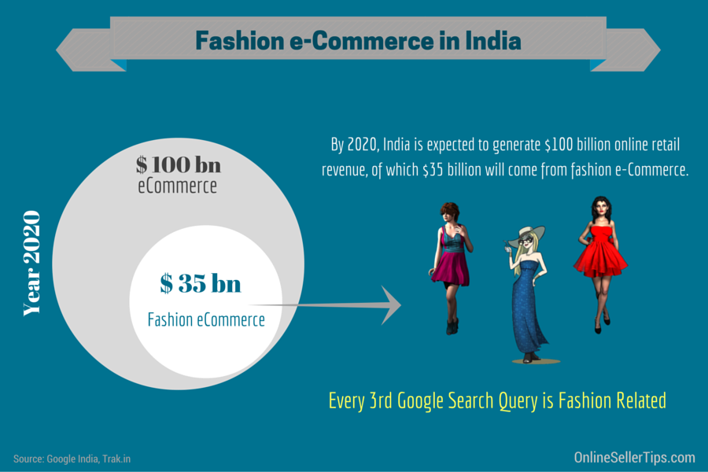

By 2020, India is expected to generate $100 billion online retail revenue, of which $35 billion will come from fashion ecommerce.

Online apparel sales are set to grow four times in the next 5 years

1. **CONCLUSION**

Today most small and medium scaled designers and brands see marketplaces as the second path, besides brick-and-mortar stores, to reach millions of consumers from all corners of the country. The next step for retailers and sellers is to realise that sustenance can be achieved only when they establish their brands in the national consciousness. This is the only way to establish trust with consumers and drive sales, allowing selling on marketplaces as a part of the growth strategy.

1. **REFERENCES**

* <http://www.digitalerra.com/a-study-on-fashion-ecommerce-in-india-in-2016/>
* <http://consumeraffairs.nic.in/consumer/writereaddata/e-Retailingindia.pdf>
* <http://www.explainthatstuff.com/ecommerce.html>
* Apparel Retail: Labeling the Indian Market (2016), available at: [www.ibef.org](http://www.ibef.org).
* http://www.technopak.com/Files/Growth%20of%20E-commerce%20in%20Fashion%20Businesses%20-%20IMAGES%20YEARBOOK%202016.pdf
* Metric Pattern Cutting For Mens, Edition 2 ,By Winifred Aldrich
* Patternmaking For Fashion Design , Fourth Edition, By Helen Joseph-Armstrong
* Techniques Of Drafting and Pattern Making, By Padmavati B
* Metric Pattern Cutting For Women’s Wear, Fourth Edition, By Winifred Aldrich
* Dressmaking By Alison Smith
* Metric Pattern Cutting For Children, Edition 2, By Winifred Aldrich
* Metric Pattern Cutting For Children’s Wear And Baby Wear, Edition 4, By- Winifred Aldrich

**Annexure 1: HOW TO MEASURE THE HUMAN BODY?**

1. 

* **Waist (Relaxed / Extended):** On garments with a waist seam, measure from side to side along the waist seam. On garments with a waistband, measure from side to side along the center of the waistband. Double the measurement. For extended measurements, measure as above with elastic or knit fully extended. Double the measurement.
* **Hip / seat :** Lay garment flat with the front of the garment facing you. Measure up the specified amount on the size specification sheet from crotch point. Measure side to side following the contour of the waist seam.
* **Thigh:**  Lay one entire leg flat. At the crotch, measure down as specified on the size specification sheet. At this point, measure across the leg parallel to waist from fold to fold, double the measurement.
* **Knee:** With leg flat, locate the knee. Measure up the specified amount on the size specification sheet. At this point measure across the leg from point to point. Double measurement.
* **Bottom Opening / Leg Opening (Relaxed / Extended):** Lay the bottom of the pant leg flat. Measure straight across the bottom opening from fold to fold. Double the measurement.
* **Front Rise:** Lay garment flat with front of the garment facing you. Measure from the crotch seam up the center front seam to the top edge of the garment (including waistband.)
* **Back Rise:** Lay garment flat with back of the garment facing you. Measure from the crotch seam up the centre back seam the top edge of the garment (including waistband)
* **Inseam:** Lay one entire leg flat with inseam fading you. Measure from where the crotch seam joins the inseam down to the bottom of the garment.
* **Out Seam:** Lay one entire leg flat. Measure from the top of the garment to the bottom of leg following the contour of the side seam.
* **Center Back Length (Skirts):** Garment is flat with back facing you. Measure from top of waistband down centre back to bottom of garment.
* **Trunk Length / Torso Length:** Measure from the high point of shoulder down the front rise to the fold at the crotch. Double the measurement.
* **Front Length (High Point of Shoulder)**: Measure from the high point of shoulder or from the fold of natural shoulder to the bottom of garment, keeping the tape measure parallel to the center front
* **Front Length (High Point of Shoulder)**: Measure from the high point of shoulder or from the fold of natural shoulder to the bottom of garment, keeping the tape measure parallel to the center front
* **Back Length (Center Back Neck):** Measure from the joining seam at the neck opening (Collar) to the bottom edge of the garment.
* **Chest – Bust:** Lay garment flat. Measure straight across garment from side to side 1” from the bottom of armholes. Double the measurement.
* **Sweep:** Lay garment flat, making sure that any pleats are fully extended. Measure at bottom of garment following the contour of hem. Double the measurement. For extended measurement, measure as above with elastic or knit fully extended.
* **Across Shoulder:** Lay garment flat with the back of the garment facing you. Locate the shoulder points, where the shoulder seams meet the top of the armhole when there is no shoulder seam; measure where the natural fold of the shoulder meets the top of the armhole. Measure straight across from shoulder point to shoulder point.
* **Across Back** : Lay garment flat with back of the garment fading you. Measure down to the center of the armhole. At this point, measure straight across form armhole to armhole seam.
* **Armhole Circumference:** Aligning front and back armhole seams and position so that the armhole seam has no wrinkles. Measure from bottom to top of armhole following seam contour. Double the measurement.
* **Upper arm:** With the tape measure at a right angle to the center fold of the sleeve, measure straight across form underarm to center fold. Double the measurement.
* **Sleeve Length (From Center Back Neck):** Garment with center back seam: Starting where the center back seam meets neck seam, measure across the back to the point where the shoulder seam joins the armhole, following the contour of the center fold of the sleeve to the bottom. To determine center back neck of garment without center back seam, measure along the back neck seam from shoulder seam to shoulder seam. Half of this amount is the center back neck. Measure as above.
* **Sleeve Length (From Shoulder):** Measure along the outside fold of the sleeve from the armhole seam at shoulder to the bottom of the sleeve.
* **Cuff Opening (Relaxed / Extended):** Lay the sleeve flat (sleeve closed on button styles). Measure straight across the bottom of the sleeve fold to fold. Double the measure.
* **Collar Length (Button to Button):** Open collar and lay flat. Measure along the center of the collar stand from the outside end of buttonhole to the center of the button.
* **Collar Length (On Seam):** With the collar open and lying flat, measure along the collar joining seam from end to end, following the contour of the joining seam.
* **Neck Circumference (Relaxed / Extended):** Close neckline and lay flat from center back to center front. Measure along neck seam opening. For extended measurements, measure as above with elastic or knit fully extended. Placket and zipper openings must be included in extended measurement.
* **Neck Drat – Front / Back:** Measure down from the imaginary line (point to point) to the neck/collar seam at the center front.
* **Neck Width:** Measure from side to side, the inside width of the neck at the fold.
* **Collar Point:** Measure along the collar point edge from the collar-joining seam to the outer end of the collar.

**Annexure 2 : SIZE CHART**

**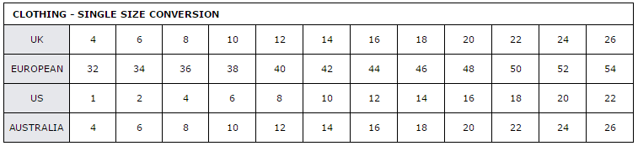**

**Infants**

|  |  |  |  |  |  |
| --- | --- | --- | --- | --- | --- |
|  | 0-3 m | 3-6 m | 6-12 m | 12-18 m | 18-24 m |
| Weight (lbs) | 0-6 | 7-15 | 16-22 | 23-27 | 28-30 |
| Chest (inches) | 12 | 14 | 16 | 18 | 20 |
| Length (inches) | 10-16 | 17-24 | 25-28 | 29-31 | 32-34 |

**Kids**

|  |  |  |  |  |  |
| --- | --- | --- | --- | --- | --- |
| Size | Height, inches | Weight, lbs | Chest | Waist | Hip |
| 4 | 42-44 | 37-41 | 22.5 | 21 | 23.5 |
| 5 | 45-47 | 42-46 | 23.5 | 21.5 | 24.5 |
| 6 | 48-49 | 47-53 | 24.5 | 22 | 25.5 |
| 6x (girls) / 7 (boys) | 50-51 | 54-58 | 25.5 | 22.5 | 26.5 |

Girls

|  |  |  |  |  |
| --- | --- | --- | --- | --- |
| Size | Height, inches | Bust, inches | Waist, inches | Hips, inches |
| 7 | 51-52 | 26 | 23 | 27 |
| 8 | 53-54 | 27 | 23.5 | 28 |
| 10 | 55-57 | 28.5 | 24.5 | 29.5 |
| 12 | 58-59 | 30 | 25.5 | 31.5 |
| 14 | 60-62 | 31.5 | 26.5 | 33.5 |
| 16 | 63-64 | 33 | 27.5 | 35.5 |

Boys

|  |  |  |  |  |
| --- | --- | --- | --- | --- |
| Size | Height, inches | Chest, inches | Waist, inches | Hips, inches |
| 8 | 50-53 | 27 | 23.5 | 27.5 |
| 10 | 54-57 | 28.5 | 25 | 29.5 |
| 12 | 58-60 | 30 | 26 | 31.5 |
| 14 | 61-63 | 32 | 27 | 33.5 |
| 16 | 64-65 | 33.5 | 28 | 35.5 |
| 18 | 65-66 | 35 | 29 | 37.5 |
| 20 | 67-68 | 37 | 30 | 39.5 |

**Mens**

Shirt

|  |  |  |  |  |
| --- | --- | --- | --- | --- |
| Size | Chest Measurement | | Neck Measurement | |
|  | Inches | CM | Inches | CM |
| XS | 32-34 | 81-86 | 14.25 | 36 |
| S | 34-36 | 86-91 | 14.5 | 37 |
| M | 36-38 | 91-96 | 15 | 38 |
| L | 38-40 | 96-101 | 16 | 41 |
| XL | 40-42 | 101-106 | 17 | 43 |
| XXL | 42-44 | 106-111 | 17.5 | 44 |
| XXXL | 44-46 | 111-116 | 18 | 46 |

Trouser

|  |  |  |
| --- | --- | --- |
| SIZE | WAIST MEASUREMENT | |
|  | INCHES | CM |
| 26" | 26 | 66 |
| 28" | 28 | 71 |
| 30" | 30 | 76 |
| 31" | 31 | 78.5 |
| 32" | 32 | 81 |
| 33" | 33 | 83.5 |
| 34" | 34 | 86 |
| 36" | 36 | 91 |
| 38" | 38 | 96 |

**Womens**

Shirt

|  |  |  |  |  |  |  |
| --- | --- | --- | --- | --- | --- | --- |
| SIZE | BUST | | WAIST | | HIPS | |
|  | INCHES | CM | INCHES | CM | INCHES | CM |
| XXS | 31 | 78 | 24 | 60 | 33 | 83.5 |
| XS | 32 | 80.5 | 25 | 62.5 | 34 | 86 |
| S | 33 | 83 | 26 | 65 | 35 | 88.5 |
| M | 35 | 88 | 28 | 70 | 37 | 93.5 |
| L | 37 | 93 | 30 | 75 | 39 | 98.5 |
| XL | 39 | 98 | 31 | 80 | 41 | 103.5 |
| XXL | 41 | 103 | 33 | 85 | 43 | 108.5 |
| XXXL | 44 | 110.5 | 36 | 92.5 | 46 | 116 |

Trouser

|  |  |  |  |  |
| --- | --- | --- | --- | --- |
| SIZE | WAIST MEASUREMENT | | HIP MEASUREMENT | |
|  | INCHES | CM | INCHES | CM |
| 4 | 24 | 60 | 33 | 83.5 |
| 6 | 25 | 62.5 | 34 | 86 |
| 8 | 26 | 65 | 35 | 88.5 |
| 10 | 28 | 70 | 37 | 93.5 |
| 12 | 30 | 75 | 39 | 98.5 |
| 14 | 31 | 80 | 41 | 103.5 |
| 16 | 33 | 85 | 43 | 108.5 |
| 18 | 36 | 92.5 | 46 | 116 |

**Annexure 3: TOP 10 ONLINE SITES FOR APPAREL:**

TOP 10 WEBSITES FOR APPAREL

|  |  |  |
| --- | --- | --- |
| S.NO | SITE NAME | SITE ADDRESS |
| 1. | Flipkart | https://www.flipkart.com/ |
| 2 | Amazon | http://www.amazon.in/ |
| 3 | Snapdeal | https://www.snapdeal.com/ |
| 4. | Jabong | http://www.jabong.com/ |
| 5. | Myntra | https://www.myntra.com/ |
| 6. | Voonik | https://www.voonik.com/ |
| 7. | Yepme | http://www.yepme.com/ |
| 8. | Yehbhi | http://www.yebhi.com/ |
| 9. | Ajio | https://www.ajio.com/ |
| 10. | Abof | http://www.abof.com/ |

**ANNEXURE 4: VARIOUS STYLES OF GARMENTS**

| Infants | | Kids | | Adults | |
| --- | --- | --- | --- | --- | --- |
| Boys | Girls | Boys | Girls | Men | Women |
| 1. Jersey Trouser | 1. Circular Skirt | 1. Classic Blazer | 1. Pina Fore | 1. Casual Shirt | 1. Yoke Shirt |
| 1. Basic Dungaree Trouser | 1. Gathered Skirt | 1. Classic Formal Coat | 1. Classic Dress | 1. Casual Shirt Easy Fitting | 1. Basic Shirt Or Blouse |
| 1. Trouser with extra fullness | 1. Flared Skirt | 1. Anorak | 1. Sleveless Dress | 1. Basic Work Shirt | 1. Casual Dartless Shirt Or Blouse |
| 1. Easy fitting romper | 1. Basic Dress | 1. Duffle Coat | 1. Low Waisted Dress | 1. Fitted Jacket | 1. Oversize Dartless Shirt |
| 1. Placket fastening romper | 1. Basic blouse | 1. Casual Jacket | 1. Simple Waisted Dress | 1. Semi-Fitted | 1. Peasant Blouse |
| 1. Romper with yoke | 1. Flat A Line Dress | 1. Rain Coat | 1. High Waisted Dress | 1. Easy Fitting Jacket | 1. Strapped Camisole |
| 1. Snow suit | 1. Yoke Dress | 1. Dungree | 1. Pleated Dress | 1. Jean Jacket | 1. Tie Neck Top |
| 1. Overjacket | 1. Smocked Dress | 1. Basic Trouser | 1. Panalled Dress | 1. Jacket Gathered | 1. Long Sleeved Tunic |
| 1. Gathered Knicker | 1. Sleeveless 2. Dress | 1. Fashion Trouser | 1. Smock Pina Fore | 1. Short Gathered Jacket | 1. Classic Princess Line Blouse |
| 1. Easy fitting Trouser | 1. Pinafore | 1. Culotte | 1. Bib Tent | 1. Full Back | 1. Short Sleeved Blouse |
| 1. Basic jacket | 1. Jersey Trouser | 1. Play Shorts | 1. Torso Jumper | 1. Straight Style | 1. Crop Top |
| 1. Jean Jacket | 1. Basic Dungaree Trouser | 1. Pyjama | 1. Smock Coat | 1. Basic Trouser | 1. Knit Top |
| 1. Dungaree Trouser (full) | 1. Trouser with extra fullness | 1. Trouser | 1. Classic Blazer | 1. Shaping The Leg | 1. Classic Tailored Trousers |
| 1. Dungaree Trouser (half) | 1. Jersey Romper | 1. Slack | 1. Classic Formal Coat | 1. Trouser With Pleated Waistline | 1. Tapered 2. Capri Trouser |
| 1. Casual Shirt | 1. Easy fitting Trouser | 1. Jeans | 1. Anorak | 1. Slimline | 1. Classic Palazzo |
|  | 1. Snow Suit | 1. Pleated Trousers | 1. Duffle Coat | 1. Jeans | 1. Wide Leg Shorts |
|  | 1. Overjacket | 1. Baggy pant | 1. Casual Jacket | 1. Work Trouser | 1. Culotte |
|  | 1. Basic jacket | 1. Round neck T-shirt | 1. Rain Coat | 1. Basic Shorts | 1. Box Pleated Culottes |
|  | 1. Jean Jacket | 1. Casual Shirt | 1. Flared Skirt | 1. Anoraks | 1. Flared Culottes |
|  | 1. Gathered Knickers | 1. Bell Bottom Pants | 1. Four Gored Skirt | 1. Overalls | 1. Trouser With Pleated Waistline |
|  | 1. Dungaree Trouser | 1. Knickers | 1. Sectioned Skirt | 1. Dungaree | 1. Flared And Gathered 2. Trouser |
|  | 1. Dungaree Trouser | 1. Pea Coat | 1. Basic Trouser | 1. Classic Suit Jacket | 1. Baggy Pant |
|  | 1. Casual Shirt | 1. Tanktop Jumpsuit | 1. Fashion Trouser | 1. Easy Fitting Classic Suit Jacket | 1. Hip Pop Pant |
|  |  | 1. Bib-overall | 1. Culotte | 1. Double Breasted Suit Jacket | 1. Pull On Pant |
|  |  | 1. Kurta | 1. Dungree | 1. Baggy Pant | 1. High Waist Pant |
|  |  |  | 1. Play Shorts | 1. High Waist Pant | 1. Jeans With V-Yoke |
|  |  |  | 1. Pyjama | 1. Jeans With V-Yoke | 1. Clown Pant |
|  |  |  | 1. Trouser | 1. Clown Pant | 1. Contour Pant With Creaseline Flare |
|  |  |  | 1. Slack | 1. Pant With Flared Leg | 1. Pant With Flared Leg |
|  |  |  | 1. Jeans | 1. Straight Kurta | 1. Short-Short |
|  |  |  | 1. Pleated Trousers | 1. Sherwani | 1. Short |
|  |  |  | 1. Baggy pant |  | 1. Jamaica |
|  |  |  | 1. Western Jean |  | 1. Bermuda Pant |
|  |  |  | 1. Bell Bottom Pants |  | 1. Pedal-Pushers |
|  |  |  | 1. Short Short |  | 1. Capri Pants |
|  |  |  | 1. Flared Short |  | 1. Styled Jumpsuit |
|  |  |  | 1. Knickers |  | 1. Great Coverall |
|  |  |  | 1. Classic Blouse |  | 1. Double-Breasted Jacket |
|  |  |  | 1. Night Dress With Yoke |  | 1. Style Jacket |
|  |  |  | 1. Round neck T-shirt |  | 1. The Wrap Around Style Mannish Jacket |
|  |  |  | 1. Casual Shirt |  | 1. Three Panel Style Mannish Jacket |
|  |  |  | 1. Cardigan |  | 1. Slip Dress With A Slinky Skirt |
|  |  |  | 1. Pea Coat |  | 1. Twist Bodice With A Slinky Skirt |
|  |  |  | 1. Tanktop Jumpsuit |  | 1. All-In-One Bias Dress |
|  |  |  | 1. Bib-overall |  | 1. Shift Dress |
|  |  |  | 1. Straight Kurta |  | 1. Tent Dress |
|  |  |  | 1. Palazoo |  | 1. Shirt Dress |
|  |  |  | 1. Chudidar |  | 1. Empire Line Dress |
|  |  |  | 1. Lehenga Choli |  | 1. Fitted |
|  |  |  |  |  | 1. Panel Dress |
|  |  |  |  |  | 1. Straight |
|  |  |  |  |  | 1. A-Line |
|  |  |  |  |  | 1. Inverted Triangle |
|  |  |  |  |  | 1. Bell Shape |
|  |  |  |  |  | 1. Flared A line |
|  |  |  |  |  | 1. Basic Flared Skirt |
|  |  |  |  |  | 1. Gathered Dirndl Skirt |
|  |  |  |  |  | 1. Gored Skirt |
|  |  |  |  |  | 1. Pegged Skirt With Pleats |
|  |  |  |  |  | 1. Skirts With Yoke |
|  |  |  |  |  | 1. Tiered Skirt |
|  |  |  |  |  | 1. Kick-pleated Skirt |
|  |  |  |  |  | 1. All-around Pleated Skirt |
|  |  |  |  |  | 1. Inverted Box Pleat |
|  |  |  |  |  | 1. Godet Skirt |
|  |  |  |  |  | 1. Wrap Skirt |
|  |  |  |  |  | 1. Full Circle Skirt |
|  |  |  |  |  | 1. Straight Kurta |
|  |  |  |  |  | 1. Palazoo |
|  |  |  |  |  | 1. Chudidar |
|  |  |  |  |  | 1. Kamiz |
|  |  |  |  |  | 1. Salwar suit |
|  |  |  |  |  | 1. Lehenga Choli |
| Source:  Metric Pattern Cutting For Children’s Wear And Baby Wear Edition 4 By- Winifred Aldrich  Techniques Of Drafting And Pattern Making Garments By Padmavati B.  Pattern Making for Fashion Design Edition 4 By Helen Joseph Armstrong  Dressmaking By Alison Smith  Metric Pattern Cutting For Children Edition 2 By Winifred Aldrich  Metric Pattern Cutting For Women’s Wear Fourth Edition By Winifred Aldrich  Metric Pattern Cutting For Mens Edition 2 By Winifred Aldrich | | | | | |

|  |  |  |  |  |  |  |  |
| --- | --- | --- | --- | --- | --- | --- | --- |
| S.No | Classification No. | Category | Name | Type | Image | Book Name | Pg |
|  |  | Boys | Trouser | Jersey Trouser |  | Metric Pattern Cutting For Children’s Wear And Baby Wear  Edition 4  By- Winifred Aldrich | 32 |
|  |  | Boys | Trouser | Basic Dungaree Trouser |  | Metric Pattern Cutting For Children’s Wear And Baby Wear  Edition 4  By- Winifred Aldrich | 32 |
|  |  | Boys | Trouser | Trouser with extra fullness | C:\Users\aditi\Desktop\New folder\IMG_7258.JPG | Metric Pattern Cutting For Children’s Wear And Baby Wear  Edition 4  By- Winifred Aldrich | 32 |
|  |  | Boys | Romper | Easy fitting romper |  | Metric Pattern Cutting For Children’s Wear And Baby Wear  Edition 4  By- Winifred Aldrich | 34 |
|  |  | Boys | Romper | Placket fastening romper | C:\Users\aditi\Desktop\New folder\IMG_7259.JPG | Metric Pattern Cutting For Children’s Wear And Baby Wear  Edition 4  By- Winifred Aldrich | 34 |
|  |  | Boys | Romper | Romper with yoke | C:\Users\aditi\Desktop\New folder\IMG_7259.JPG | Metric Pattern Cutting For Children’s Wear And Baby Wear  Edition 4  By- Winifred Aldrich | 34 |
|  |  | Boys | Snow Suit | Snow suit |  | Metric Pattern Cutting For Children’s Wear And Baby Wear  Edition 4  By- Winifred Aldrich | 36 |
|  |  | Boys | Jacket | Overjacket |  | Metric Pattern Cutting For Children’s Wear And Baby Wear  Edition 4  By- Winifred Aldrich | 36 |
|  |  | Boys | Pant Derivative | Gathered Knicker | Image result for gathered knickers infants line drawing | Metric Pattern Cutting For Children’s Wear And Baby Wear  Edition 4  By- Winifred Aldrich | 38 |
| 10. |  | Boys | Trouser | Easy fitting Trouser | C:\Users\aditi\Desktop\New folder\IMG_7270.JPG | Metric Pattern Cutting For Children’s Wear And Baby Wear  Edition 4  By- Winifred Aldrich | 84 |
| 11. |  | Boys | Jacket | Basic jacket | C:\Users\aditi\Desktop\New folder\IMG_7266.JPG | Metric Pattern Cutting For Children’s Wear And Baby Wear  Edition 4  By- Winifred Aldrich | 36 |
| 12. |  | Boys | Jacket | Jean Jacket | C:\Users\aditi\Desktop\New folder\IMG_7266.JPG | Metric Pattern Cutting For Children’s Wear And Baby Wear  Edition 4  By- Winifred Aldrich | 80 |
| 13. |  | Boys | Dungaree | Dungaree Trouser (full) | C:\Users\aditi\Desktop\New folder\IMG_7270.JPG | Metric Pattern Cutting For Children’s Wear And Baby Wear  Edition 4  By- Winifred Aldrich | 84 |
| 14. |  | Boys | Dungaree | Dungaree Trouser (half) | C:\Users\aditi\Desktop\New folder\IMG_7270.JPG | Metric Pattern Cutting For Children’s Wear And Baby Wear  Edition 4  By- Winifred Aldrich | 84 |
| 15. |  | Boys | Shirt | Casual Shirt | C:\Users\aditi\Desktop\New folder\IMG_7262.JPG | Metric Pattern Cutting For Children’s Wear And Baby Wear  Edition 4  By- Winifred Aldrich | 60 |

|  |  |  |  |  |  |  |  |
| --- | --- | --- | --- | --- | --- | --- | --- |
| S.No. | Classification No. | Category | Name | Type | Image | Book Name | P. No |
|  |  | Girls | Skirt | Circular Skirt |  | Metric Pattern Cutting For Children’s Wear And Baby Wear  Edition 4  By- Winifred Aldrich | 58 |
|  |  | Girls | Skirt | Gathered Skirt |  | Metric Pattern Cutting For Children’s Wear And Baby Wear  Edition 4  By- Winifred Aldrich | 58 |
|  |  | Girls | Skirt | Flared Skirt |  | Metric Pattern Cutting For Children’s Wear And Baby Wear  Edition 4  **By- Winifred Aldrich** | 58 |
|  |  | Girls | Dress | Basic Dress | C:\Users\aditi\Desktop\New folder\IMG_7262.JPG | Metric Pattern Cutting For Children’s Wear And Baby Wear  Edition 4  By- Winifred Aldrich | 60 |
|  |  | Girls | Top | Basic blouse | C:\Users\aditi\Desktop\New folder\IMG_7262.JPG | Metric Pattern Cutting For Children’s Wear And Baby Wear  Edition 4  By- Winifred Aldrich | 60 |
|  |  | Girls | Dress | Flat A Line Dress |  | Metric Pattern Cutting For Children’s Wear And Baby Wear  Edition 4  By- Winifred Aldrich | 60 |
|  |  | Girls | Dress | Yoke Dress |  | Metric Pattern Cutting For Children’s Wear And Baby Wear  Edition 4  By- Winifred Aldrich | 62 |
|  |  | Girls | Dress | Smocked Dress |  | Metric Pattern Cutting For Children’s Wear And Baby Wear  Edition 4  By- Winifred Aldrich | 62 |
|  |  | Girls | Dress | Sleeveless  Dress |  | Metric Pattern Cutting For Children’s Wear And Baby Wear  Edition 4  By- Winifred Aldrich | 62 |
|  |  | Girls | Dress | Pinafore |  | Metric Pattern Cutting For Children’s Wear And Baby Wear  Edition 4  By- Winifred Aldrich | 64 |
|  |  | Girls | Trouser | Jersey Trouser |  | Metric Pattern Cutting For Children’s Wear And Baby Wear  Edition 4  By- Winifred Aldrich | 32 |
|  |  | Girls | Trouser | Basic Dungaree Trouser |  | Metric Pattern Cutting For Children’s Wear And Baby Wear  Edition 4  By- Winifred Aldrich | 32 |
|  |  | Girls | Trouser | Trouser with extra fullness | C:\Users\aditi\Desktop\New folder\IMG_7258.JPG | Metric Pattern Cutting For Children’s Wear And Baby Wear  Edition 4  By- Winifred Aldrich | 32 |
|  |  | Girls | Trouser | Jersey Romper |  | Metric Pattern Cutting For Children’s Wear And Baby Wear  Edition 4  By- Winifred Aldrich | 34 |
|  |  | Girls | Romper | Placket fastening romper | C:\Users\aditi\Desktop\New folder\IMG_7259.JPG | Metric Pattern Cutting For Children’s Wear And Baby Wear  Edition 4  By- Winifred Aldrich | 34 |
|  |  | Girls | Romper | Romper with yoke | C:\Users\aditi\Desktop\New folder\IMG_7259.JPG | Metric Pattern Cutting For Children’s Wear And Baby Wear  Edition 4  By- Winifred Aldrich | 34 |
|  |  | Girls | Trouser | Easy fitting Trouser | C:\Users\aditi\Desktop\New folder\IMG_7270.JPG | Metric Pattern Cutting For Children’s Wear And Baby Wear  Edition 4  By- Winifred Aldrich | 84 |
|  |  | Girls | Bodysuit | Snow Suit |  | Metric Pattern Cutting For Children’s Wear And Baby Wear  Edition 4  By- Winifred Aldrich | 36 |
|  |  | Girls | Jacket | Overjacket |  | Metric Pattern Cutting For Children’s Wear And Baby Wear  Edition 4  By- Winifred Aldrich | 36 |
|  |  | Girls | Jacket | Basic jacket | C:\Users\aditi\Desktop\New folder\IMG_7266.JPG | Metric Pattern Cutting For Children’s Wear And Baby Wear  Edition 4  By- Winifred Aldrich | 36 |
|  |  | Girls | Jacket | Jean Jacket | C:\Users\aditi\Desktop\New folder\IMG_7266.JPG | Metric Pattern Cutting For Children’s Wear And Baby Wear  Edition 4  By- Winifred Aldrich | 80 |
|  |  | Girls | Pant derivative | Gathered Knickers | Image result for gathered knickers infants line drawing | Metric Pattern Cutting For Children’s Wear And Baby Wear  Edition 4  By- Winifred Aldrich | 38 |
|  |  | Girls | Dungaree | Dungaree Trouser | C:\Users\aditi\Desktop\New folder\IMG_7270.JPG | Metric Pattern Cutting For Children’s Wear And Baby Wear  Edition 4  By- Winifred Aldrich | 84 |
|  |  | Girls | Dungaree | Dungaree Trouser | C:\Users\aditi\Desktop\New folder\IMG_7270.JPG | Metric Pattern Cutting For Children’s Wear And Baby Wear  Edition 4  By- Winifred Aldrich | 84 |
|  |  | Girls | Shirt | Casual Shirt | C:\Users\aditi\Desktop\New folder\IMG_7262.JPG | Metric Pattern Cutting For Children’s Wear And Baby Wear  Edition 4  By- Winifred Aldrich | 60 |

|  |  |  |  |  |  |  |  |
| --- | --- | --- | --- | --- | --- | --- | --- |
| S.No | Classification No. | Category | Product | Style | Image | Book Name | Pg |
|  |  | Boys | Over Garment | Classic Blazer | C:\Users\cnbc\Desktop\itp pics\DOJM5121.jpg | Metric Pattern Cutting For Children  Edition 2  By Winifred Aldrich | 74 |
|  |  | Boys | Over Garment | Classic Formal Coat | C:\Users\cnbc\Desktop\itp pics\DOJM5121.jpg | Metric Pattern Cutting For Children  Edition 2  By Winifred Aldrich | 74 |
|  |  | Boys | Over Garment | Anorak | C:\Users\cnbc\Desktop\itp pics\IMYD6344.jpg | Metric Pattern Cutting For Children  Edition 2  By Winifred Aldrich | 76 |
|  |  | Boys | Over Garment | Duffle Coat | C:\Users\cnbc\Desktop\itp pics\IMYD6344.jpg | Metric Pattern Cutting For Children  Edition 2  By Winifred Aldrich | 76 |
|  |  | Boys | Over Garment | Casual Jacket | C:\Users\cnbc\Desktop\itp pics\YBTM4774.jpg | Metric Pattern Cutting For Children  Edition 2  By Winifred Aldrich | 78 |
|  |  | Boys | Over Garment | Rain Coat | C:\Users\cnbc\Desktop\itp pics\VDYC2711.jpg | Metric Pattern Cutting For Children  Edition 2  By Winifred Aldrich | 82 |
|  |  | Boys | Overall | Dungree | C:\Users\cnbc\Desktop\itp pics\WUXU3470.jpg | Metric Pattern Cutting For Children  Edition 2  By Winifred Aldrich | 108 |
|  |  | Boys | Trouser | Basic Trouser | C:\Users\cnbc\Desktop\itp pics\TDJS6722.jpg | Metric Pattern Cutting For Children  Edition 2  By Winifred Aldrich | 102 |
|  |  | Boys | Trouser | Fashion Trouser | C:\Users\cnbc\Desktop\itp pics\SUBS5078.jpg | Metric Pattern Cutting For Children  Edition 2  By Winifred Aldrich | 104 |
|  |  | Boys | Pant | Culotte | Image result for culotte kids boys line drawing | Metric Pattern Cutting For Children  Edition 2  By Winifred Aldrich | 106 |
|  |  | Boys | Pants | Play Shorts | C:\Users\cnbc\Desktop\itp pics\DNRR4419.jpg | Dressmaking  By Alison Smith | 250 |
|  |  | Boys | Pants | Pyjama | Image result for pyjama kids line drawing | Dressmaking  By Alison Smith | 257 |
|  |  | Boys | Pants | Trouser |  | Pattern Making for Fashion Design  Edition 4  By Helen Joseph Armstrong | 750 |
|  |  | Boys | Pants | Slack |  | Pattern Making for Fashion Design  Edition 4  By Helen Joseph Armstrong | 750 |
|  |  | Boys | Pants | Jeans |  | Pattern Making for Fashion Design  Edition 4  By Helen Joseph Armstrong | 750 |
|  |  | Boys | Pants | Pleated Trousers |  | Pattern Making for Fashion Design  Edition 4  By Helen Joseph Armstrong | 757 |
|  |  | Boys | Pants | Baggy pant |  | Pattern Making for Fashion Design  Edition 4  By Helen Joseph Armstrong | 758 |
| 1. B |  | Boys | T-shirt | Round neck T-shirt |  | Dressmaking  By Alison Smith | 126 |
|  |  | Boys | Shirt | Casual Shirt |  | Pattern Making for Fashion Design  Edition 4  By Helen Joseph Armstrong | 759 |
|  |  | Boys | Pants | Bell Bottom Pants |  | Pattern Making for Fashion Design  Edition 4  By Helen Joseph Armstrong | 759 |
|  |  | Boys | Pants | Knickers |  | Pattern Making for Fashion Design  Edition 4  By Helen Joseph Armstrong | 764 |
|  |  | Boys | Jacket | Pea Coat |  | Pattern Making for Fashion Design  Edition 4  By Helen Joseph Armstrong | 745 |
|  |  | Boys | Jumpsuit | Tanktop Jumpsuit |  | Pattern Making for Fashion Design  Edition 4  By Helen Joseph Armstrong | 768 |
|  |  | Boys | Jumpsuit | Bib-overall |  | Pattern Making for Fashion Design  Edition 4  By Helen Joseph Armstrong | 769 |
|  |  | Boys | Kurta (Ethnic wear) | Kurta | Related image | Techniques Of Drafting And Pattern Making Garments  By Padmavati B. | 102 |

|  |  |  |  |  |  |  |  |
| --- | --- | --- | --- | --- | --- | --- | --- |
| S.No | Category No. | Category | Product | Style | Image | Book Name | Pg |
|  |  | Girls | Dress | Pina Fore | TSML2747.jpg | Metric Pattern Cutting For Children  Edition 2  By Winifred Aldrich | 62 |
|  |  | Girls | Dress | Classic Dress | C:\Users\cnbc\Desktop\itp pics\MICG8843.jpg | Metric Pattern Cutting For Children  Edition 2  By Winifred Aldrich | 64 |
|  |  | Girls | Dress | Sleveless Dress | C:\Users\cnbc\Desktop\itp pics\GIWL8510.jpg | Metric Pattern Cutting For Children  Edition 2  By Winifred Aldrich | 66 |
|  |  | Girls | Dress | Low Waisted Dress | C:\Users\cnbc\Desktop\itp pics\GIWL8510.jpg | Metric Pattern Cutting For Children  Edition 2  By Winifred Aldrich | 66 |
|  |  | Girls | Dress | Simple Waisted Dress | C:\Users\cnbc\Desktop\itp pics\QEVZ4139.jpg | Metric Pattern Cutting For Children  Edition 2  By Winifred Aldrich | 68 |
|  |  | Girls | Dress | High Waisted Dress | C:\Users\cnbc\Desktop\itp pics\QEVZ4139.jpg | Metric Pattern Cutting For Children  Edition 2  By Winifred Aldrich | 68 |
|  |  | Girls | Dress | Pleated Dress | C:\Users\cnbc\Desktop\itp pics\UMLE7829.jpg | Metric Pattern Cutting For Children  Edition 2  By Winifred Aldrich | 70 |
|  |  | Girls | Dress | Panalled Dress | C:\Users\cnbc\Desktop\itp pics\UMLE7829.jpg | Metric Pattern Cutting For Children  Edition 2  By Winifred Aldrich | 70 |
|  |  | Girls | Dress | Smock Pina Fore | C:\Users\cnbc\Desktop\itp pics\FAFV4112.jpg | Metric Pattern Cutting For Children  Edition 2  By Winifred Aldrich | 72 |
|  |  | Girls | Dress | Bib Tent |  | Pattern Making for Fashion Design  Edition 4  By Helen Joseph Armstrong | 725 |
| 1. G |  | Girls | Dresses | Torso Jumper |  | Pattern Making for Fashion Design  Edition 4  By Helen Joseph Armstrong | 726 |
|  |  | Girls | Over Garment | Smock Coat | C:\Users\cnbc\Desktop\itp pics\FAFV4112.jpg | Metric Pattern Cutting For Children  Edition 2  By Winifred Aldrich | 72 |
|  |  | Girls | Over Garment | Classic Blazer | C:\Users\cnbc\Desktop\itp pics\DOJM5121.jpg | Metric Pattern Cutting For Children  Edition 2  By Winifred Aldrich | 74 |
|  |  | Girls | Over Garment | Classic Formal Coat | C:\Users\cnbc\Desktop\itp pics\DOJM5121.jpg | Metric Pattern Cutting For Children  Edition 2  By Winifred Aldrich | 74 |
|  |  | Girls | Over Garment | Anorak | C:\Users\cnbc\Desktop\itp pics\IMYD6344.jpg | Metric Pattern Cutting For Children  Edition 2  By Winifred Aldrich | 76 |
|  |  | Girls | Over Garment | Duffle Coat | C:\Users\cnbc\Desktop\itp pics\IMYD6344.jpg | Metric Pattern Cutting For Children  Edition 2  By Winifred Aldrich | 76 |
|  |  | Girls | Over Garment | Casual Jacket | C:\Users\cnbc\Desktop\itp pics\YBTM4774.jpg | Metric Pattern Cutting For Children  Edition 2  By Winifred Aldrich | 78 |
|  |  | Girls | Over Garment | Rain Coat | C:\Users\cnbc\Desktop\itp pics\VDYC2711.jpg | Metric Pattern Cutting For Children  Edition 2  By Winifred Aldrich | 82 |
|  |  | Girls | Skirt | Flared Skirt | C:\Users\cnbc\Desktop\itp pics\VJHW3944.jpg | Metric Pattern Cutting For Children  Edition 2  By Winifred Aldrich | 92 |
|  |  | Girls | Skirt | Four Gored Skirt | C:\Users\cnbc\Desktop\itp pics\VJHW3944.jpg | Metric Pattern Cutting For Children  Edition 2  By Winifred Aldrich | 92 |
|  |  | Girls | Skirt | Sectioned Skirt | C:\Users\cnbc\Desktop\itp pics\VJHW3944.jpg | Metric Pattern Cutting For Children  Edition 2  By Winifred Aldrich | 92 |
|  |  | Girls | Trouser | Basic Trouser | C:\Users\cnbc\Desktop\itp pics\TDJS6722.jpg | Metric Pattern Cutting For Children  Edition 2  By Winifred Aldrich | 102 |
|  |  | Girls | Trouser | Fashion Trouser | C:\Users\cnbc\Desktop\itp pics\SUBS5078.jpg | Metric Pattern Cutting For Children  Edition 2  By Winifred Aldrich | 104 |
|  |  | Girls | Overall | Culotte | Image result for culotte kids boys line drawing | Metric Pattern Cutting For Children  Edition 2  By Winifred Aldrich | 106 |
|  |  | Girls | Overall | Dungree | C:\Users\cnbc\Desktop\itp pics\WUXU3470.jpg | Metric Pattern Cutting For Children  Edition 2  By Winifred Aldrich | 108 |
|  |  | Girls | Pants | Play Shorts | C:\Users\cnbc\Desktop\itp pics\DNRR4419.jpg | Dressmaking  By Alison Smith | 201 |
|  |  | Girls | Pants | Pyjama | Image result for pyjama kids line drawing | Dressmaking  By Alison Smith | 205 |
|  |  | Girls | Pants | Trouser |  | Pattern Making for Fashion Design  Edition 4  By Helen Joseph Armstrong | 750 |
|  |  | Girls | Pants | Slack |  | Pattern Making for Fashion Design  Edition 4  By Helen Joseph Armstrong | 750 |
|  |  | Girls | Pants | Jeans |  | Pattern Making for Fashion Design  Edition 4  By Helen Joseph Armstrong | 750 |
|  |  | Girls | Pants | Pleated Trousers |  | Pattern Making for Fashion Design  Edition 4  By Helen Joseph Armstrong | 757 |
|  |  | Girls | Pants | Baggy pant |  | Pattern Making for Fashion Design  Edition 4  By Helen Joseph Armstrong | 758 |
|  |  | Girls | Pants | Western Jean |  | Pattern Making for Fashion Design  Edition 4  By Helen Joseph Armstrong | 759 |
|  |  | Girls | Pants | Bell Bottom Pants |  | Pattern Making for Fashion Design  Edition 4  By Helen Joseph Armstrong | 760 |
|  |  | Girls | Pants | Short Short |  | Pattern Making for Fashion Design  Edition 4  By Helen Joseph Armstrong | 764 |
|  |  | Girls | Pants | Flared Short |  | Pattern Making for Fashion Design  Edition 4  By Helen Joseph Armstrong | 764 |
|  |  | Girls | Pants | Knickers |  | Pattern Making for Fashion Design  Edition 4  By Helen Joseph Armstrong | 764 |
|  |  | Girls | Top | Classic Blouse | C:\Users\cnbc\Desktop\itp pics\MICG8843.jpg | Metric Pattern Cutting For Children  Edition 2  By Winifred Aldrich | 64 |
|  |  | Girls | Nightwear | Night Dress With Yoke | C:\Users\cnbc\Desktop\itp pics\FGMQ1349.jpg | Metric Pattern Cutting For Children  Edition 2  By Winifred Aldrich | 124 |
|  |  | Girls | T-shirt | Round neck T-shirt |  | Dressmaking  By Alison Smith | 126 |
|  |  | Girls | Top | Casual Shirt |  | Pattern Making for Fashion Design  Edition 4  By Helen Joseph Armstrong | 732 |
|  |  | Girls | Jacket | Cardigan |  | Pattern Making for Fashion Design  Edition 4  By Helen Joseph Armstrong | 743 |
|  |  | Girls | Jacket | Pea Coat |  | Pattern Making for Fashion Design  Edition 4  By Helen Joseph Armstrong | 745 |
|  |  | Girls | Jumpsuit | Tanktop Jumpsuit |  | Pattern Making for Fashion Design  Edition 4  By Helen Joseph Armstrong | 768 |
|  |  | Girls | Jumpsuit | Bib-overall |  | Pattern Making for Fashion Design  Edition 4  By Helen Joseph Armstrong | 769 |
|  |  | Girls | Kurta | Straight Kurta | Image result for kurta for girls line drawing | Techniques Of Drafting And Pattern MakingGarments For Kids And Adolescents  By Padmavati B. | 211 |
|  |  | Girls | Trousers (Ethnic wear) | Palazoo | Image result for pattern making for palazzo | Techniques Of Drafting and Pattern Making  By Padmavati B | 212 |
|  |  | Girls | Trousers (Ethnic wear) | Chudidar | Image result for pattern making for kurta | Techniques Of Drafting and Pattern Making  By Padmavati B | 215 |
|  |  | Girls | Ethnic wear | Lehenga Choli | Image result for girls lehenga choli line drawing | Techniques Of Drafting and Pattern Making  By Padmavati B | 220 |
| S.No. | Classification No. | Category | Product | Style | Image | Book Name | P.No |
|  |  | Mens | Shirt | Casual Shirt | C:\Users\aditi\Desktop\New folder\IMG_7222.PNG | Metric Pattern Cutting For Mens  Edition 2  By Winifred Aldrich | 66 |
|  |  | Mens | Shirt | Casual Shirt Easy Fitting | C:\Users\aditi\Desktop\New folder\FullSizeRender.jpg | Metric Pattern Cutting For Mens  Edition 2  By Winifred Aldrich | 66 |
|  |  | Mens | Shirt | Basic Work Shirt | C:\Users\aditi\Desktop\New folder\FullSizeRender_19.jpg | Metric Pattern Cutting For Mens  Edition 2  By Winifred Aldrich | 125 |
|  |  | Mens | Jacket | Fitted Jacket | C:\Users\aditi\Desktop\New folder\IMG_7228.PNG | Metric Pattern Cutting For Mens  Edition 2  By Winifred Aldrich | 68 |
|  |  | Mens | Jacket | Semi-Fitted | C:\Users\aditi\Desktop\New folder\FullSizeRender_1.jpg | Metric Pattern Cutting For Mens  Edition 2  By Winifred Aldrich | 68 |
|  |  | Mens | Jacket | Easy Fitting Jacket | C:\Users\aditi\Desktop\New folder\FullSizeRender_2.jpg | Metric Pattern Cutting For Mens  Edition 2  By Winifred Aldrich | 70 |
|  |  | Mens | Jacket | Jean Jacket | C:\Users\aditi\Desktop\New folder\FullSizeRender_13.jpg | Metric Pattern Cutting For Mens  Edition 2  By Winifred Aldrich | 119 |
|  |  | Mens | Jacket | Jacket Gathered | C:\Users\aditi\Desktop\New folder\IMG_7226.PNG | Metric Pattern Cutting For Mens  Edition 2  By Winifred Aldrich | 120 |
|  |  | Mens | Jacket | Short Gathered Jacket | C:\Users\aditi\Desktop\New folder\FullSizeRender_16.jpg | Metric Pattern Cutting For Mens  Edition 2  By Winifred Aldrich | 120 |
|  |  | Mens | Coat | Full Back | C:\Users\aditi\Desktop\New folder\FullSizeRender_3.jpg | Metric Pattern Cutting For Mens  Edition 2  By Winifred Aldrich | 72 |
|  |  | Mens | Coat | Straight Style | C:\Users\aditi\Desktop\New folder\FullSizeRender_4.jpg | Metric Pattern Cutting For Mens  Edition 2  By Winifred Aldrich | 74 |
|  |  | Mens | Trouser | Basic Trouser | C:\Users\aditi\Desktop\New folder\FullSizeRender_5.jpg | Metric Pattern Cutting For Mens  Edition 2  By Winifred Aldrich | 80 |
|  |  | Mens | Trouser | Shaping The Leg | C:\Users\aditi\Desktop\New folder\IMG_7224.PNG | Metric Pattern Cutting For Mens  Edition 2  By Winifred Aldrich | 80 |
|  |  | Mens | Trouser | Trouser With Pleated Waistline | C:\Users\aditi\Desktop\New folder\FullSizeRender_6.jpg | Metric Pattern Cutting For Mens  Edition 2  By Winifred Aldrich | 82 |
|  |  | Mens | Trouser | Slimline | C:\Users\aditi\Desktop\New folder\FullSizeRender_8.jpg | Metric Pattern Cutting For Mens  Edition 2  By Winifred Aldrich | 85 |
|  |  | Mens | Trouser | Jeans | C:\Users\aditi\Desktop\New folder\FullSizeRender_12.jpg | Metric Pattern Cutting For Mens  Edition 2  By Winifred Aldrich | 98 |
|  |  | Mens | Trouser | Work Trouser | C:\Users\aditi\Desktop\New folder\FullSizeRender_22.jpg | Metric Pattern Cutting For Mens  Edition 2  By Winifred Aldrich | 132 |
|  |  | Mens | Shorts | Basic Shorts | C:\Users\aditi\Desktop\New folder\FullSizeRender_14.jpg | Metric Pattern Cutting For Mens  Edition 2  By Winifred Aldrich | 112 |
|  |  | Mens | Anoraks | Anoraks | C:\Users\aditi\Desktop\New folder\FullSizeRender_17.jpg | Metric Pattern Cutting For Mens  Edition 2  By Winifred Aldrich | 122 |
|  |  | Mens | Overalls | Overalls | C:\Users\aditi\Desktop\New folder\FullSizeRender_20.jpg | Metric Pattern Cutting For Mens  Edition 2  By Winifred Aldrich | 128 |
|  |  | Mens | Dungaree | Dungaree | C:\Users\aditi\Desktop\New folder\FullSizeRender_21.jpg | Metric Pattern Cutting For Mens  Edition 2  By Winifred Aldrich | 130 |
|  |  | Mens | Suit Jacket | Classic Suit Jacket | C:\Users\aditi\Desktop\New folder\FullSizeRender_9.jpg | Metric Pattern Cutting For Mens  Edition 2  By Winifred Aldrich | 98 |
|  |  | Mens | Suit Jacket | Easy Fitting Classic Suit Jacket | C:\Users\aditi\Desktop\New folder\FullSizeRender_10.jpg | Metric Pattern Cutting For Mens  Edition 2  By Winifred Aldrich | 92 |
|  |  | Mens | Suit Jacket | Double Breasted Suit Jacket | C:\Users\aditi\Desktop\New folder\FullSizeRender_11.jpg | Metric Pattern Cutting For Mens  Edition 2  By Winifred Aldrich | 98 |
|  |  | Mens | Trouser | Baggy Pant | C:\Users\aditi\Desktop\itp pics\MJZA4231.jpg | Patternmaking For Fashion Design  Fourth Edition  By Helen Joseph-Armstrong | 581 |
|  |  | Mens | Trouser | High Waist Pant | C:\Users\aditi\Desktop\itp pics\DJBP5975.jpg | Patternmaking For Fashion Design  Fourth Edition  By Helen Joseph-Armstrong | 584 |
|  |  | Mens | Trouser | Jeans With V-Yoke | C:\Users\aditi\Desktop\itp pics\WDTZ2648.jpg | Patternmaking For Fashion Design  Fourth Edition  By Helen Joseph-Armstrong | 587 |
|  |  | Mens | Trouser | Clown Pant | C:\Users\aditi\Desktop\itp pics\DCQF7035.jpg | Patternmaking For Fashion Design  Fourth Edition  By Helen Joseph-Armstrong | 592 |
|  |  | Mens | Trouser | Pant With Flared Leg | C:\Users\aditi\Desktop\itp pics\LIPS3934.jpg | Patternmaking For Fashion Design  Fourth Edition  By Helen Joseph-Armstrong | 591 |
|  |  | Mens | Kurta (Ethnic wear) | Straight Kurta | Image result for pattern making for kurta | Techniques Of Drafting and Pattern Making  By Padmavati B | 50 |
|  |  | Mens | Ethnic wear | Sherwani | Image result for sherwani mens line drawing | Techniques Of Drafting and Pattern Making  By Padmavati B | 53 |

|  |  |  |  |  |  |  |  |
| --- | --- | --- | --- | --- | --- | --- | --- |
| S.No. | Class. No. | Category | Product | Style | Image | Source | Pg |
|  |  | Womens | Top | Yoke Shirt | C:\Users\aditi\Desktop\itp pics\KJED7752.jpg | Patternmaking For Fashion Design  Fourth Edition  By Helen Joseph-Armstrong | 453 |
|  |  | Womens | Top | Basic Shirt Or Blouse | C:\Users\aditi\Desktop\itp pics\RBJS0872.jpg | Patternmaking For Fashion Design  Fourth Edition  By Helen Joseph-Armstrong | 328 |
|  |  | Womens | Top | Casual Dartless Shirt Or Blouse | C:\Users\aditi\Desktop\itp pics\RBJS0872.jpg | Patternmaking for fashion design  Fourth Edition  By Helen joseph-Armstrong | 265 |
|  |  | Womens | Top | Oversize Dartless Shirt | C:\Users\aditi\Desktop\itp pics\RBJS0872.jpg | Metric Pattern Cutting For Women’s Wear  Fourth Edition  By Winifred Aldrich | 125 |
|  |  | Womens | Top | Peasant Blouse | C:\Users\aditi\Desktop\itp pics\WEWM7729.jpg | Metric Pattern Cutting For Women’s Wear  Fourth Edition  By Winifred Aldrich | 255 |
|  |  | Womens | Tops | Strapped Camisole | 005%20bodices%203 | Dressmaking  By Alison Smith | 221 |
|  |  | Womens | Tops | Tie Neck  Top | C:\Users\aditi\Desktop\itp pics\LLJH2355.jpg | Dressmaking  By Alison Smith | 224 |
|  |  | Womens | Tops | Long Sleeved Tunic | C:\Users\aditi\Desktop\itp pics\IOOZ0824.jpg | Dressmaking  By Alison Smith | 226 |
|  |  | Womens | Tops | Classic Princess Line Blouse | C:\Users\aditi\Desktop\itp pics\YGNP1801.jpg | Dressmaking  By Alison Smith | 228 |
|  |  | Womens | Tops | Short Sleeved Blouse | C:\Users\aditi\Desktop\itp pics\SXQB1908.jpg | Dressmaking  By Alison Smith | 223 |
|  |  | Womens | Tops | Crop Top | C:\Users\aditi\Desktop\itp pics\VJKD1464.jpg | Patternmaking For Fashion Design  Fourth Edition  By Helen Joseph-Armstrong | 621 |
|  |  | Womens | Tops | Knit Top | C:\Users\aditi\Desktop\itp pics\TLMY4813.jpg | Patternmaking For Fashion Design  Fourth Edition  By Helen Joseph-Armstrong | 622 |

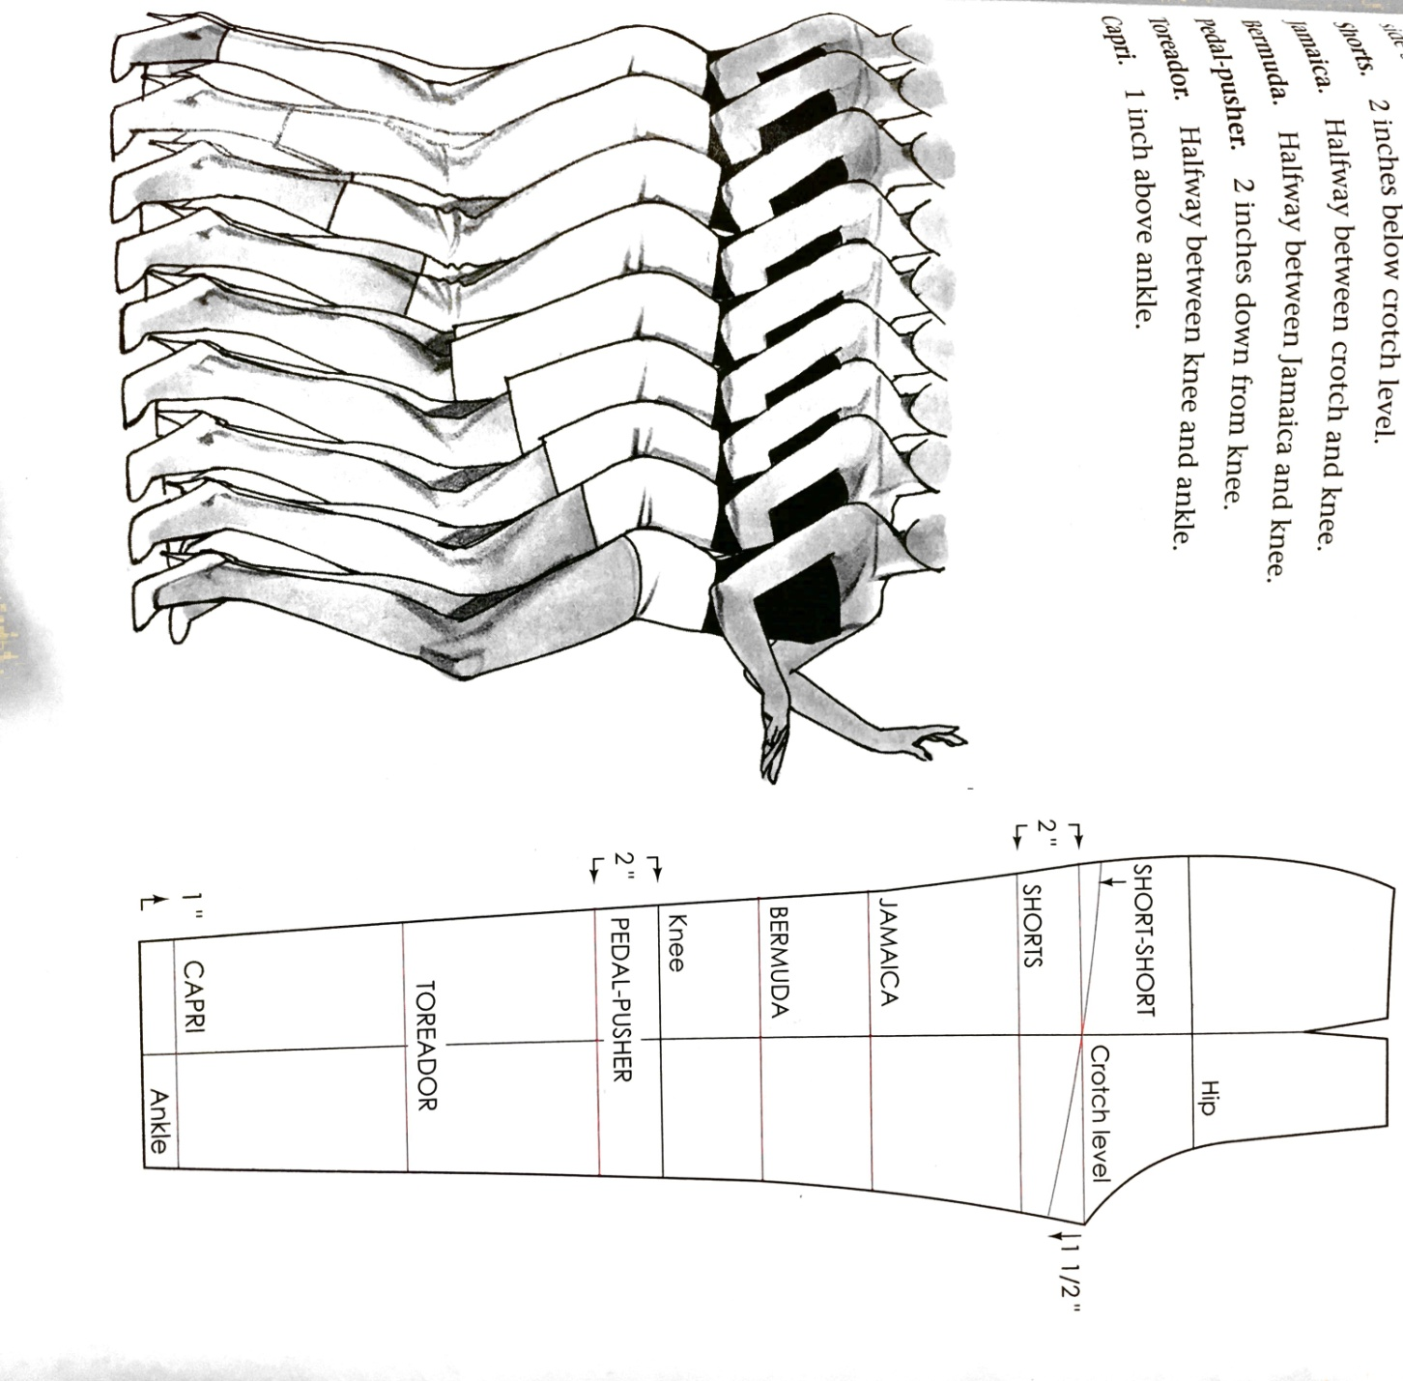

|  |  |  |  |  |  |  |  |
| --- | --- | --- | --- | --- | --- | --- | --- |
| S.No. | Classification No. | Category | Product | Style | Image | Source | P.No |
|  |  | Womens | Trouser | Classic Tailored Trousers | C:\Users\aditi\Desktop\itp pics\XNDM6757.jpg | Dressmaking  By Alison Smith | 204 |
|  |  | Womens | Trouser | Tapered  Capri Trouser | C:\Users\aditi\Desktop\itp pics\WMBA0324.jpg | Dressmaking  By Alison Smith | 208 |
|  |  | Womens | Trouser | Classic Palazzo | C:\Users\aditi\Desktop\itp pics\XECN0471.jpg | Dressmaking  By Alison Smith | 210 |
|  |  | Womens | Trouser | Wide Leg  Shorts | C:\Users\aditi\Desktop\itp pics\DNRR4419.jpg | Dressmaking  By Alison Smith | 216 |
|  |  | Womens | Trouser | Culotte | C:\Users\aditi\Desktop\itp pics\HBDM0367.jpg | Patternmaking For Fashion Design  Fourth Edition  By Helen Joseph-Armstrong | 564 |
|  |  | Womens | Trouser | Box Pleated Culottes | C:\Users\aditi\Desktop\itp pics\HBDM0367.jpg | Metric Pattern Cutting For Women’s Wear  Fourth Edition  By Winifred Aldrich | 102 |
|  |  | Womens | Trouser | Flared Culottes | C:\Users\aditi\Desktop\itp pics\HBDM0367.jpg | Metric Pattern Cutting For Women’s Wear  Fourth Edition  By Winifred Aldrich | 113 |
|  |  | Womens | Trouser | Trouser With Pleated Waistline | C:\Users\aditi\Desktop\itp pics\LNQJ1867.jpg | Metric Pattern Cutting For Women’s Wear  Fourth Edition  By Winifred Aldrich | 117 |
|  |  | Womens | Trouser | Flared And Gathered  Trouser | C:\Users\aditi\Desktop\itp pics\LNQJ1867.jpg | Metric Pattern Cutting For Women’s Wear  Fourth Edition  By Winifred Aldrich | 121 |
|  |  | Womens | Trouser | Baggy Pant | C:\Users\aditi\Desktop\itp pics\MJZA4231.jpg | Patternmaking For Fashion Design  Fourth Edition  By Helen Joseph-Armstrong | 581 |
|  |  | Womens | Trouser | Hip Pop Pant | C:\Users\aditi\Desktop\itp pics\FBBC7234.jpg | Patternmaking For Fashion Design  Fourth Edition  By Helen Joseph-Armstrong | 582 |
|  |  | Womens | Trouser | Pull On Pant | C:\Users\aditi\Desktop\itp pics\EIZR7329.jpg | Patternmaking For Fashion Design  Fourth Edition  By Helen Joseph-Armstrong | 583 |
|  |  | Womens | Trouser | High Waist Pant | C:\Users\aditi\Desktop\itp pics\DJBP5975.jpg | Patternmaking For Fashion Design  Fourth Edition  By Helen Joseph-Armstrong | 584 |
|  |  | Womens | Trouser | Jeans With V-Yoke | C:\Users\aditi\Desktop\itp pics\WDTZ2648.jpg | Patternmaking For Fashion Design  Fourth Edition  By Helen Joseph-Armstrong | 587 |
|  |  | Womens | Trouser | Clown Pant | C:\Users\aditi\Desktop\itp pics\DCQF7035.jpg | Patternmaking For Fashion Design  Fourth Edition  By Helen Joseph-Armstrong | 592 |
|  |  | Womens | Trouser | Contour Pant With Creaseline Flare | C:\Users\aditi\Desktop\itp pics\IRVL1629.jpg | Patternmaking For Fashion Design  Fourth Edition  By Helen Joseph-Armstrong | 590 |
|  |  | Womens | Trouser | Pant With Flared Leg | C:\Users\aditi\Desktop\itp pics\LIPS3934.jpg | Patternmaking For Fashion Design  Fourth Edition  By Helen Joseph-Armstrong | 591 |

|  |  |  |  |  |  |  |  |
| --- | --- | --- | --- | --- | --- | --- | --- |
| S.No. | Classification No. | Category | Product | Style | Image | Source | P. No. |
|  |  | Womens | Pant Derivative | Short-Short | C:\Users\aditi\Desktop\itp pics\OORA9814.jpg | Patternmaking For Fashion Design  Fourth Edition  By Helen Joseph-Armstrong | 494 |
|  |  | Womens | Pant Derivative | Short | C:\Users\aditi\Desktop\itp pics\CHFL4330.jpg | Metric Pattern Cutting For Women’s Wear  Fourth Edition  By Winifred Aldrich | 328 |
|  |  | Womens | Pant Derivative | Jamaica | C:\Users\aditi\Desktop\itp pics\CHFL4330.jpg | Metric Pattern Cutting For Women’s Wear  Fourth Edition  By Winifred Aldrich | 265 |
|  |  | Womens | Pant Derivative | Bermuda Pant | C:\Users\aditi\Desktop\itp pics\CHFL4330.jpg | Metric Pattern Cutting For Women’s Wear  Fourth Edition  By Winifred Aldrich | 125 |
|  |  | Womens | Pant Derivative | Pedal-Pushers | pants | Metric Pattern Cutting For Women’s Wear  Fourth Edition  By Winifred Aldrich | 255 |
|  |  | Womens | Pant Derivative | Capri Pants | scan0012 | Patternmaking For Fashion Design  Fourth Edition  By Helen Joseph-Armstrong | 596 |

|  |  |  |  |  |  |  |  |
| --- | --- | --- | --- | --- | --- | --- | --- |
| S.No | Classification No. | Category | Product | Style | Image | Source | Pg. |
|  |  | Womens | Jumpsuit | Styled Jumpsuit | C:\Users\aditi\Desktop\itp pics\WZLV1239.jpg | Patternmaking For Fashion Design  Fourth Edition  By Helen Joseph-Armstrong | 600 |
|  |  | Womens | Jumpsuit | Great Coverall | C:\Users\aditi\Desktop\itp pics\EYSY9395.jpg | Patternmaking For Fashion Design  Fourth Edition  By Helen Joseph-Armstrong | 601 |

|  |  |  |  |  |  |  |  |
| --- | --- | --- | --- | --- | --- | --- | --- |
| S.No. | Classification No. | Category | Product | Style | Image | Source | Pg. |
|  |  | Womens | Jackets | Double-Breasted Jacket | C:\Users\aditi\Desktop\itp pics\AUDZ6675.jpg | Patternmaking For Fashion Design  Fourth Edition  By Helen Joseph-Armstrong | 494 |
|  |  | Womens | Jackets | Style Jacket | C:\Users\aditi\Desktop\itp pics\ASBI1375.jpg | Patternmaking For Fashion Design  Fourth Edition  By Helen Joseph-Armstrong | 488 |
|  |  | Womens | Jackets | The Wrap Around Style Mannish Jacket | C:\Users\aditi\Desktop\itp pics\FHUE0838.jpg | Patternmaking For Fashion Design  Fourth Edition  By Helen Joseph-Armstrong | 501 |
|  |  | Womens | Jackets | Three Panel Style Mannish Jacket | C:\Users\aditi\Desktop\itp pics\DGML8269.jpg | Patternmaking For Fashion Design  Fourth Edition  By Helen Joseph-Armstrong | 502 |

|  |  |  |  |  |  |  |  |
| --- | --- | --- | --- | --- | --- | --- | --- |
| S.No. | Classification No. | Category | Product | Style | Image | Source | P. No |
|  |  | Womens | Dresses | Slip Dress With A Slinky Skirt | C:\Users\aditi\Desktop\itp pics\HSDQ4859.jpg | Patternmaking For Fashion Design  Fourth Edition  By Helen Joseph-Armstrong | 435 |
|  |  | Womens | Dresses | Twist Bodice With A Slinky Skirt | C:\Users\aditi\Desktop\itp pics\PGOV8586.jpg | Patternmaking For Fashion Design  Fourth Edition  By Helen Joseph-Armstrong | 441 |
|  |  | Womens | Dresses | All-In-One Bias Dress | C:\Users\aditi\Desktop\itp pics\SOLN2212.jpg | Patternmaking For Fashion Design  Fourth Edition  By Helen Joseph-Armstrong | 444 |
|  |  | Womens | Dresses | Shift Dress | scan0010 | Metric Pattern Cutting For Women’s Wear  Fourth Edition  By Winifred Aldrich | 114 |
|  |  | Womens | Dresses | Tent Dress |  | Patternmaking For Fashion Design  Fourth Edition  By Helen Joseph-Armstrong | 399 |
|  |  | Womens | Dresses | Shirt Dress | scan0010 | Metric Pattern Cutting For Women’s Wear  Fourth Edition  By Winifred Aldrich | 116 |
|  |  | Womens | Dresses | Empire Line Dress |  | Patternmaking For Fashion Design  Fourth Edition  By Helen Joseph-Armstrong | 397 |
|  |  | Womens | Dresses | Fitted | scan0010 | Metric Pattern Cutting For Women’s Wear  Fourth Edition  By Winifred Aldrich | 118 |
|  |  | Womens | Dresses | Panel Dress |  | Patternmaking For Fashion Design  Fourth Edition  By Helen Joseph-Armstrong | 395 |

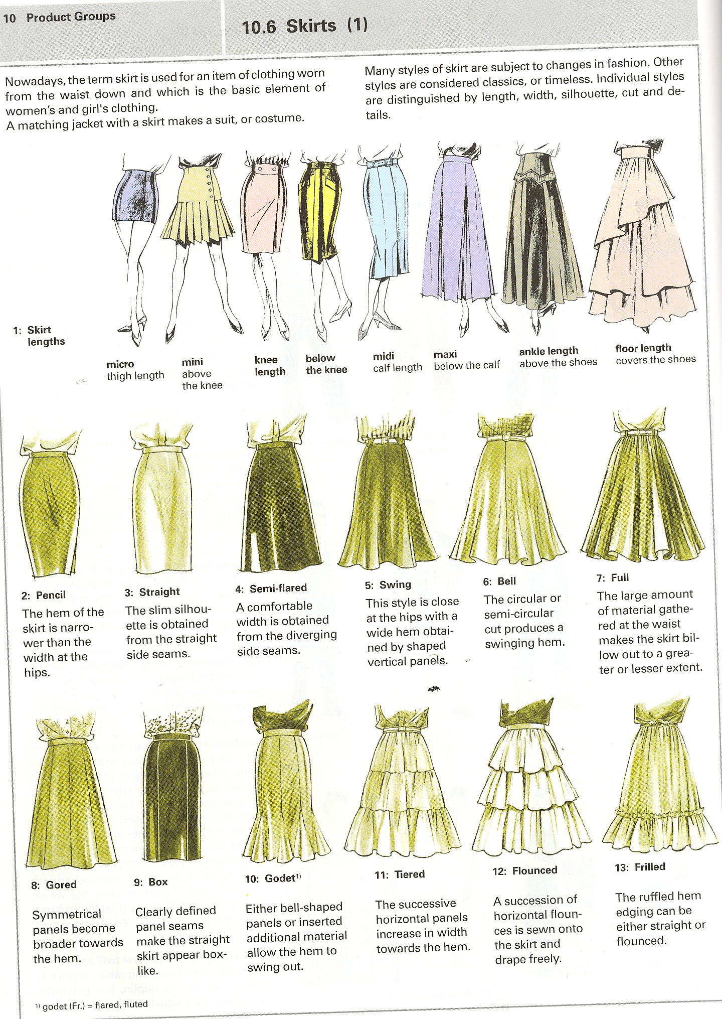

|  |  |  |  |  |  |  |  |
| --- | --- | --- | --- | --- | --- | --- | --- |
| S.No | Classification No. | Category | Name | Type | Image | Source | Pg. |
|  |  | Womens | Skirts | Straight |  | Patternmaking For Fashion Design  Fourth Edition  By Helen Joseph-Armstrong | 222 |
|  |  | Womens | Skirts | 1. Line |  | Patternmaking For Fashion Design  Fourth Edition  By Helen Joseph-Armstrong | 222 |
|  |  | Womens | Skirts | Inverted Triangle |  | Patternmaking For Fashion Design  Fourth Edition  By Helen Joseph-Armstrong | 222 |
|  |  | Womens | Skirts | Bell Shape |  | Patternmaking For Fashion Design  Fourth Edition  By Helen Joseph-Armstrong | 222 |
|  |  | Womens | Skirts | Flared A line |  | Patternmaking For Fashion Design  Fourth Edition  By Helen Joseph-Armstrong | 239 |
|  |  | Womens | Skirts | Basic Flared Skirt |  | Patternmaking For Fashion Design  Fourth Edition  By Helen Joseph-Armstrong | 240 |
|  |  | Womens | Skirts | Gathered Dirndl Skirt |  | Patternmaking For Fashion Design  Fourth Edition  By Helen Joseph-Armstrong | 248 |
|  |  | Womens | Skirts | Gored Skirt |  | Patternmaking For Fashion Design  Fourth Edition  By Helen Joseph-Armstrong | 250 |
|  |  | Womens | Skirts | Pegged Skirt With Pleats |  | Patternmaking For Fashion Design  Fourth Edition  By Helen Joseph-Armstrong | 258 |
|  |  | Womens | Skirts | Skirts With Yoke |  | Patternmaking For Fashion Design  Fourth Edition  By Helen Joseph-Armstrong | 260 |
|  |  | Womens | Skirts | Tiered Skirt |  | Patternmaking For Fashion Design  Fourth Edition  By Helen Joseph-Armstrong | 265 |
|  |  | Womens | Skirt | Kick-pleated Skirt |  | Patternmaking For Fashion Design  Fourth Edition  By Helen Joseph-Armstrong | 277 |
|  |  | Womens | Skirt | All-around Pleated Skirt |  | Patternmaking For Fashion Design  Fourth Edition  By Helen Joseph-Armstrong | 279 |
|  |  | Womens | Skirt | Inverted Box Pleat |  | Patternmaking For Fashion Design  Fourth Edition  By Helen Joseph-Armstrong | 281 |
|  |  | Womens | Skirt | Godet Skirt |  | Patternmaking For Fashion Design  Fourth Edition  By Helen Joseph-Armstrong | 284 |
|  |  | Womens | Skirt | Wrap Skirt |  | Patternmaking For Fashion Design  Fourth Edition  By Helen Joseph-Armstrong | 286 |
|  |  | Womens | Skirt | Full Circle Skirt |  | Patternmaking For Fashion Design  Fourth Edition  By Helen Joseph-Armstrong | 288 |
|  |  | Womens | Kurta | Straight Kurta | Image result for pattern making for kurta | Techniques Of Drafting and Pattern Making  By Padmavati B | 102 |
|  |  | Womens | Trousers (Ethnic wear) | Palazoo | Image result for pattern making for palazzo | Techniques Of Drafting and Pattern Making  By Padmavati B | 112 |
|  |  | Womens | Trousers (Ethnic wear) | Chudidar | Image result for pattern making for kurta | Techniques Of Drafting and Pattern Making  By Padmavati B | 105 |
|  |  | Womens | Top (Ethnic wear) | Kamiz | Image result for pattern making for kurta | Techniques Of Drafting and Pattern Making  By Padmavati B | 102 |
|  |  | Womens | Ethnic Wear | Salwar suit | salwar suits models fashion sketches - Google Search: | Techniques Of Drafting and Pattern Making  By Padmavati B | 111 |
|  |  | Womens | Ethnic wear | Lehenga Choli | C:\Users\aditi\Downloads\IMG_2540.JPG | Techniques Of Drafting and Pattern Making  By Padmavati B | 115 |

**Annexure 5 : TOP 10 BRANDS FOR APPAREL**

INFANTS

|  |  |
| --- | --- |
| S.NO | Brands |
| 1. | Gini and Jony |
| 2. | Mothercare |
| 3. | FS Mini Klub |
| 4. | Mulfi |
| 5. | Baby world |
| 6. | Donuts |
| 7. | Liliput |
| 8. | Kuchipoo |
| 9. | Ahad |
| 10. | Camey |

KIDS

|  |  |
| --- | --- |
| S.NO | Brands (Boys) |
| 1. | Gini and Jony |
| 2. | Little kangaroo |
| 3. | Pantoons |
| 4. | Lilliput |
| 5. | Palm tree |
| 6. | Allen solly Jr. |
| 7. | US polo |
| 8. | Camey |
| 9. | Indian terrain |
| 10. | SML original |

|  |  |
| --- | --- |
| S.NO | Brands (Girls) |
| 1. | FS mini klub |
| 2. | Gini and Jony |
| 3. | Little studio |
| 4. | Mothercare |
| 5. | Lilliput |
| 6. | Ahad |
| 7. | Baby world |
| 8. | Donut |
| 9. | Fingers |
| 10. | UCB |

ADULTS

|  |  |
| --- | --- |
| S.NO | WOMEN |
| 1. | Vermoda |
| 2. | Mast & Harbour |
| 3. | Biba |
| 4. | Park Avenue |
| 5. | Pepe jeans |
| 6. | Drapes |
| 7. | Global desi |
| 8. | Hashtag |
| 9. | W |
| 10. | Tokyo talkies |

|  |  |
| --- | --- |
| S.NO | MEN |
| 1. | Jack & Jones |
| 2. | Basics |
| 3. | Wrangler |
| 4. | Yep me |
| 5. | Blackberry |
| 6. | Derby |
| 7. | Peter England |
| 8. | Urban touch |
| 9. | Royal men |
| 10. | John players |